Game-like Activities to Practice ESL Listening, Speaking, Reading & Writing

Donna Price
San Diego Community College
Continuing Education Program

dprice@sdccd.edu

Research
Stephen Krashen: affective filter hypothesis

Penny Ur: game-like activities

John Comings: part of a community

Make activities game-like by:

Giving points

Giving a time limit

Making it a race

Dividing class into teams
Giving a small prize

Saying there will be a winner

A. Class Building Game
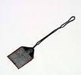
- 1) Two Truths and a Lie (L,S,R,W)* p. 2

B. Moving Activities
- 1) Fly Swatter Game (L,W) p. 2

- 2) Dictation Relay (L,S,R,W) p. 2

- 3) Scrambled Questions (L,S,R,W) p. 2

- 4) Conversation Cards (L,S) p. 3

◻ 5) Student Interview (L,S,W) p. 4

C. Group Seated Activities
- 2) Unscramble (L,S,R) p. 5


D. Dice Games
- 1) Questions (L,S) p. 6 Template p. 7

- 2) Vocabulary Dice Game (L,S) p. 8

Common Activities Made More Game-Like
- Crossword puzzle (It's a race--which pair can solve the puzzle the quickest?)
- Word scramble (The group that unscrambles the words the fastest wins!)

- Word search (The first pair who solves the word search wins! Winners discuss vocabulary while others are finishing.)

*L = Listening, S = Speaking, R = Reading, W = Writing

Donna Price San Diego Community College Continuing Education Program
1

Two Truths and a Lie
Procedure:

- Tell your students two truths and a lie.
- In pairs/small groups, students decide which statements are true and which one is a
lie.
- Share the answer.
- Students write two truths and one lie on a piece of paper.
- Students read their two truths and one lie to their partners or to the whole group.
- The partner/group guesses the answer.

from 50 Stimulating Classroom Activities

Fly Swatter Game
Procedure:

- Write 10-15 irregular past tense verbs on the board.
- Divide the class into two groups. Have the students line up into two groups.
- Hand the front person of each group a fly swatter. Give the simple present of a verb.

- The front person of each group finds the irregular verb on the board and hits it with the fly swatter.

- The person who hits it first wins a point for their team. Each person should hand the fly swatter to the next person in line.

- The team with the most points wins.

from 50 Stimulating Classroom Starters

Dictation Relay
Procedure:

- Teacher posts a list of words or sentences on the wall in several places.
- Student are divided into groups of 4.

- One member of each group (the runner) goes to the wall to read the word or sentence. The other group members stay seated.

- The runners must then walk back to the group and dictate what they read to their group--no yelling! If necessary, the runner goes back to the wall to check.

- Students take turn being the runner.

- Students check each others' papers as they write or at the end.
- The first to complete all the words or sentences accurately wins.
(Variation: #1 = runner, #2 = repeater, #3 = checker, #4 = reader)

from 50 Stimulating Classroom Starters

Scrambled Questions
Procedure:

- Teacher writes each word from a question on a separate piece of large paper.

- Teacher says a sentence. Students think of the question. This must be a review of questions and answers that have been studied.

- Students make a line in front of the class holding up their papers in the correct order of the question.

- Or, students make a line in front of the class in scrambled order and the students who are seated direct the movement of each student holding a word.

Donna Price San Diego Community College Continuing Education | 2

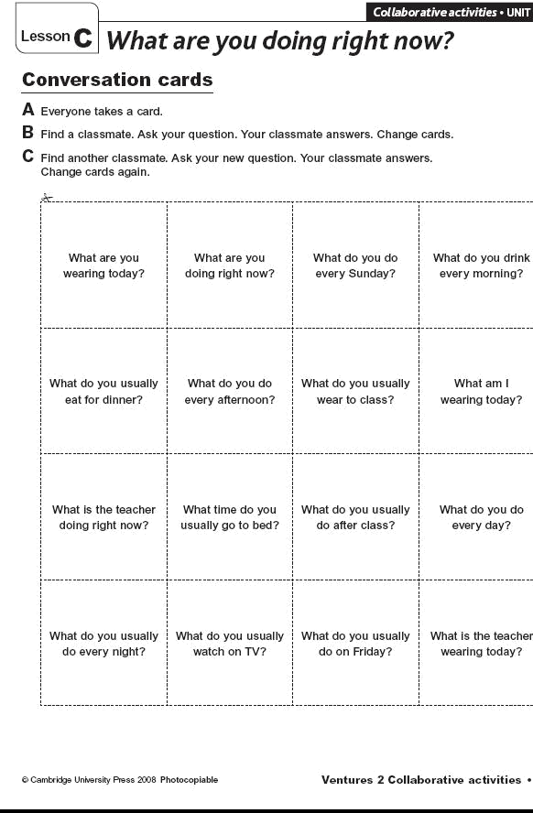

Donna Price San Diego Community College Continuing Education | 3

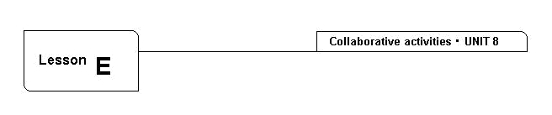
Writing

Student interview
A Talk to your classmates. Complete the chart.

A Maria, can you drive?
B Yes, I can.
 |  |  | Names
1. | Find a student who can drive. |  | Maria | .
1. | Find a student who can drive. |  |  | .
2. | Find a student who can cook. | ______________________________________
3. | Find a student who can read a bus schedule. | ______________________________________
4. | Find a student who can’t type. | ______________________________________
5. | Find a student who can build things. | ______________________________________
6. | Find a student who can speak three languages. | ______________________________________
7. | Find a student who can paint a house. | ______________________________________
8. | Find a student who can’t use a computer. | ______________________________________

B Write sentences about your classmates.

- Maria can drive.

- _____________________________________________________________

- _____________________________________________________________

- _____________________________________________________________

- _____________________________________________________________

- _____________________________________________________________

- _____________________________________________________________

- _____________________________________________________________

© Cambridge University Press 2008 Photocopiable

Ventures 1 Collaborative activities • 72

Donna Price San Diego Community College Continuing Education

4

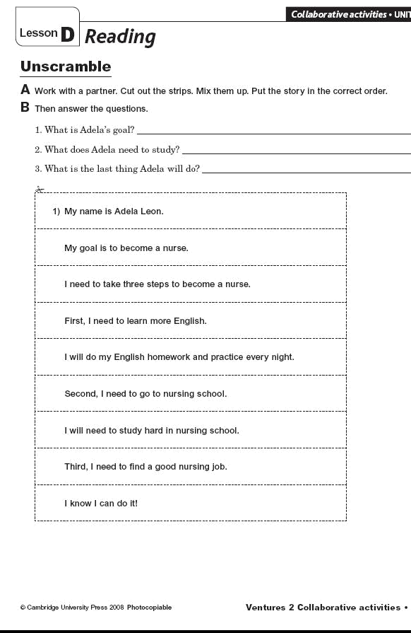

Donna Price San Diego Community College Continuing Education | 5

Questions Board Game
Procedure:

- 2-4 students put markers on the start. In groups, take turns rolling the die. The person with the highest number begins.

- Roll the die again. Student moves the marker to the correct place. Student reads the question out loud and answers it.

- Student gives the die to the person sitting on the right. The person who gets to the finish first wins!


START | What do you like to | How many cups of | What do you like to
 | do in your free | coffee do you drink | watch on TV?
 | time? | a day?
How often do you | How often do you | Where do you eat | Where do you go for
go to the cinema? | have English | your breakfast at | walks?
 | classes? | home?

Where do you go | What do you like to | Where does your | Where do you go
shopping? | eat? | best friend live? | during the
 |  |  | weekends?

Where do you go for | What do you do on | How do you get to | How often do you
holidays? | Friday nights? | school? | wash your hair?

What clothes do you | How often do you | What time do you | How many hours do
like to wear for | see your friends? | get up on Sunday | you work every
school? |  | mornings? | day?
 |  |  | How much time do
FINISH | Where do you | Where do you go to | you take to do your
 | work? | relax? | homework?

from 50 Stimulating Classroom Activities

Donna Price San Diego Community College Continuing Education | 6

Board Game Template


START

FINISH

Donna Price San Diego Community College Continuing Education | 7

Vocabulary Dice Game
Procedure:

- Teacher makes handout with instructions on what each number on the die means.
- Teacher makes vocabulary cards.
- Divide the class into groups.
- Give each group a die and instruction paper.
- Go over the instructions and give an example.

- Students take turns tossing the die. Then they take a vocabulary card. Depending on their die, they have to either:

1 on the die: act it out
2 on the die: draw a picture of the word
3 on the die: create a sentence using the vocabulary word
4 on the die: create a question to ask the group using the vocabulary word

5 on the die: explain the vocabulary word w/o using the actual word and the group guesses the word.

6 on the die: student chooses between 1-5.

from 50 Stimulating Classroom Activities

Extra Moving Activity:

Give One, Get One
Procedure:

- Ask students to individually start a list (something you have been studying in class), such as:

--things found in the classroom

--activities done over the weekend --names of food

- After a few minutes ask students to compare their lists to a classmate's list.

- Comparing their lists, they must give an item not on their classmate's list and take an item they didn't have on their own list.

- After giving and getting ideas, students move on to other classmates.
- Rewards can be given for the longest lists.

from Kagen and 50 Stimulating Classroom Starters

Donna Price San Diego Community College Continuing Education | 8

Extra Dice Game:

Roll the Dice Conversation Practice

Roll the dice once; find the category below. Roll the dice a second time,  and find the specific question # in that category. Talk about the question.

 | 1 Personal |  | 2 Family
 | Information
 |  | 1. How many people are in your family?
1. What's your last name? |  | 2. Are you married or single?
2. | Where are you from? | 3. | Who do you live with?
3. | What's your zip code? | 4. | How many sisters do you have?
4. | What's your address? | 5. | How many brothers do you have?
5. When is your birthday? |  | 6. | Do you have any nieces or nephews?

- What's your area code?

3 Health | 5
 | Community

- What do you do when you have a headache?

2. Why do people sometimes get a backache? | 1. Where do you buy stamps?
- What do you take if you have a stomachache? ^{2.} Where do you wash your clothes?
4. | What do you take if you have a sore throat? | 3. | Where do you buy food?
5. Do you eat a healthy breakfast? What do you |  | 4. What is the address of your school?
eat? |  | 5. | Where do children play?
6. | What exercise do you like to do? | 6. | Why did you decide to come to this city?
 | 4 Education | 6 | Work &Travel
1. | How did you learn about this school? | 1 Do you want a full-time job or a part-time
2. | How long have you been studying here? | job? Why?
3. | What do you want to do after you complete | 2. | What job do you want to have?
this class? |  | 3. | Do you like using the computer? What do
4. | Do you like to read? What do you read | you do on the computer?
outside of class? |  | 4. | What job did you have in your country?

- Is there a training program near your school? 5. Did you work in this country? What did

6. Do you speak English outside of class? If yes, | you do?
who do you speak to? | 6. Do you have any skills? Give two examples.

Donna Price San Diego Community College Continuing Education | 9

Useful Phrases

Games Phrases
Your turn.
My turn.
Who's next?

I'm next. You're next.
I agree/I don't agree.

Clarification Phrases
How do you spell ____________?
What does ________ mean?
I don't understand.

Please speak more slowly.
Please repeat.
Could you repeat that?

Polite Phrases
Thank you.

You're welcome.

Leave Taking Phrases
It was nice talking to you.

See you later.
See you soon.
See you tomorrow.

Have a nice weekend.

Donna Price San Diego Community College Continuing Education | 10

MATERIALS MANAGERS

Duties:

Pass out papers for the teacher.

Distribute and collect books.

Be sure the cabinet is neat before you leave.

Be sure all materials (dictionaries, tapes, etc.,) are put away before you leave.

LANGUAGE YOU NEED TO DO THESE JOBS:

Did everyone get a handout?

Here you go. Here you are.

Does anyone need a sheet?

Who needs one?

There is one book missing.

Who forgot to put back the …?

Should everyone get a book, or should students share?

Donna Price San Diego Community College Continuing Education | 11

TRAINERS

Duties:

Help new students. Ask them to sit with you.
Introduce yourself.

Show the new students where to sign in. Show them where the materials are.

Help the students feel comfortable.

LANGUAGE YOU NEED TO DO THESE JOBS:

Hi. Welcome to the class. My name is ________

What's your name?

Every day you sign this sheet when you come in. When you leave, you sign out. (Show the student the sign-in attendance sheet).

The books and materials are over there in the cabinet.
(Show the student).

Donna Price San Diego Community College Continuing Education | 12

If you have any questions, please ask me. I can help you.

Commitment Sheet

I will use the following three game-like activities in my classroom to reinforce a specific skill (L, S, R, W) during the next three months.

- __________________________________________________

- __________________________________________________

- __________________________________________________

References
Websites
Donna's workshop handouts: http://www.quia.com/pages/donna/workshops

50 Stimulating Classroom Starters: http://www.quia.com/pages/donna/workshops

Different games every day: http://www.agameaday.com/
Icebreakers: http://www.icebreakers.ws/

Icebreakers, what to do on the first day:

http://honolulu.hawaii.edu/intranet/committees/FacDevCom/guidebk/teachtip/teac
htip.htm
Games, puzzles, worksheets, templates: http://www.suelebeau.com/freetools.htm

Variety of games: http://www.group-games.com/games-by-type

Word search, crossword puzzles: http://puzzlemaker.discoveryeducation.com/

Workplace Basics: SCANS (Secretary's Commission on Achieving Necessary Skills) http://www.ericdigests.org/1992-5/skills.htm

Worksheets, puzzles: http://www.theteacherscorner.net/printable-worksheets/

Other Resources

A Course in Language Teaching. Penny Ur, Cambridge University Press

Cathy's Cards, Kathy Diaz, Alta ESL

Conversation Inspirations, Nancy Zelman, Alta ESL

Cooperative Learning, Spencer Kagen, Kagen Publishing

Five-Minute Activities, Penny Ur and Andrew Right, Cambridge University Press

Learner Persistence, from NCSALL Student Circle Guide, John Comings

Principles of Language Learning and Teaching, Douglas Brown, Longman

Donna Price San Diego Community College Continuing Education 13

Ventures, Books 1, 2, 3, 4, and Teacher's Toolkit CD-ROM in the Teacher's Edition, K. Lynn Savage, Gretchen Bitterlin, Dennis Johnson, Donna Price, Sylvia Ramirez, Cambridge University Press

Zero Prep, Laurel Pollard and Natalie Hess, Alta ESL

Donna Price San Diego Community College Continuing Education 14

