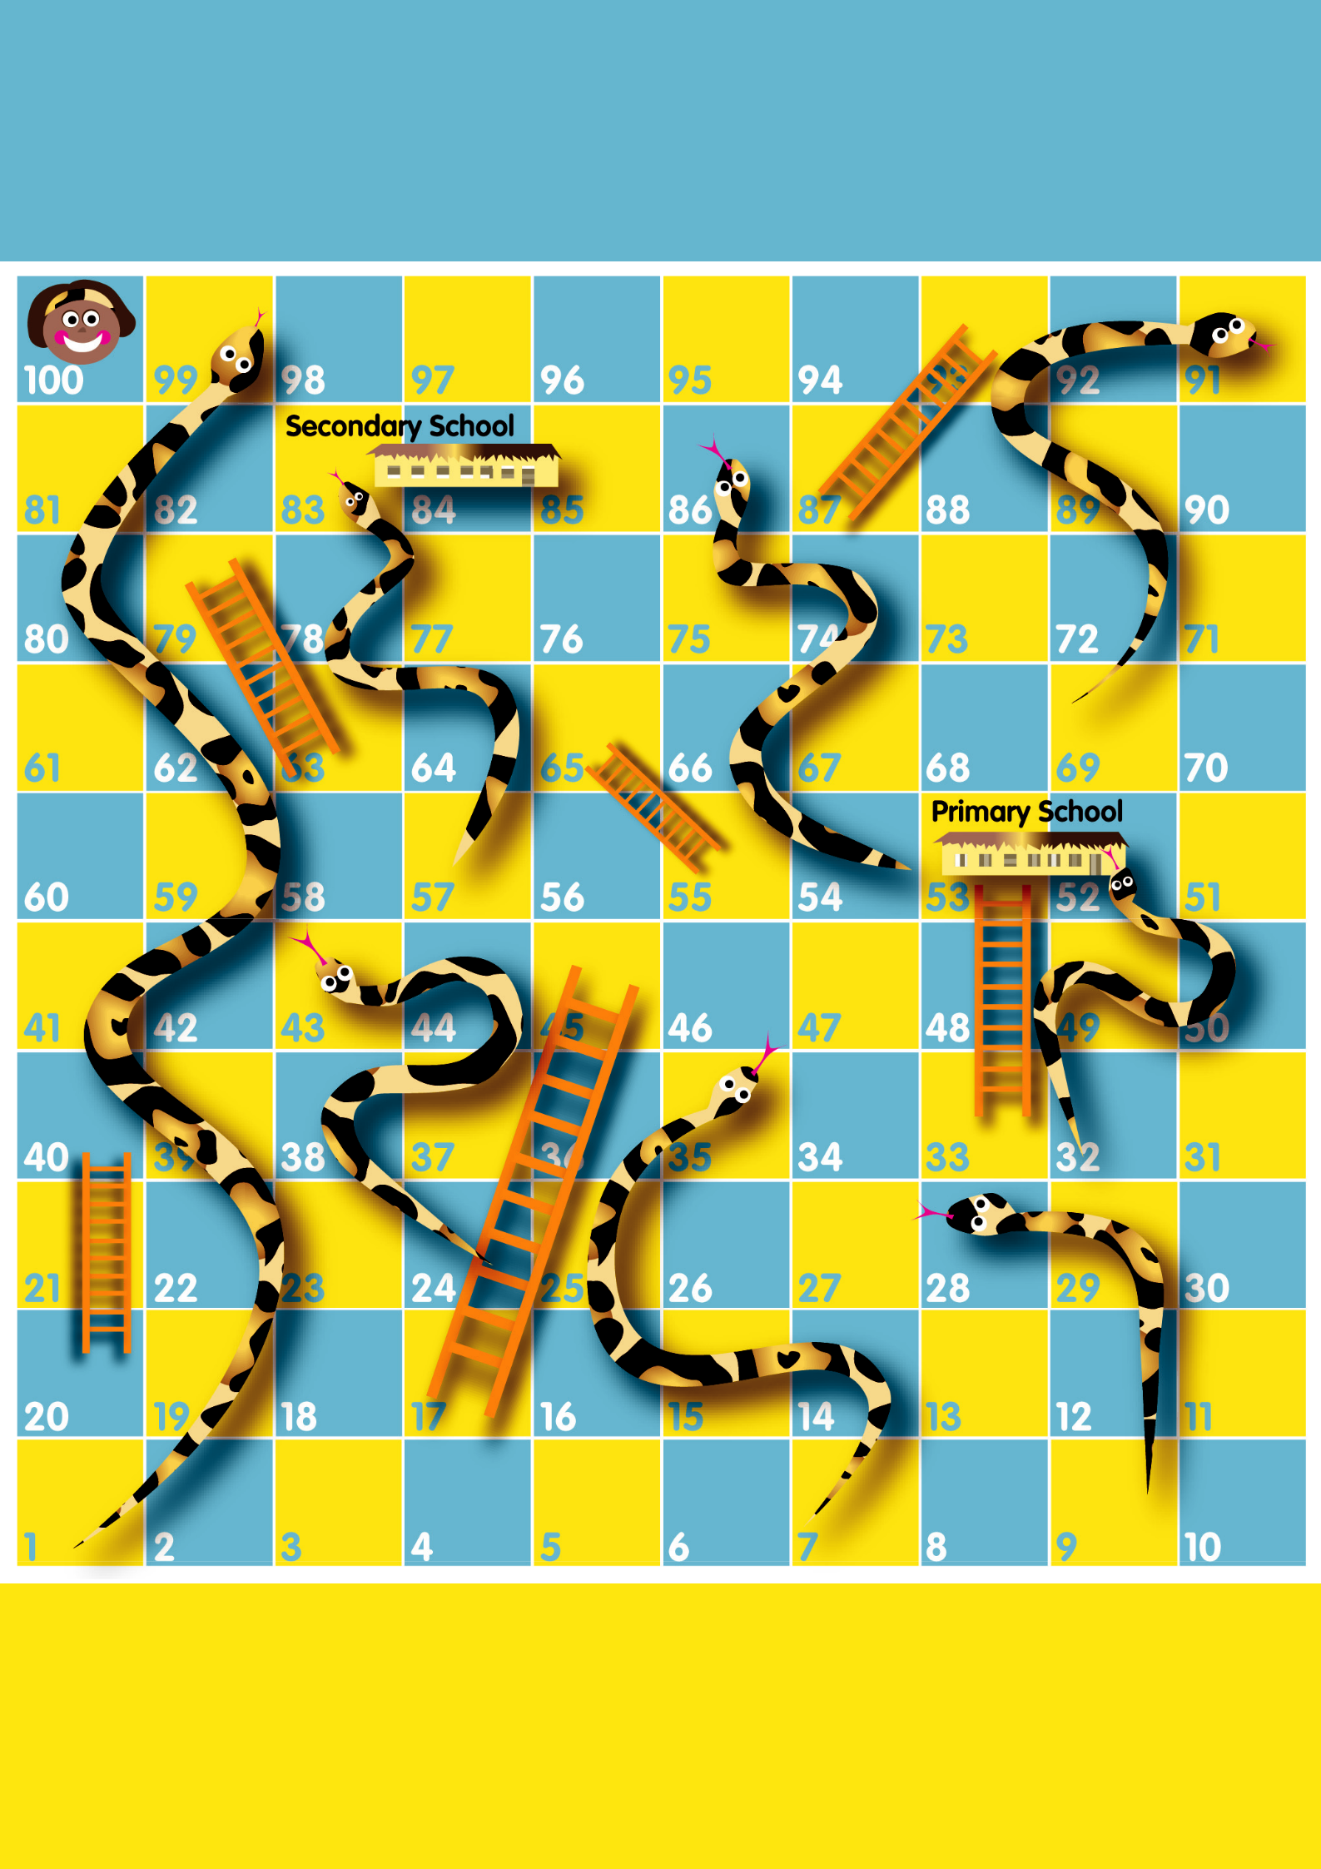
The Game of Girls’ Education

Let’s Make All Girls Winners

Snakes and Ladders:

Ups and downs for girls’ education

This Snakes and Ladders game is about the obstacles girls face getting to school and staying there in many countries and some of the ways girls’ chances of education can be made more secure. Girls make up 60% of the 110 million children worldwide who never go to school. Poverty means girls often

need to work disrupting their schooling. Schools, teachers and textbooks are often inadequate. The journey to school can be dangerous. Sometimes community traditions, such as marrying girls at a young age mean girls have to leave school. Often school is expensive and families can only pay for one child, usually a son, to go to school.

Girls who don’t go to school suffer in

many ways. Just by finishing primary school, a girl halves her chances of getting HIV/AIDS. Giving girls an education allows them to defend their rights and ensure they have better futures.

Why play Snakes and Ladders now?

In 2000, world leaders decided it was time for action and signed up to a set of goals aiming to halve world poverty by 2015. One Millennium Development Goal sought to promote gender equality, empower women and get all girls into school. By 2005, there were meant to be equal numbers of boys and girls in school.

2005 has been reached but in more than 70 countries there are still fewer girls than boys in school and in half of these one in five girls don’t even go to primary

school. Without dramatic progress, more than 30 countries will still have large numbers of girls out of school by 2015. Countries in Asia and Africa are struggling most. In Africa, only one in five girls are enrolled in secondary school and only a tiny proportion complete secondary

education. On current trends, it will take more than 100 years before all girls in Africa go to primary school.

On 8 July 2005, Tony Blair is hosting a meeting of the leaders of the world’s richest countries –
the G8 – in Scotland. People from all over the world are coming together to tell world leaders that it’s time to ‘Make Poverty History’. Millions of children are sending ‘buddies’, cut-outs of out-of-school girls and boys, to the G8 as part of the Send My Friend to School campaign, organised by the Global Campaign for Education.

The ‘snakes and ladders’ on the way to getting all girls to school

Playing our giant game of snakes and ladders will show you what it is like for millions of girls, for whom access to education is a game of chance. Sometimes you will get a helping hand – a ladder – such as a school near your house, or a great teacher. But more often you will face big challenges in getting educated, for instance taking time out from

school to care for brothers and sisters or being bullied at school. Getting into school is only the first step – you may well be forced to
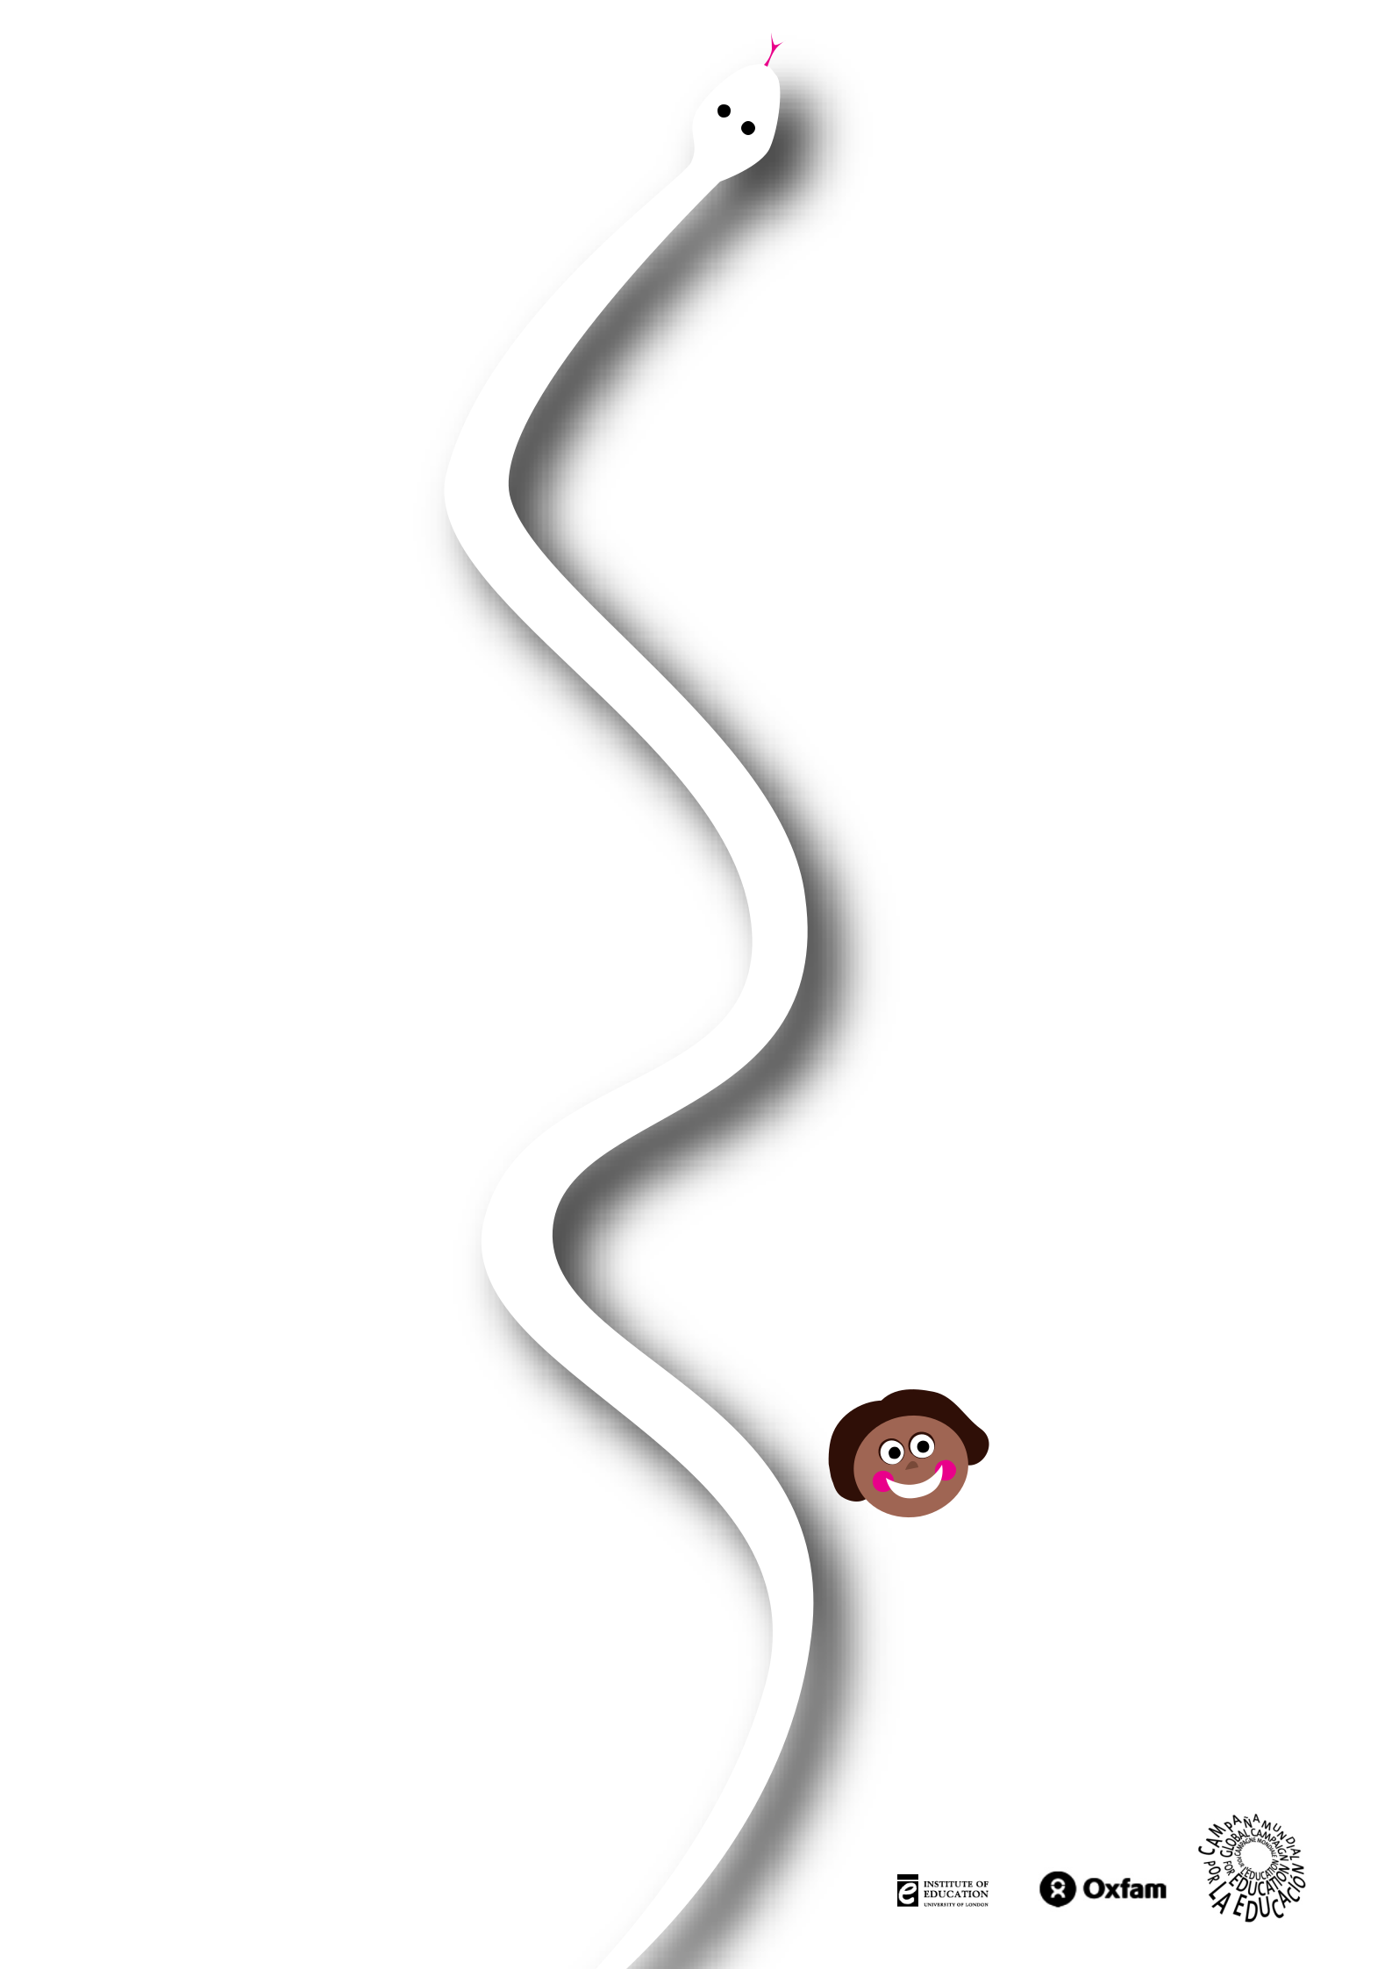
drop out again by another kind of ‘snake’, such as getting married when you are very young.

Some ‘Snakes’: obstacles to girls’ education

You have to work to earn money so your family can eat

Your brother’s education is more important than yours

Your community believes girls should not go to school

G8 leaders are ignoring girls’ education

Your mother and father are sick with AIDS and need your help

Teachers and boys say you are stupid

You have to get married and leave school

School fees are expensive and you can’t afford to pay

Some ‘Ladders’: how girls’ education can be encouraged

Your government abolishes all school fees

G8 leaders pledge generous money for girls’ education

A new woman teacher at your school encourages you

School timetables are made flexible so it is easier for you to attend

A new school is built close to your home making the journey safer for girls Boys and girls get separate toilets

Your father believes education is important for his daughters

Three girls in your village graduate and get good jobs

What next?

Why not make your own snakes and ladders board and play the game with your class at school. You could think about other snakes and ladders that affect girls’ education around the world and include them in the game.

To find out about other ways you can support girls’ education visit the Global Campaign for Education “Send My Friend”

website: www.sendmyfriend.org

The Girls’ Education Snakes and Ladders game has been developed by the Beyond Access: Gender, Education and Development Project. The project was launched in 2003 to share ideas about how to achieve gender-equitable education and meet the Millennium Development Goals. It is a partnership between the Institute of Education, University of London, Oxfam and the Department for International Development. To find out more, see our websites www.ioe.ac.uk/efps/beyondaccess or

www.ungei.org

Thanks to Martin Jezierski for painting the game, and to www.us2design.co.uk for leaflet design.

