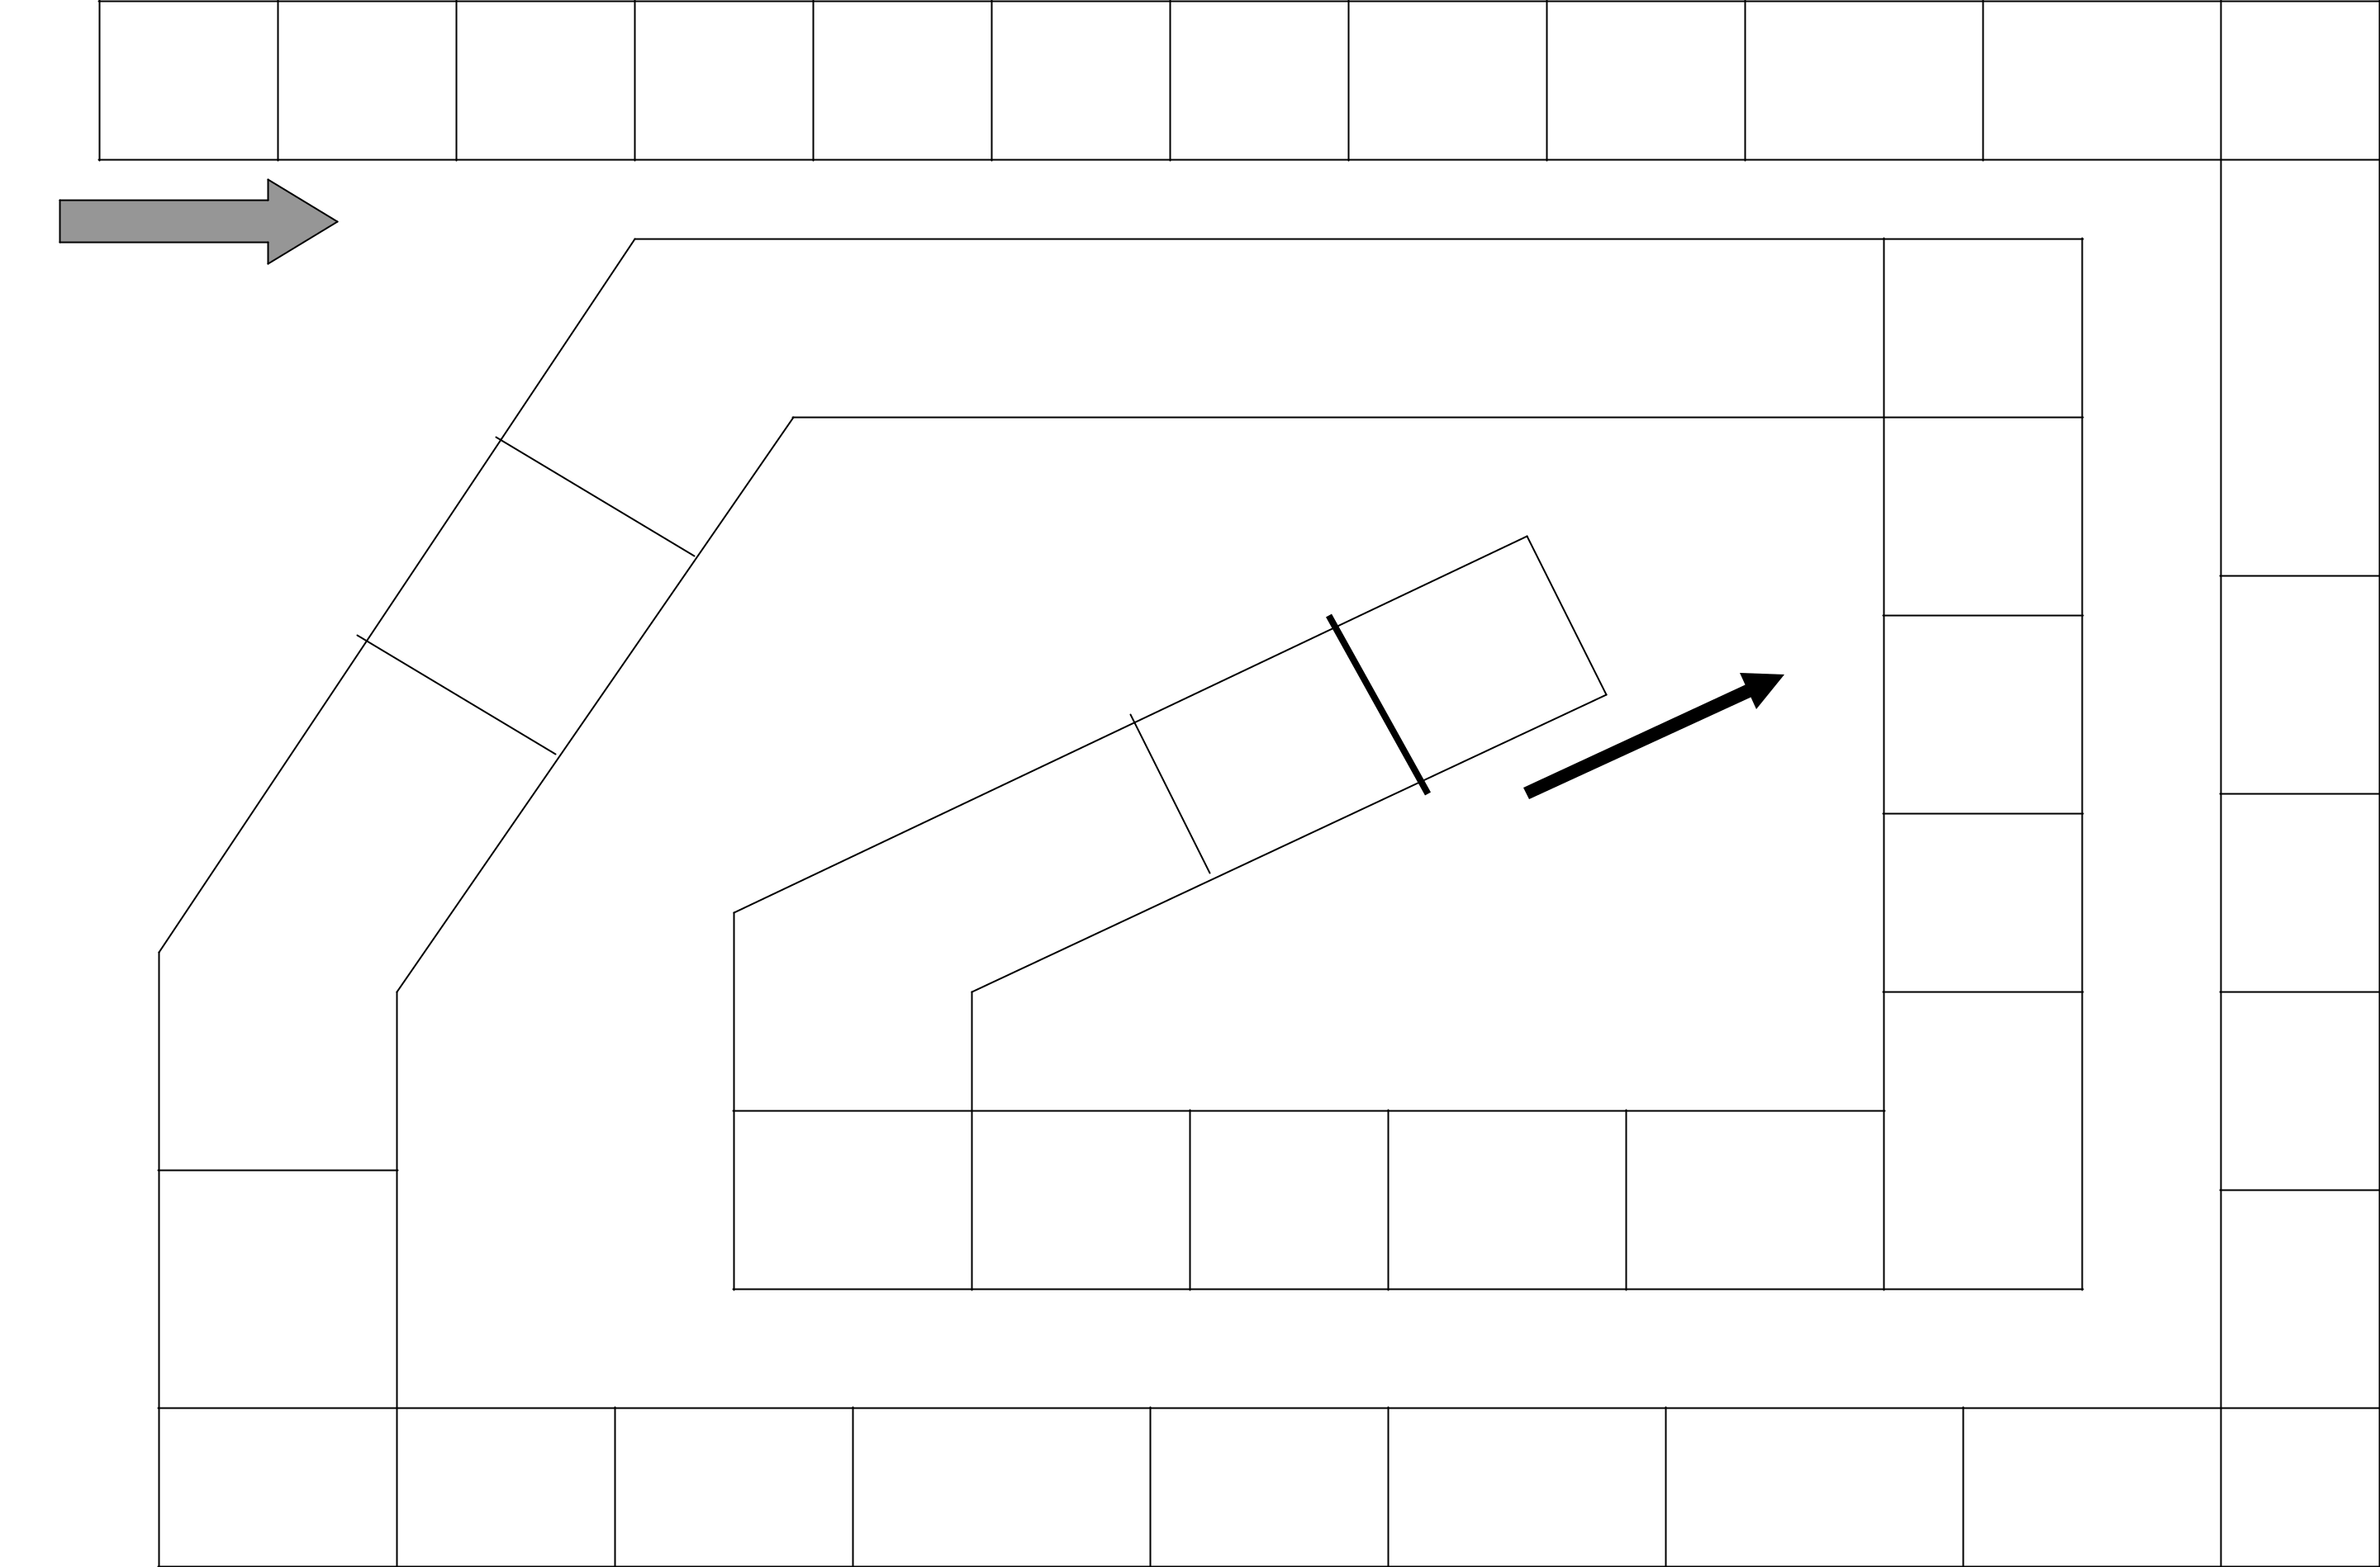

START

FINISH

© 2001

esl-lounge.com

