2019 Headache Diary |  |  |  |  |  |  |  |  |  |  |  |  |  |  |  |  |  |  |  |  |  |  | Name: |  |  |  |  |  |  |  |  |  |  |  |  |  |  |  |  |  |  |  | Mark medication changes below each month
January |  |  |  |  |  |  |  |  |  |  | February |  |  |  |  |  |  |  |  |  |  | March |  |  |  |  |  |  |  |  |  | April |  |  |  |  |  |  |  |  |  |  | May |  |  |  |  |  |  |  |  |  | June
M T W T F S S |  |  |  |  |  |  |  |  |  |  | M T W T F S S |  |  |  |  |  |  |  |  |  |  | M T W T F S S |  |  |  |  |  |  |  |  |  | M T W T F S S |  |  |  |  |  |  |  |  |  |  | M T W T F S S |  |  |  |  |  |  |  |  |  | M T W T F S S
1 |  |  | 2 | 3 | 4 | 5 | 6 |  |  |  |  |  |  |  |  | 1 | 2 | 3 |  |  |  |  |  |  |  | 1 | 2 | 3 |  | 1 |  |  | 2 |  | 3 | 4 | 5 | 6 | 7 |  |  |  |  |  | 1 | 2 | 3 | 4 | 5 |  |  |  |  |  |  |  |  |  | 1 | 2
7 | 8 |  | 9 | 10 | 11 | 12 | 13 |  |  | 4 |  | 5 |  | 6 | 7 | 8 | 9 | 10 |  |  | 4 |  | 5 | 6 | 7 | 8 | 9 | 10 |  |  | 8 |  | 9 |  | 10 | 11 | 12 | 13 | 14 |  |  | 6 |  | 7 | 8 | 9 | 10 | 11 | 12 |  |  | 3 |  | 4 |  | 5 | 6 | 7 | 8 | 9
14 | 15 |  | 16 | 17 | 18 | 19 | 20 |  |  |  | 11 | 12 |  | 13 | 14 | 15 | 16 | 17 |  |  |  | 11 | 12 | 13 | 14 | 15 | 16 | 17 |  |  |  | 15 | 16 |  | 17 | 18 | 19 | 20 | 21 |  |  |  | 13 | 14 | 15 | 16 | 17 | 18 | 19 |  |  |  | 10 | 11 |  | 12 | 13 | 14 | 15 | 16
21 | 22 |  | 23 | 24 | 25 | 26 | 27 |  |  |  | 18 | 19 |  | 20 | 21 | 22 | 23 | 24 |  |  |  | 18 | 19 | 20 | 21 | 22 | 23 | 24 |  |  |  | 22 | 23 |  | 24 | 25 | 26 | 27 | 28 |  |  |  | 20 | 21 | 22 | 23 | 24 | 25 | 26 |  |  |  | 17 | 18 |  | 19 | 20 | 21 | 22 | 23
28 | 29 |  | 30 | 31 |  |  |  |  |  |  | 25 | 26 |  | 27 | 28 |  |  |  |  |  |  | 25 | 26 | 27 | 28 | 29 | 30 | 31 |  |  |  | 29 | 30 |  |  |  |  |  |  |  |  |  | 27 | 28 | 29 | 30 | 31 |  |  |  |  |  | 24 | 25 |  | 26 | 27 | 28 | 29 | 30
 |  |  |  |  |  |  |  |  |  |  |  |  |  |  |  |  |  |  |  |  |  |  |  |  |  |  |  |  |  |  |  | ..............................................................................................
.............................................................................................. |  |  |  |  |  |  |  |  |  |  | .............................................................................................. |  |  |  |  |  |  |  |  |  |  | .............................................................................................. |  |  |  |  |  |  |  |  |  | .............................................................................................. |  |  |  |  |  |  |  |  |  |  | .............................................................................................. |  |  |  |  |  |  |  |  |  | ..............................................................................................
 |  |  |  |  |  |  |  |  |  |  | .............................................................................................. |  |  |  |  |  |  |  |  |  |  | .............................................................................................. |  |  |  |  |  |  |  |  |  | Totals: |  |  |  |  |  |  |  |  |  |  | .............................................................................................. |  |  |  |  |  |  |  |  |  | ..............................................................................................
..............................................................................................
Totals: |  |  |  |  |  |  |  |  |  |  | Totals: |  |  |  |  |  |  |  |  |  |  | Totals: |  |  |  |  |  |  |  |  |  |  |  |  |  |  |  |  |  |  |  |  | Totals: |  |  |  |  |  |  |  |  |  | Totals:
July |  |  |  |  |  |  |  |  |  |  | August |  |  |  |  |  |  |  |  |  |  | September |  |  |  |  |  |  |  |  |  | October |  |  |  |  |  |  |  |  |  |  | November |  |  |  |  |  |  |  |  |  | December
M T W T F S S |  |  |  |  |  |  |  |  |  |  | M T W T F S S |  |  |  |  |  |  |  |  |  |  | M T W T F S S |  |  |  |  |  |  |  |  |  | M T W T F S S |  |  |  |  |  |  |  |  |  |  | M T W T F S S |  |  |  |  |  |  |  |  |  | M T W T F S S
1 | 2 |  | 3 | 4 | 5 | 6 | 7 |  |  |  |  |  |  |  | 1 | 2 | 3 | 4 |  |  |  |  |  |  |  |  |  | 1 |  |  |  |  | 1 |  | 2 | 3 | 4 | 5 | 6 |  |  |  |  |  |  |  | 1 | 2 | 3 |  |  |  |  |  |  |  |  |  |  | 1
8 | 9 |  | 10 | 11 | 12 | 13 | 14 |  |  | 5 |  | 6 |  | 7 | 8 | 9 | 10 | 11 |  |  | 2 |  | 3 | 4 | 5 | 6 | 7 | 8 |  |  | 7 |  | 8 |  | 9 | 10 | 11 | 12 | 13 |  |  | 4 |  | 5 | 6 | 7 | 8 | 9 | 10 |  |  | 2 |  | 3 |  | 4 | 5 | 6 | 7 | 8
15 | 16 |  | 17 | 18 | 19 | 20 | 21 |  |  |  | 12 | 13 |  | 14 | 15 | 16 | 17 | 18 |  |  |  | 9 | 10 | 11 | 12 | 13 | 14 | 15 |  |  |  | 14 | 15 |  | 16 | 17 | 18 | 19 | 20 |  |  |  | 11 | 12 | 13 | 14 | 15 | 16 | 17 |  |  |  | 9 | 10 |  | 11 | 12 | 13 | 14 | 15
22 | 23 |  | 24 | 25 | 26 | 27 | 28 |  |  |  | 19 | 20 |  | 21 | 22 | 23 | 24 | 25 |  |  |  | 16 | 17 | 18 | 19 | 20 | 21 | 22 |  |  |  | 21 | 22 |  | 23 | 24 | 25 | 26 | 27 |  |  |  | 18 | 19 | 20 | 21 | 22 | 23 | 24 |  |  |  | 16 | 17 |  | 18 | 19 | 20 | 21 | 22
29 | 30 |  | 31 |  |  |  |  |  |  |  | 26 | 27 |  | 28 | 29 | 30 | 31 |  |  |  |  | 23 | 24 | 25 | 26 | 27 | 28 | 29 |  |  |  | 28 | 29 |  | 30 | 31 |  |  |  |  |  |  | 25 | 26 | 27 | 28 | 29 | 30 |  |  |  |  | 23 | 24 |  | 25 | 26 | 27 | 28 | 29
30 |  |  |  |  |  |  |  |  |  |  |  |  |  |  |  |  |  |  |  |  |  |  |  |  |  |  |  |  |  |  |  |  |  |  |  |  |  |  |  |  |  |  |  |  |  |  |  |  |  |  |  | 30 |  | 31
.............................................................................................. |  |  |  |  |  |  |  |  |  |  | .............................................................................................. |  |  |  |  |  |  |  |  |  |  | .............................................................................................. |  |  |  |  |  |  |  |  |  | .............................................................................................. |  |  |  |  |  |  |  |  |  |  | .............................................................................................. |  |  |  |  |  |  |  |  |  | ..............................................................................................
.............................................................................................. |  |  |  |  |  |  |  |  |  |  | .............................................................................................. |  |  |  |  |  |  |  |  |  |  | .............................................................................................. |  |  |  |  |  |  |  |  |  | .............................................................................................. |  |  |  |  |  |  |  |  |  |  | .............................................................................................. |  |  |  |  |  |  |  |  |  | ..............................................................................................
Totals: |  |  |  |  |  |  |  |  |  |  | Totals: |  |  |  |  |  |  |  |  |  |  | Totals: |  |  |  |  |  |  |  |  |  | Totals: |  |  |  |  |  |  |  |  |  |  | Totals: |  |  |  |  |  |  |  |  |  | Totals:


Instructions

- Headache commenced during sleep should be marked with a square. eg 2nd

- If headache starts whilst you are awake mark the date with a circle. eg 11th

- If the headache resolves in less than 1½ hrs strike out the day. eg 8th or 16th

- Mark with * date of any change in headache medication and add detail in space beneath the month. eg 26th*

- For females who menstruate, please underline your period days. eg 17th, 18th, 19th, 20th, 21st

6. If the headache lasts more than one day, please mark as follows. eg 4th, 5th, 6th, 7th

- Any warning symptoms of an attack before retiring to bed mark with a ‘W’. eg 23rd ^{W}

- If you have a lesser headache mark as 14th and if this disappears within 1½ hrs mark as eg 14th There is a short Video on how to complete this diary by Prof Paul Spira and more diaries are available from the Patient Resources section at www.aspenpharma.com.au

SAMPLE CALENDAR

M | T | W | T | F | S | S
1 | 2 | 3 | 4 | 5 | 6 | 7
8 | 9 | 10 | 11 | 12 | 13 ^{w} 14
15 | 16 | 17 | 18 | 19 | 20 | 21

- 23 ^{w} 24 25 26 * 27 28
- 30 31

© 2009 Assoc. Prof. Paul Spira. | Disclaimer: Provision of the headache diary byAspenPharmacarestaffinnowayendorsesuseofanyproductbutisprovidedasaservicetothemedicalprofession |  | Diary sponsored by | AF03612 ASP2014

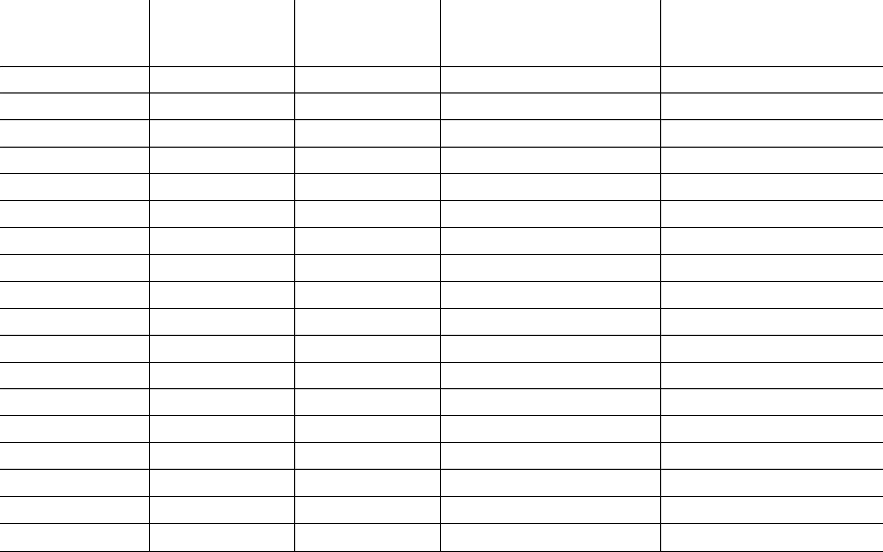  PROPHYLACTIC | FAILED | ACUTE
MEDICATIONS | PROPHYLACTIC | PHASE | INSTRUCTIONS
TO TRY | MEDICATIONS | THERAPIES

1. 1.

2. 2.

3. 3.

4. 4.

5. 5.

6. 6.

7. 7.

8. 8.

9. 9.

10. 10.

11. 11.

12. 12.

13. 13.

14. 14.

15. 15.

16. 16.

17. 17.

18. 18.

TO BE COMPLETED BY DOCTOR

Aspen Australia is comprised of Aspen Asia Pacific Pty Ltd (ABN 75 146 444 484) and its subsidiaries, including Aspen Pharmacare Australia Pty Ltd (ABN 51 096 236 985), Aspen Pharma Pty Ltd (ABN 88 004 118 594), Aspen Nutritionals Australia Pty Limited ACN 160607509, Orphan Holdings Pty Ltd (ABN 50 115 816 209), Orphan Australia Pty Ltd (ABN 11 067 189 342) and Aspen Products Pty Ltd (ABN 17 003 144 170). All sales and marketing requests to: Aspen Pharmacare Pty Ltd, 34-36 Chandos Street, St Leonards NSW 2065. Tel: +61 2 8436 8300 aspen@aspenpharmacare.com.au www.aspenpharma.com.au. Prepared: October 2018 AF03612 ASP2014

