Headache diary

Helping you manage your headache


How can this booklet help you?

This booklet is designed to help you understand and manage your headaches by recording information about them and any treatments used (medicine and non-medicine options).

Your doctor will want to know the overall pattern of your headaches, how they affect you, the treatments used and what the triggers may be. Doctors and people who experience frequent and persistent headaches have found that keeping a diary for one month can help you and your doctor get more from your consultation.

Use the diary to:

track the frequency of your headaches, the treatments used and how effective they were for you

understand your headache experience including symptoms and triggers

be better prepared to discuss your headache with your health professional.

Types of headache

Headache is one of the most common reasons for visits to GPs. There are many types of headache, of which tension-type headache is the most common. Other types include migraine and cluster headache.

Headache has many triggers and causes, ranging from lifestyle factors such as sleep deprivation, dehydration and food sensitivities to mental and physical health issues.

Most of the time there is no serious underlying condition. Investigation — such as blood tests or scans — is rarely helpful, even in the case of long-term headache. Your doctor will consider the possible causes and will usually make a diagnosis based on a good understanding of your symptoms, headache history, medical history and an examination.

Describing your headache accurately can help you and your doctor understand the type of headache you have. Headaches can have many different features such as a throbbing sensation, tightness around the head, varying with movement or exertion, and may differ in the location of the pain (one -sided, both sides, or all over), as well as frequency, intensity and duration. Some headaches are accompanied by nausea or sensitivity to light or noise.

Always seek medical advice if you have concerns about your headache, especially for pain that is severe, new, or different to pain you have had before, increasing in intensity or frequency, or is accompanied by other symptoms.
Use the diary to record your headache

Complete a diary entry whenever you experience a headache. Do this for one month. Include as much information as you can about the headache and treatment used (including medicine and non-medicine options).

Include other symptoms or triggers that may be present when you experience headache (e.g. sore throat, menstruation, stress, mood, or sleep deprivation).

Also record what you ate and drank prior to the headache. Headache can be caused by sensitivity to certain foods or by fasting.

Use the questions below to assess your headache and record this information in the diary section.

About your headache

How would you rate the level of pain from the headache, if on a scale of 0—10, 0 = no pain and 10 = worst possible pain?

Where exactly did you feel the pain of the headache (e.g. one or both sides of the head)?

What did the pain feel like (e.g. ‘throbbing’, made worse by routine physical activity)?

How long did the headache last?

Triggers and symptoms

What other symptoms did you experience with the headache (e.g. nausea, sensitivity to light and/or noise)?

What do you think might have triggered the headache (e.g. stress, menstration, not enough sleep)?

Treatment

What did you do to ease the pain?

Medicines used?

Other treatments?

about your headache

Date | Headache | Duration of |  | Activity
 | rating 0—10 | headache |  | undertaken
 | (0 = no pain, 10
 | = worst possible
 | pain) and type
 | of pain
e.g. |  | 4 hours |  | Still able to work
e.g. | 5 | 4 hours |  | Still able to work
22 Mar | Dull ache across |  |  | and attend all
 | my forehead |  |  | my meetings
Symptoms and triggers

Sleep

Didn’t get my usual 8 hours of sleep last night
 |  |  |  | Treatments and how well they worked
Mood/stress |  | Other |  | Medicine |  | Other |  | Effectiveness of
 |  | symptoms |  | used/amount |  | treatment |  | medicine and/or
 |  | or triggers |  |  |  | used/amount |  | treatment
 |  |  |  |  |  |  |  | 0 (not at all)
 |  |  |  |  |  |  |  | —10 (high)
Felt stressed |  | Felt tired |  | Paracetamol |  | At lunch I went |  | 3
because I had |  |  |  | 1000 mg |  | for a quiet walk
a big deadline |  |  |  | ( = 2 tablets) |  | around the block
to meet |  |  |  |  |  | for 10 minutes

about your headache

Date | Headache | Duration of |  | Activity
 | rating 0—10 | headache |  | undertaken
 | (0 = no pain, 10
 | = worst possible
 | pain) and type
 | of pain
e.g. |  | 4 hours |  | Still able to work
e.g. | 5 | 4 hours |  | Still able to work
22 Mar | Dull ache across |  |  | and attend all
 | my forehead |  |  | my meetings
Symptoms and triggers

Sleep

Didn’t get my usual 8 hours of sleep last night
 |  |  |  | Treatments and how well they worked
Mood/stress |  | Other |  | Medicine |  | Other |  | Effectiveness of
 |  | symptoms |  | used/amount |  | treatment |  | medicine and/or
 |  | or triggers |  |  |  | used/amount |  | treatment
 |  |  |  |  |  |  |  | 0 (not at all)
 |  |  |  |  |  |  |  | —10 (high)
Felt stressed |  | Felt tired |  | Paracetamol |  | At lunch I went |  | 3
because I had |  |  |  | 1000 mg |  | for a quiet walk
a big deadline |  |  |  | ( = 2 tablets) |  | around the block
to meet |  |  |  |  |  | for 10 minutes

Questions for my doctor/health professional

Notes from doctor/health professional visit

Things you can do to prepare for your health professional’s appointment

Use this headache diary to record your health professional’s advice and information they provide during the visit.

Be prepared to discuss different options for managing your headache, including medicine and non -medicine options, and the advantages and disadvantages of each, to help decide which is best for you.

Make a list of questions and identify which are most important.

Think about lifestyle factors that could help your doctor better understand your headache, including mood, stress levels or sleeping habits.

Managing your medicines

Managing your headache may include using medicines to relieve pain. Consumer medicine information (CMI) leaflets for your medicine are available from your health professional (or from the NPS website
at www.nps.org.au/cmi). These leaflets provide important information to know before, during and after taking your medicine. You can also find out more about headaches and pain medicines on the NPS
website (www.nps.org.au/headache).

Not all headaches are the same and different treatments work for different people. If a medicine is required, you should speak to your doctor or pharmacist to work out the best one for you.

Some questions to help you get the most from your medicines include:

What is the active ingredient?

How do I use this medicine correctly?

What are the possible side effects and what can I do about them?

What should or shouldn’t I do while using this medicine?

Is it safe to use in the long term?

How does this medicine interact with my other medicines?

How will this medicine affect my other health conditions?

What alternative medicines or management should I consider?
If you take more than one medicine, you may also want to use a medicines list to keep track of your medicines. You can order or download an NPS Medicines List from www.nps.org.au/medicineslist
or call NPS on (02) 8217 8700.
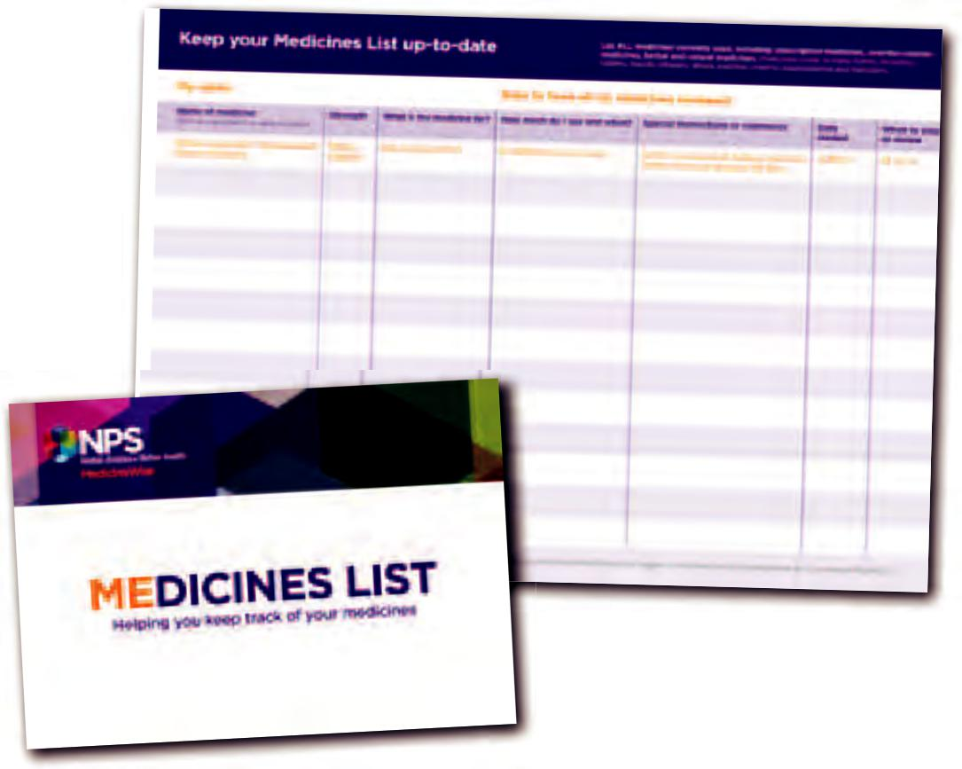

Find out more at

www.nps.org.au/headache

Call NPS Medicines Line for

medicines information over the phone

1300 633 424 (1300 MediciNe)


Level 7/418A Elizabeth St P. 02 8217 8700

Surry Hills NSW 2010 F. 02 9211 7578

PO Box 1147 E. info@nps.org.au
Strawberry Hills NSW 2012 www.nps.org.au

Independent, not-for-profit and evidence based, NPS enables better decisions about medicines and medical tests.

We are funded by the Australian Government Department of Health and Ageing.

© 2012 National Prescribing Service Limited. ABN 61 082 034 393.

This information is not intended to take the place of medical advice and you should seek advice from a qualified health professional. Reasonable care is taken to ensure that this information is accurate at the date of creation. Where permitted by law, NPS disclaims all liability (including for negligence) for any loss, damage or injury resulting from reliance on or use of this information.

NPSB1294

