 Neurology

Headache Log Name:_________________________ ____ Month ________________

Record headaches with 1 separate log for each month. Please bring completed sheets to your child’s neurology appointments.

In the “Pain Intensity” column, write the number that goes along with the face that shows how much you hurt.

Faces pain scale – revised (FPS-R)
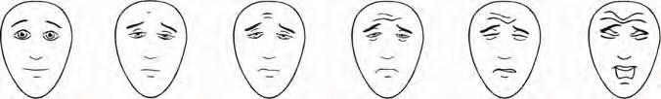

These faces show how much something can hurt.

The left-most face shows no pain. The faces show more and more pain up to the right-most face – it shows very much pain.

0 2 4 6 8 10

In the “Triggers” column, write the number of the headache trigger from this list:

1 | – Stress, anger or sadness | 4 | – Loud noises | 8 | – Lights or sun
2 | – Missed eating a meal | 5 | – Period or birth control | 9 | – Sickness
3 | – Change in sleep (too little, too much) | 6 | – Medicines (list which one) | 10 – Other
 |  | 7 | – Foods (list which one)

Preventive Medications: ________________________________________________________________________________________________

Rescue Medications:___________________________________________________________________________________________________

Date | Day of the week |  |  |  |  |  |  | Pain | Triggers | Medicine & | Other symptoms and
and | M | Tu | W | Th | F | S | Su | intensity |  | response | information, like missed school
time |  |  |  |  |  |  |  | (0 to 10) |  |  | or activities
Feb. 2 |  | x |  |  |  |  |  | 6 | 7 – Ate pineapple | 1 Ibuprofen. | Light sensitive. Happened after
8 a.m. |  |  |  |  |  |  |  |  |  | Helped with pain. | breakfast. Stayed home from
 |  |  |  |  |  |  |  |  |  |  | school.

1 of 2

Headache Log (for _____________________________)
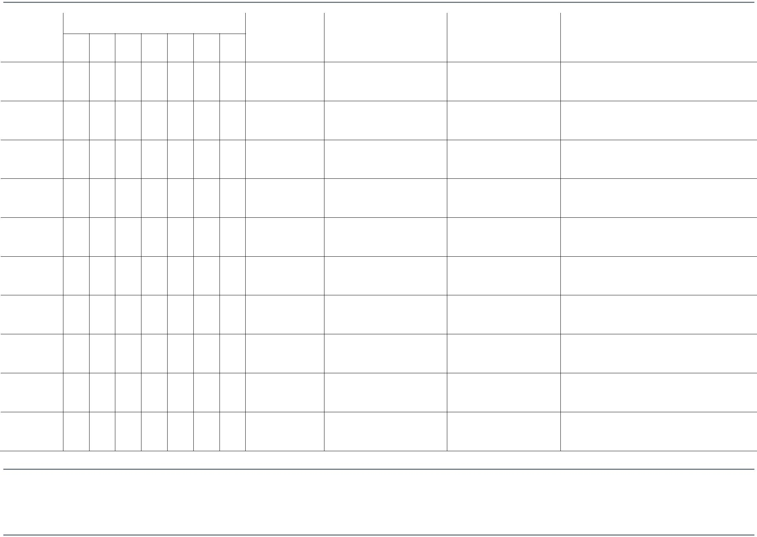

Date | Day of the week |  | Pain | Triggers | Medicine & | Other symptoms and
and | M Tu W Th F S | Su | intensity |  | response | information, like missed school
time |  |  | (0 to 10) |  |  | or activities

Seattle Children’s offers interpreter services for Deaf, hard of hearing or non-English speaking patients, family members and legal representatives free of charge. Seattle Children’s will make this information available in alternate formats upon request. Call the Family Resource Center at 206-987-2201.

This handout has been reviewed by clinical staff at Seattle Children’s. However, your child’s needs are unique. Before you act or rely upon this information, please talk with your child’s healthcare provider. © 2017 Seattle Children’s, Seattle, Washington. All rights reserved.

11/17

PE1668

Neurology
2 of 2

