  HEADACHE SERVICE - PAIN MANAGEMENT & NEUROMODULATION CENTRE |  |  |  |  |  |  |  |  |  |  |  |  |  |  |  |  | 201
 | Stephen Jones (example) |  |  |  |  |  |  |  |  |  |  |  |  | July |  |  | 201
NAME………………………………………….. |  |  |  |  |  |  |  |  |  |  | MONTH…...…………….YEAR……...……
 |  | Headache severity |  |  |  |  |  | Associated symptoms |  |  |  |  |  | Duration |  | Acute medication taken for |  | Did the medication help?
 |  |  |  | Headachefree? |  |  | Nausea | Vomiting |  | Lightsensitive | Soundsensitive |  |  | Sleep (hrs) | Headache(hrs) | headache symptoms? |  | Not at all | Slightly
 | Date | 1-10 |  |  |  |  | Nausea | Vomiting |  | Lightsensitive | Soundsensitive | Worse | withactivity | Sleep (hrs) | Headache(hrs) |  |  | Not at all | Slightly | A lot
 | 1 |  |  | ✓ |  |  |  |  |  |  |  |  |  | 6 | 0 | Write "A" if headache lasts
 | 2 | 4 |  |  |  |  | ✓ |  |  |  |  |  | ✓ | 3 | 12 |  | Paracetamol |  | ✓
 | 2 |  |  |  |  |  |  |  |  |  |  |  |  |  |  |  | all day (from waking to
 | 3 | 7 |  |  |  |  | ✓ |  |  |  |  |  | ✓ | 5 | A |  | Sumatriptan |  | ✓
 | 3 |  |  | ✓ |  |  | Please |  |  |  |  |  |  | 7 | 0 |  | sleeping)
 | 4 |  |  |  |  |  | Please |  |  |  |  |  |  | 7 | 0
 | 5 | 2 |  | complete the diary |  |  |  | even for mild |  |  |  |  |  | 7 | 10
 | 5 | 2 |  | headches, only tick |  |  |  | "headache |  |  |  |  |  | 7 | 10
 | 6 | 2 |  |  |  |  |  |  |  |  |  |  |  | 6 | 11
 | 6 | 2 |  | free" if you have no |  |  |  | headache |  |  |  |  |  | 6 | 11
 | 7 | 1 |  |  |  |  |  |  |  |  |  |  |  | 2 | 16
 | 8 | 6 |  |  |  |  | at✓all |  |  |  |  |  |  | 7 | 3
 | 9 | 8 |  |  |  |  |  | ✓ |  |  |  |  |  | 6 | 2 |  | Sumatriptan |  |  | ✓
 | 10 | 5 |  |  |  |  | ✓ |  |  |  |  |  |  | 5 | 6 | Ibuprofen + Sumatriptan |  |  | ✓
 | 11 |  |  | ✓ |  |  |  |  |  |  |  |  |  | 8 | 0
 | 12 |  |  | ✓ |  |  |  |  |  |  |  |  |  | 7 | 0
 | 13 | 8 |  |  |  |  |  | ✓ |  | ✓ |  |  | ✓ | 10 | 4 | Ibuprofen + Sumatriptan |  |  | ✓
 | 14 | 6 |  |  |  |  |  | ✓ |  |  |  |  | ✓ | 5 | 6 |  |  |  | ✓
 | 15 | 3 |  |  |  |  |  |  |  |  |  |  |  | 7 | 12 |  |  | Only include acute |  | or abortive
 | 16 | 1 |  |  |  |  |  |  |  |  |  |  |  | 7 | A |  |  | medications, not those that you
 | 17 |  |  | ✓ | HEADACHE |  |  | SEVERITY |  |  |  |  |  | 6 | 0 |  |  | take on a daily basis
 | 18 | 4 | 0 | = No pain at all |  |  |  |  |  |  |  |  |  | 5 | 9 |  | Paracetamol | ✓
 | 19 |  | 1 | = Barely✓ noticeable, |  |  |  | very mild |  |  |  |  |  | 6 | 0
 | 20 | 2 | 2 | = Minor discomfort |  |  |  |  |  |  |  |  |  | 5 | 4
 | 21 | 7 | 3 | = Noticeable but✓ can be ignored or✓tolerated |  |  |  |  |  |  |  |  | ✓ | 7 | 2 | Ibuprofen + Sumatriptan |  |  |  | ✓
 | 22 | 6 | 4 | = Mildly distressing, difficult to ignore✓ |  |  |  |  |  |  |  |  | ✓ | 6 | 3 |  | Ibuprofen |  | ✓
 | 23 | 4 | 5 | = Strong, can be distracting |  |  |  |  |  |  |  |  |  | 7 | 5
 | 24 | 2 | 6 | = Very strong, starts to dominate your attention |  |  |  |  |  |  |  |  |  | 8 | A |  | Your headache diary helps us
 | 25 | 3 | 7 | = Severe, dominates the senses, may cloud thinking |  |  |  |  |  |  |  |  |  | 6 | A |  | Paracetamol
 | 26 |  | 8 | ✓ |  |  |  |  |  |  |  |  |  | 7 | 0 |  | - diagnose your condition
 | 26 |  | 8 | = Intense, cannot think clearly |  |  |  |  |  |  |  |  |  |  |  |  | - recommend suitable treatments
 | 27 |  | 9 | ✓ |  |  |  |  |  |  |  |  |  | 6 | 0
 | 27 |  | 9 | = Very intense, intolerable
 | 28 | 2 | 10 = Excruciating, worst pain ever, can't function |  |  |  |  |  |  |  |  |  |  | 6 | 9 |  | - assess your progress
 | 29 | 4 |  |  |  |  |  |  |  |  |  |  |  | 7 | 9 |  | Paracetamol + Ibuprofen |  | ✓
 | 30 |  |  | ✓ |  |  |  |  |  |  |  |  |  | 8 | 0 |  | PleaseParacetamoltrytobe accurate and realistic when
 |  | 6 |  |  |  |  | ✓ |  |  | ✓ |  |  | ✓ | 6 | 9
 | 31 |  |  |  |  |  | ✓ |  |  | ✓ |  |  | ✓ |  |  |  |  | ✓
 |  |  |  |  |  |  |  |  |  |  |  |  |  |  |  |  | completing your diary
60 |  |  |  |  |  |  |  |  |  |  |  |  |  |  |  |  | completing your diary
HIT-6……….
Number of GP visits for headache this month……… |  |  |  |  |  |  |  |  | 0
Number of hospital visits for headache this month……… |  |  |  |  |  |  |  |  | 0 |  |  |  |  |  |  | Contact details:
 |  |  |  |  |  |  |  |  |  |  |  |  | 2
Number of days missed work/unable to function due to headache…….. |  |  |  |  |  |  |  |  |  |  |  |  | 2 |  |  | headachenurse@gstt.nhs.uk or phone: 0207 188 4714
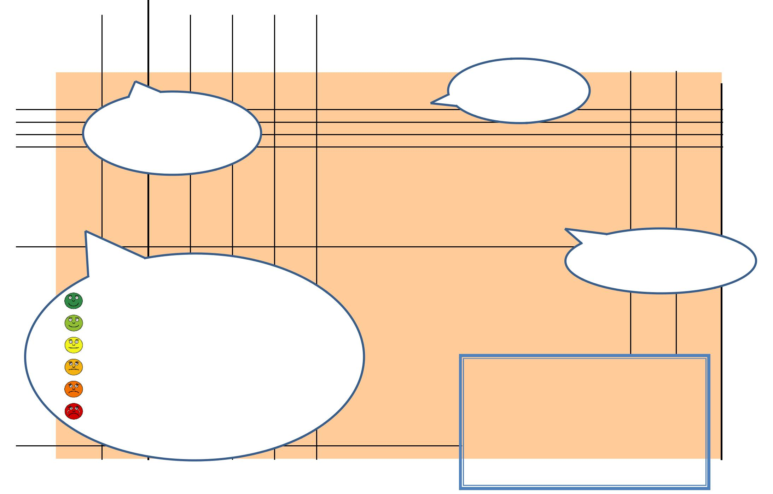

PLEASEBRING

THISDIARY
TOEVERY

APPOINTMENT

eg.
NAME………………………………………….. MONTH…...…………….YEAR……...……
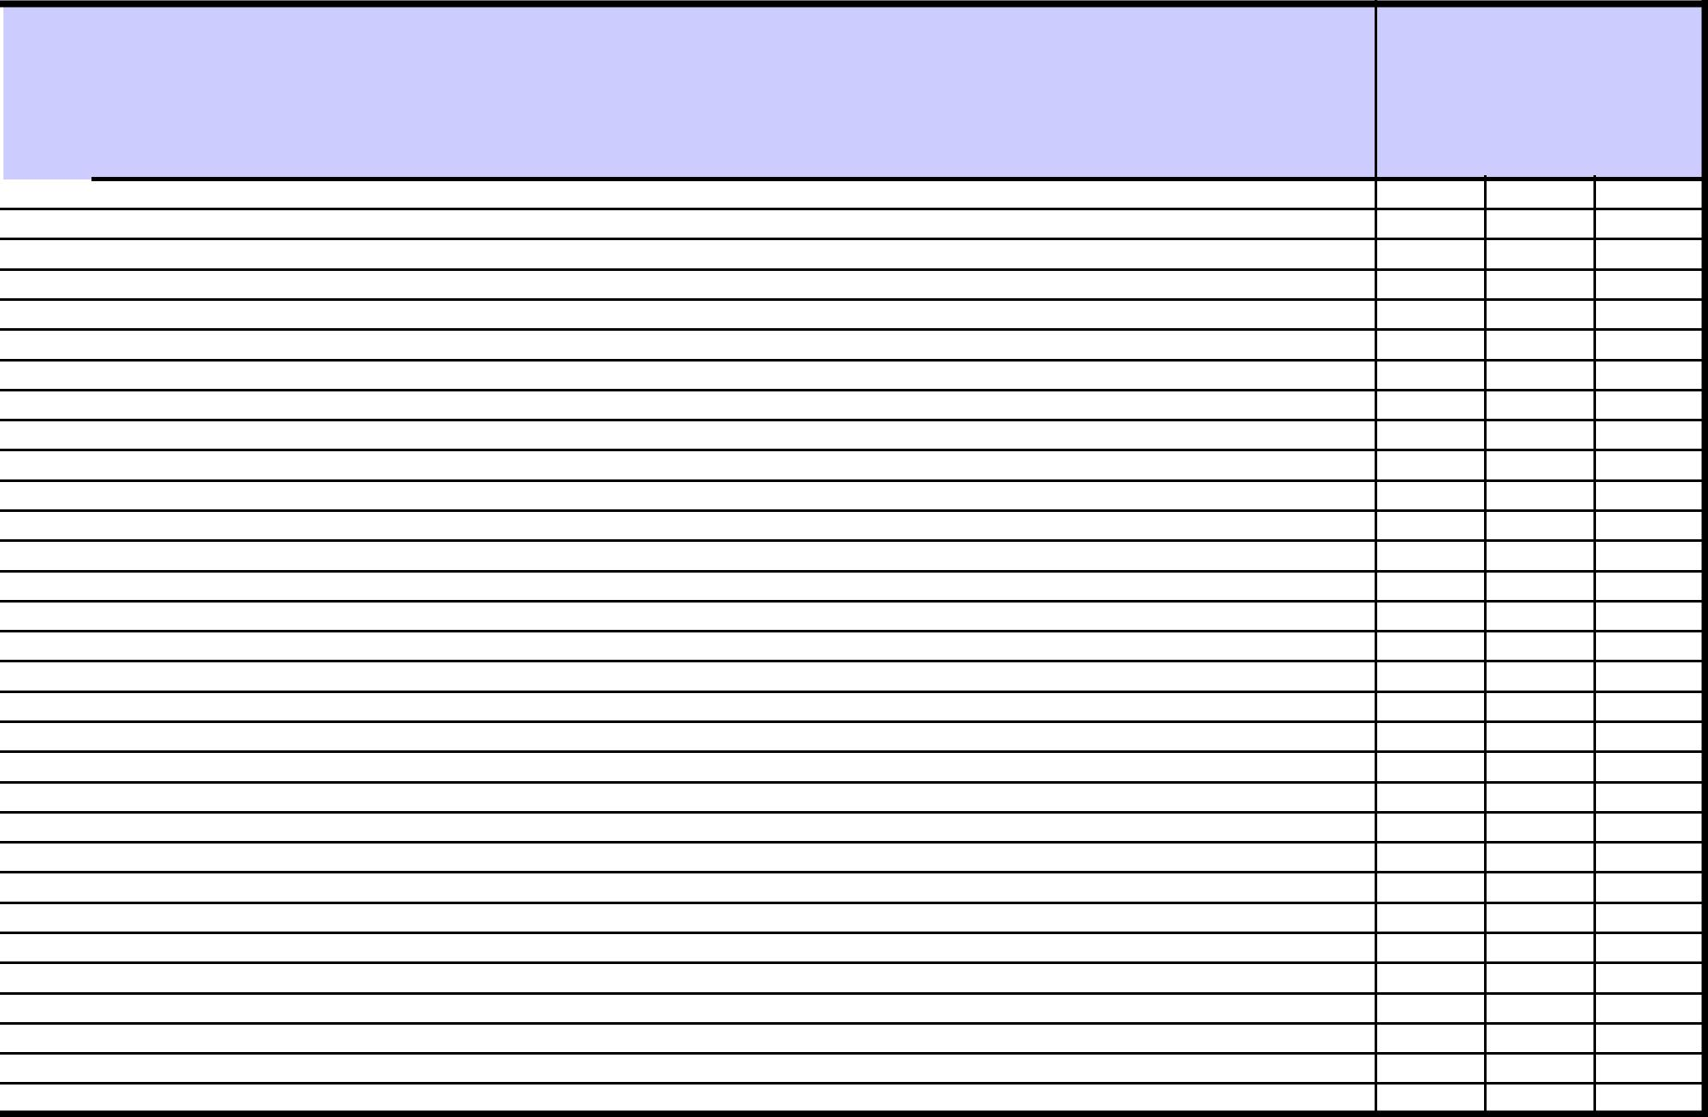

 | Headache severity |  |  | Associated symptoms |  |  |  | Duration |  |  | Acute medication taken?
Date | 1-10 | Headachefree? | Nausea | Vomiting | Lightsensitive | Soundsensitive | Worsewithactivity | Sleep(hrs) | Headache | (hrs) | (only write medication taken
 |  |  |  |  |  |  |  |  |  |  | specifically for
 |  |  |  |  |  |  |  |  |  |  | headache symptoms)
1
2
3
4
5
6
7
8
9
10
11
12
13
14
15
16
17
18
19
20
21
22
23
24
25
26
27
28
29
30
31

HIT-6……….

Number of GP visits for headache this month………

Number of hospital visits for headache this month………

Number of days missed work/unable to function due to headache……..

Did the medication help?


Not at all | Slightly | A lot

PLEASEBRING

THISDIARY
TOEVERY

APPOINTMENT

1
NAME………………………………………….. MONTH…...…………….YEAR……...……
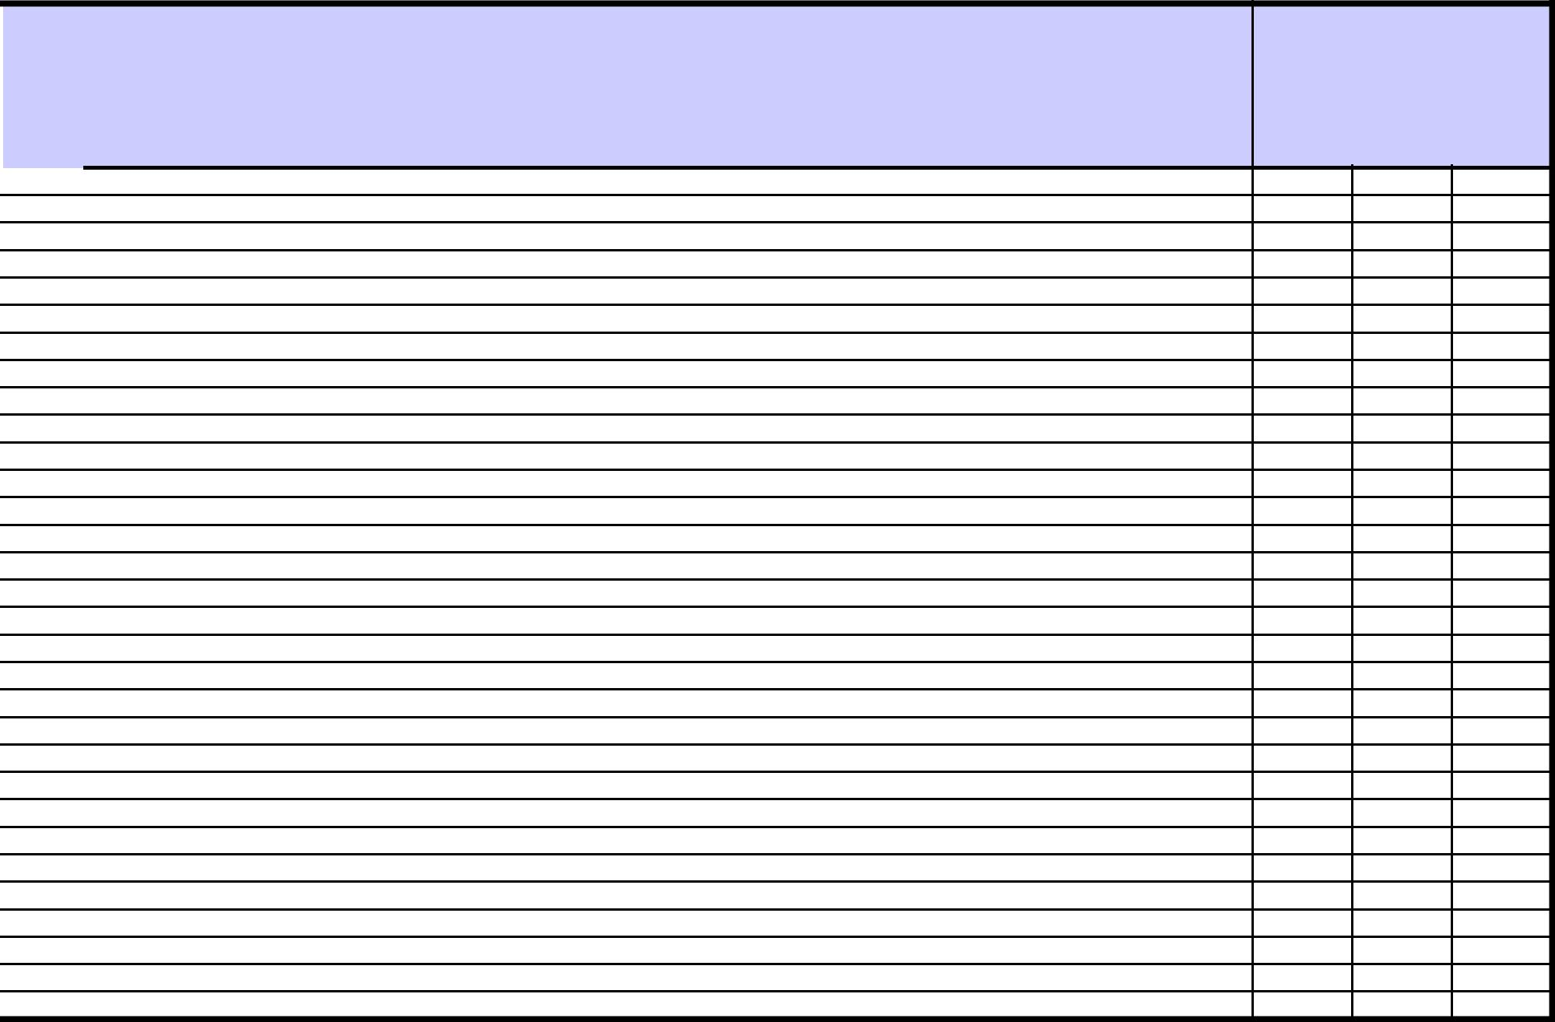

 | Headache severity |  |  | Associated symptoms |  |  |  | Duration |  |  | Acute medication taken?
Date | 1-10 | Headachefree? | Nausea | Vomiting | Lightsensitive | Soundsensitive | Worsewithactivity | Sleep(hrs) | Headache | (hrs) | (only write medication taken
 |  |  |  |  |  |  |  |  |  |  | specifically for
 |  |  |  |  |  |  |  |  |  |  | headache symptoms)
1
2
3
4
5
6
7
8
9
10
11
12
13
14
15
16
17
18
19
20
21
22
23
24
25
26
27
28
29
30
31

HIT-6……….

Number of GP visits for headache this month………

Number of hospital visits for headache this month………

Number of days missed work/unable to function due to headache……..

Did the medication help?


Not at all | Slightly | A lot

PLEASEBRING
THISDIARY

TOEVERY
APPOINTMENT

3
NAME………………………………………….. MONTH…...…………….YEAR……...……
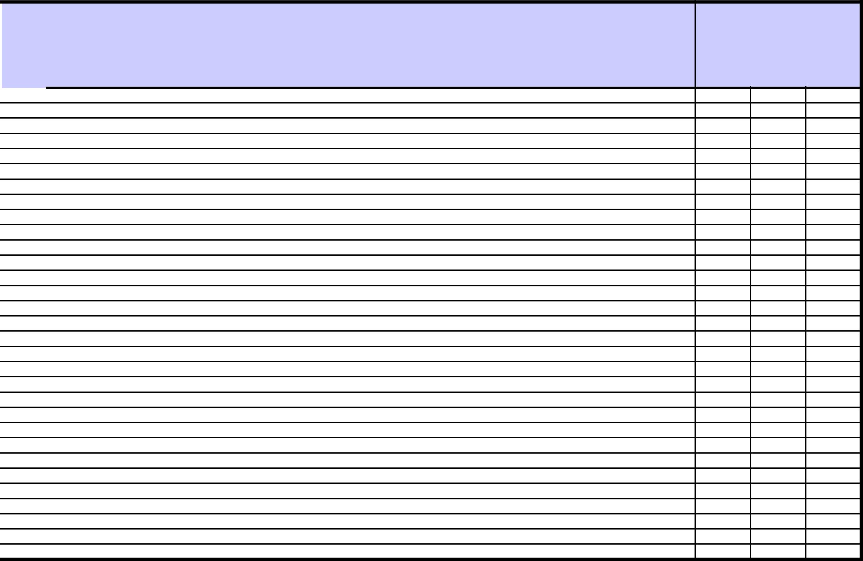

 | Headache severity |  |  | Associated symptoms |  |  |  | Duration |  |  | Acute medication taken?
Date | 1-10 | Headachefree? | Nausea | Vomiting | Lightsensitive | Soundsensitive | Worsewithactivity | Sleep(hrs) | Headache | (hrs) | (only write medication taken
 |  |  |  |  |  |  |  |  |  |  | specifically for
 |  |  |  |  |  |  |  |  |  |  | headache symptoms)
1
2
3
4
5
6
7
8
9
10
11
12
13
14
15
16
17
18
19
20
21
22
23
24
25
26
27
28
29
30
31

HIT-6……….

Number of GP visits for headache this month………

Number of hospital visits for headache this month………

Number of days missed work/unable to function due to headache……..

Did the medication help?


Not at all | Slightly | A lot

PLEASEBRING
THISDIARY

TOEVERY
APPOINTMENT

NAME………………………………………….. MONTH…...…………….YEAR……...……
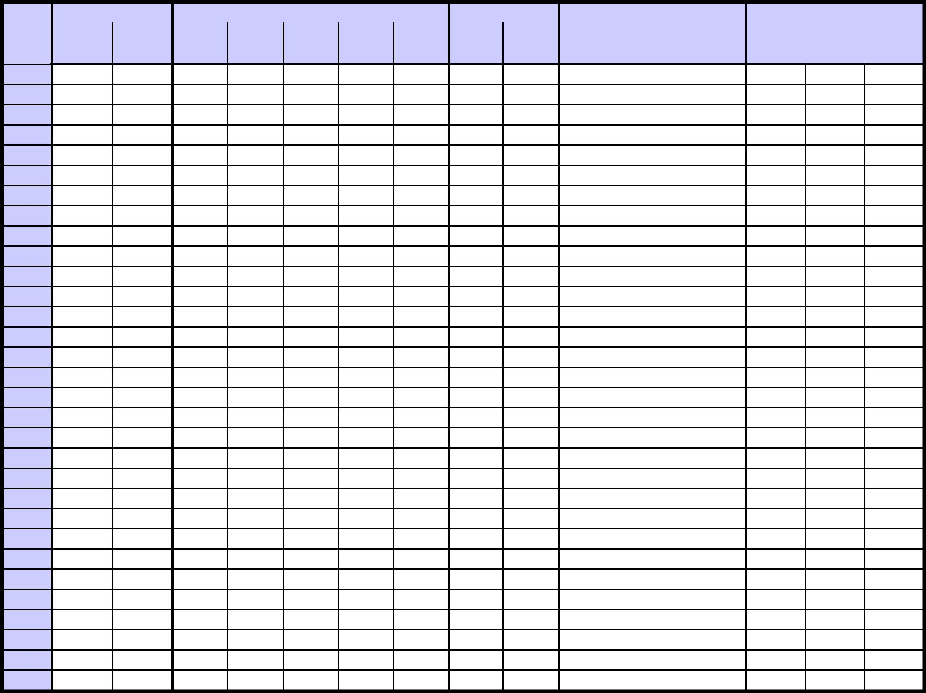

Date | Headache severity |  | Nause | Associated symptoms |  | Duration |  | (hrs) | Acute medication taken?
Date | 1-10 | Headachefree? | Nause | Vomit | LightsensitiveSoundsensiWorsewith | Sleep(hrs) | Headache | (hrs) | (only write medication taken
 |  |  |  |  |  |  |  |  | specifically for

1

2

3

4

5

6

7

8

9

10

11

12

13

14

15

16

17

18

19

20

21

22

23

24

25

26

27

28

29

30

31

HIT-6……….

Number of GP visits for headache this month………

Did the medication help?


Not at | Slightl | A lot

PLEASEBRING

THISDIARY

TOEVERY
APPOINTMENT

Number of hospital visits for headache this month………
Number of days missed work/unable to function due to headache…….. | 4

