Certificate Of Marriage
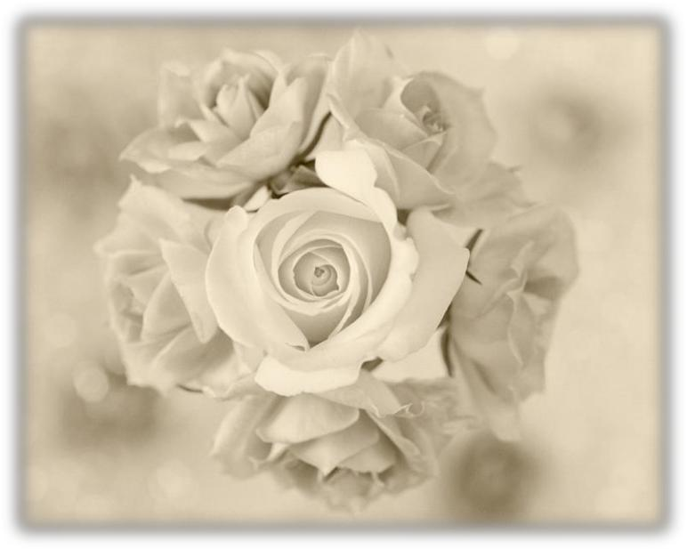

This is to Certify That

__________________________

&

__________________________

Were United In Marriage At

_____________________________

On the ______ day of ____________ In the year ______

Officiated by ________________________________

May Your Lives Blend Together In Harmony and Joy

