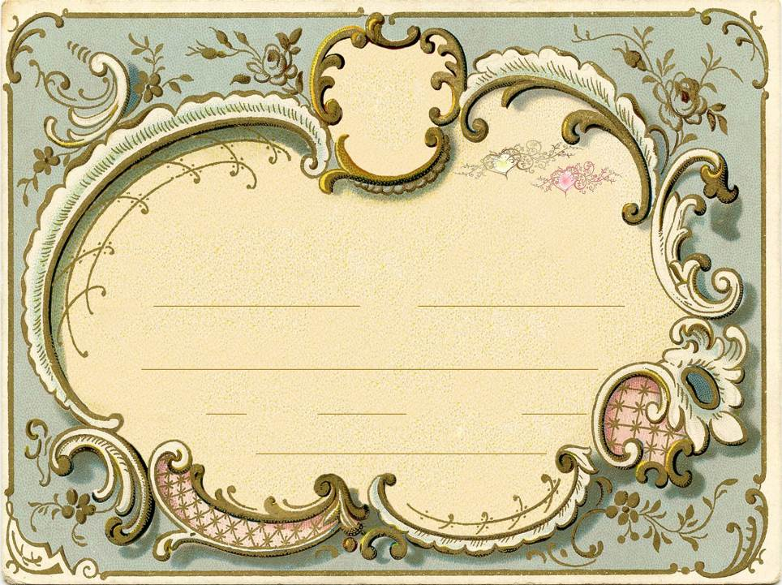

Certificate Of Marriage

This Certifies That

and

Were United In Marriage

at

on the day of in the year by

