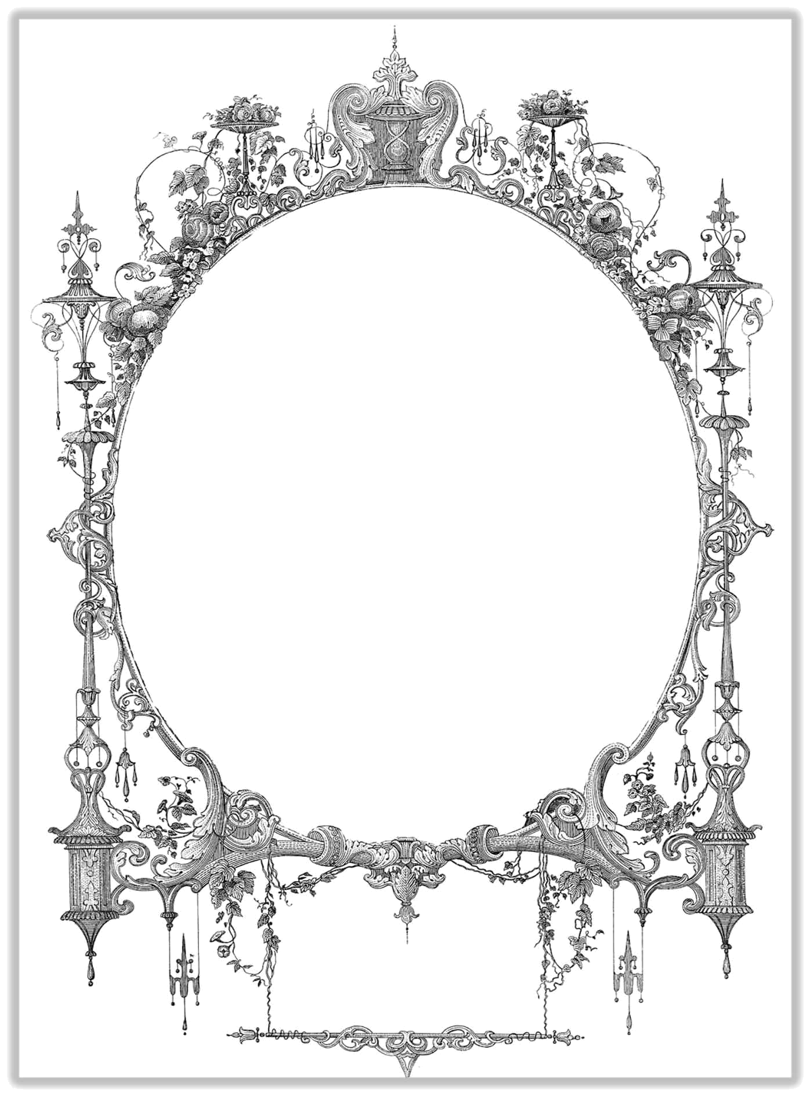

CERTIFICATE

OF MARRIAGE

This is to Certify That

______________________

&

______________________

Were United in Marriage

at ________________________

On the ______ day of ___________

In the year ____

Officiated by __________

In Holy Matrimony

I Thee Wed

