

Marriage Renewal of Vows

This certificate certifies that this loving couple
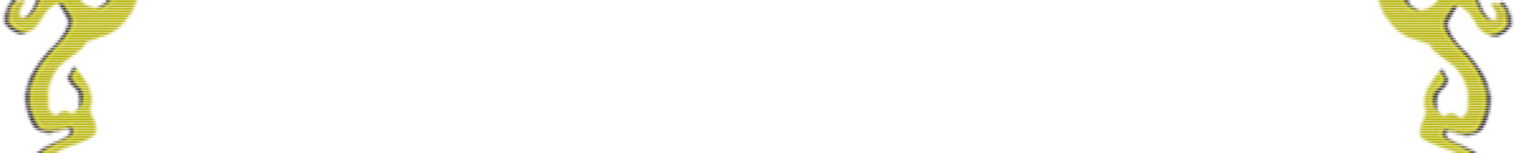

________________________________________________________________

have come together after ____________ years of marriage

on this joyous day of _________________ to renew and

reaffirm their wedding vows and

commitment to one another.


