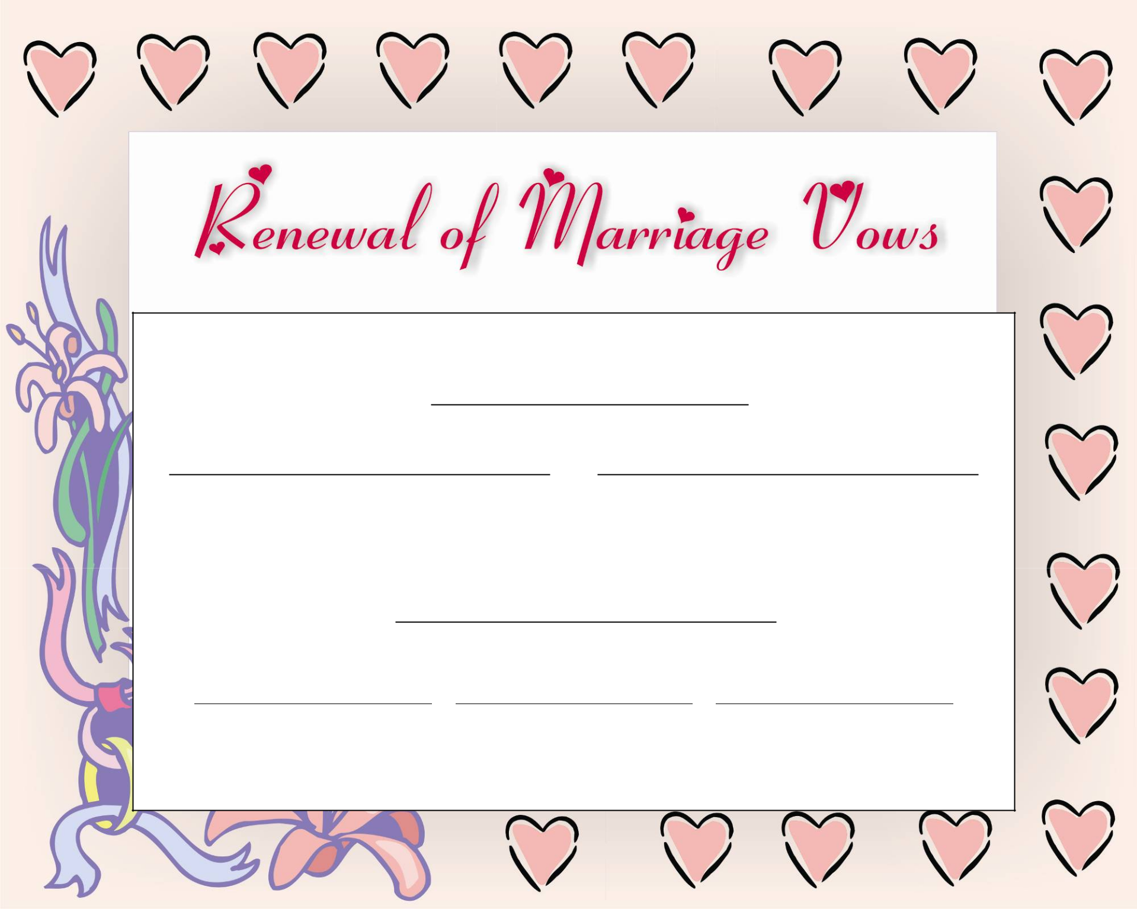

This Certifies that

on
(Date)

and
(Name) (Name)

Have Renewed Their Marriage Vows

at
(Location)

(Officiant) (Witness) (Witness)

www.FreePrintableCertificates.net

