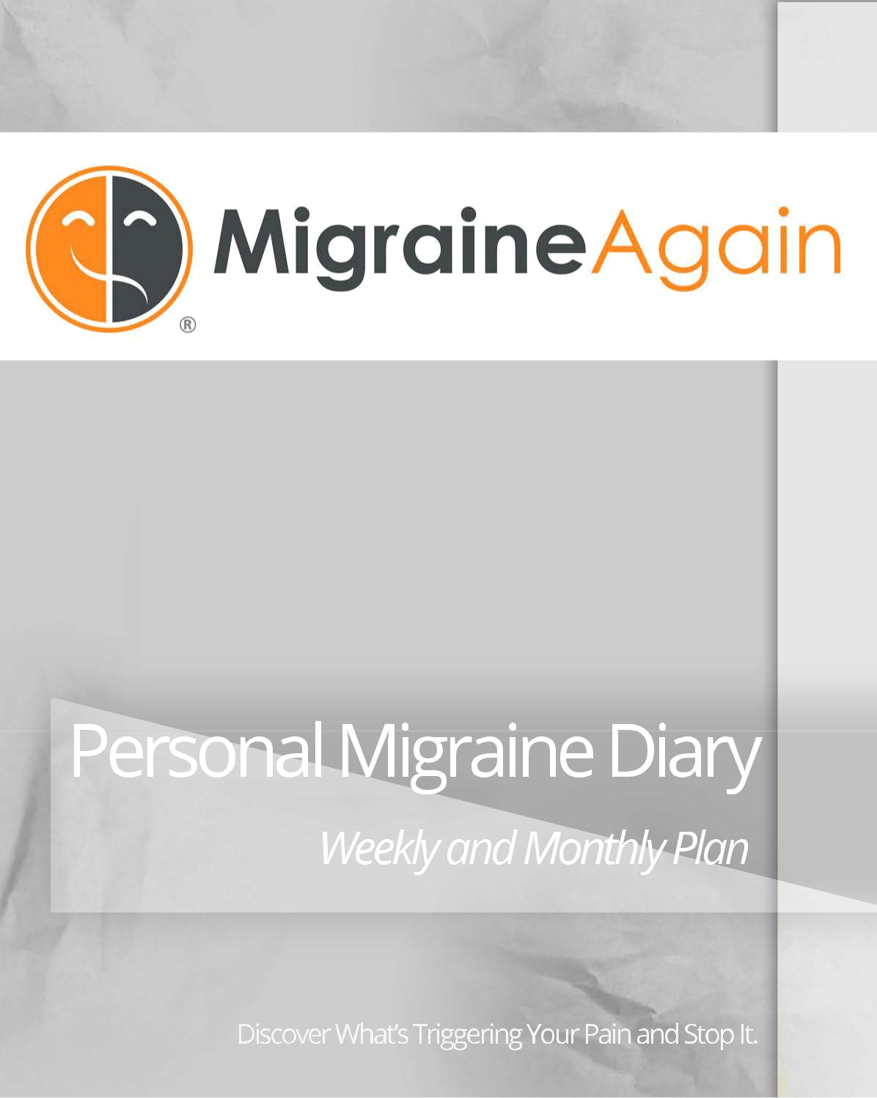

Personal Migraine Diary

Weekly and Monthly Plan

Discover What’s Triggering Your Pain and Stop It.



Migraine Again Personal Migraine Diary

Getting the Most from your Diary

In the first seven days, you’ll begin to see what may be triggering your migraine activity. Remember, triggers aren’t causes; they are controllable and uncontrollable variables that affect your brain chemistry and genetic predisposition to migraine disease. It’s a neurological condition that’s in your genes, not in your head.

Step 1 -‐ Review the List of the Most Common Triggers

- Read Up – Be sure you understand the definition of each trigger. If any of these are unfamiliar to you, you can read up on them on MigraineAgain.com.

- Mark It Down -‐ Put an X in a box when you’re exposed to that trigger, whether or not it seems to produce a reaction. If you can’t carry your diary with you, make a note on your phone’s notepad or an index card each day. Or dictate the day’s happenings on Evernote or your phone’s message system until you can sit down and transfer it.
- Detail Your Triggers -‐ For example, note “red wine” under Alcohol or “T-‐ Storm” under “Approaching Storm” make note of that in the box.

Step 2 -‐ Begin with the Weekly Headache and Symptom Diary

- Rate Any Pain -‐ If/when you have any migraine symptoms, give it a rating of 1 (low) to 10 (high). Celebrate the days you have a big zero! Add up the # of Days you had pain and enter it under Total Days. Add up the Pain Ratings, divided by the number of pain days, to get your Average Rating. These are your benchmarks from which to improve.
- Note Brands -‐ Note specific about the treatment you’ve used by brand name, such as Excedrin Migraine or Imitrex, or method. If your treatment isn’t administered daily, (such as Botox, Cefaly, etc) make a note of when you began or ended it.

- Track Healthy Habits – Take credit for what you’re actively doing to prevent future migraine attacks. The best defense is a good offense. This might include things like yoga/Pilates, exercise, sex (yes!), adequate sleep and hydration, decaffeination and prayer.

- Highlight Suspicions -‐ At the end of each week, highlight anything that raises suspicion in your mind – this is the beginning of discovery.

Step 3 Transfer 4 Weekly Diaries to the Monthly Diary (if desired)

- Capture Weather Patterns -‐ This will allow you to capture more weather activity, humidity, travel and altitude exposure.

- Watch Hormone Cycles – See the impact of monthly ovulation and menstruation cycles.
- Observe More Data -‐ See more stress, sensory, food and drink triggers.

- Abbreviate -‐ In the monthly diary, you’ll need to use the single-‐letter abbreviations, such as P for Pain or Pressure, under Symptoms and Treatments. Keep your weekly diaries attached so you can get into detail if needed.

Step 4 -‐ Highlight First Month Observations

- Look for Direct Patterns -‐ Remember, not every trigger produces a reaction every time, because they are additive – you may not have been exposed to enough triggers to pass your migraine threshold and activate migraine symptoms.
- Time Shift -‐ As you look for patterns, remember that storms usually occur after pain begins, and food triggers precede an attack by 2-‐48 hours.

- Look for Rebound -‐ Examine your use of pain medications and how many hours or days you have between attacks to see if you have an analgesic rebound cycle going.

Step 5 – Repeat Steps 2-‐4.

- Be Patient – You might have eaten Chinese food four times, and it produced a reaction only twice. The more data you have the more clarity you’ll have.

- Compare Weekly and Monthly Scores – No subjectivity or poor recall – you now have scores on each page of your diary to see if you’re trending up or down.

- Begin Adjusting – If you are clear on what’s happening with your triggers and symptoms, you can start making adjustments. Be careful -‐ easy to misread your own data. Don’t give up because you think you discovered the one mega-‐trigger and you still get a migraine. There’s something else going on.

Step 6 – Review Diaries with a Migraine Specialist.

- Consult a Specialist – Only a doctor is qualified to diagnose you and prescribe medication. We encourage you to see a headache specialist, not a generalist, and share your diaries and suspicions.

- Don’t Hide -‐ There is no need to hide medication or unhealthy habits from yourself or your doctor. Better to be clear about it and find a better option if necessary. You didn’t cause your migraines, but you can get control of them.
- Seek Support – You’ll find support and ideas from fellow migraineurs in the Migraine Again community.
- Get Coached – Still struggling? Our Migraine Again Coaches may be able to help you go into deeper detail on your diaries than your doctor has time to do, and consider more non-‐medical prevention and treatment options.

To Your Health,

Paula K. Dumas

Editor, MigraineAgain.com


Week _______________________________________

Weekly Headache and Symptom Diary

 | Day of Week |  | M | T | W | Th | F | Sa | Su |  |  | Avg Rating |  | Total Days
 | Date (1-‐31)
 | Pain Rating (0 low-‐10 high)
 | Symptoms*
 | Treatments**
 | Healthy Habits***
 |  |  |  |  |  |  |  |  |  |  | Key:
 | Observed Triggers |  |  |  |  |  |  |  |  |  | Symptoms *
 | Weather |  |  |  |  |  |  |  |  |  |  | P=Head Pain/Pressure
 | Approaching Storm |  |  |  |  |  |  |  |  |  |  | N=Nausea/Vomiting
 | High Altitude |  |  |  |  |  |  |  |  |  |  | V=Visual Disturbances or Aura
 | High Heat/Humid |  |  |  |  |  |  |  |  |  |  | C=Congestion/Runny Nose
 | Air Travel |  |  |  |  |  |  |  |  |  |  | L=Light Sensitivity
 | Hormones |  |  |  |  |  |  |  |  |  |  | S=Other Sensory Issues
 | Menstruation |  |  |  |  |  |  |  |  |  |  | O=Other
 | Ovulation
 | Menopause |  |  |  |  |  |  |  |  |  | Treatments **
 | Oral Contraceptive |  |  |  |  |  |  |  |  |  |  | N=Natural (Ice, Liquids, etc)
 | Sensory |  |  |  |  |  |  |  |  |  |  | A=Analgesic (Aspirin, Ibuprofin, etc)
 | Odor/Perfume |  |  |  |  |  |  |  |  |  |  | T=Triptan (Imitrex etc)
 | Paint/Nail Polish |  |  |  |  |  |  |  |  |  |  | P=Preventative RX
 | Smoke |  |  |  |  |  |  |  |  |  |  | H=Herbs/Supplements
 | Cleaning Products |  |  |  |  |  |  |  |  |  |  | B=Botox
 | Bright Light |  |  |  |  |  |  |  |  |  |  | C=Cefaly
 | Flourescents
 | Loud Sound/Music |  |  |  |  |  |  |  |  |  | Healthy Habits ***
 | Stress |  |  |  |  |  |  |  |  |  |  | Y=Yoga/Pilates
 | Dehydration |  |  |  |  |  |  |  |  |  |  | E=Exercise
 | Sleep Disturbances |  |  |  |  |  |  |  |  |  |  | 8=8 Hours Sleep
 | Emotional Stress |  |  |  |  |  |  |  |  |  |  | S=Sex (yes!)
 | Anxiety |  |  |  |  |  |  |  |  |  |  | H=Hydration
 | Sex |  |  |  |  |  |  |  |  |  |  | D=Decaffeinating
 | Exercise |  |  |  |  |  |  |  |  |  |  | P=Prayer
 | Food & Drink
 | Aged Cheese
 | Chocolate
 | Nuts/Peanut Butter
 | Marinated/Pickled
 | Bacon/Hot Dogs
 | 2+Cups Caffeine
 | Alcohol
 | Artificial Sweetener
 | MSG
_______________

Make an appointment with your doctor or headache specialist to review. You can also consult Migraine Again coaches to interpret your diary and help you find more migraine-‐free days.

Copyright 2014 MigraineAgain.com



Date

Day (M-‐Su)

Pain Rating (0-‐10)

Symptoms* Treatments** Daily Habits ***

Observed Triggers

Weather

Approaching Storm

High Altitude

High Heat/Humid

Air Travel

Hormones

Menstruation

Ovulation

Menopause

Oral Contraceptive

Sensory

Odor/Perfume

Paint/Nail Polish

Smoke

Cleaning Products

Bright Light

Flourescents

Loud Sound/Music

Stress

Dehydration

Sleep Disturbances

Emotional Stress

Anxiety

Sex

Exercise

Food & Drink

Aged Cheese

Chocolate

Nuts/Peanut Butter

Marinated/Pickled

Bacon/Hot Dogs

2+Cups Caffeine

Alcohol

Artificial Sweetener

MSG

_______________
Month _____________________________

Monthly Headache and Symptom Diary

1 | 2 | 3 | 4 | 5 | 6 | 7 | 8 | 9 | 10 | 11 | 12 | 13 | 14 | 15 | 16 | 17 | 18 | 19 | 20 | 21 | 22 | 23 | 24 | 25 | 26 | 27 | 28 | 29 | 30 | 31

Avg Total Rating Days



Key: | Symptoms * |  |  | Treatments ** |  |  | Healthy Habits ***
 | P=Head Pain/Pressure | L=Light Sensitivity |  | N=Natural (Ice, Liquids, etc) | H=Herbs/Supplements |  | Y=Yoga/Pilates | H=Hydration
 | N=Nausea/Vomiting | S=Other Sensory Issues |  | A=Analgesic (Aspirin, Ibuprofin, etc) | B=Botox |  | E=Exercise | D=Decaffeinating
 | V=Visual Disturbances/Aura | O=Other |  | T=Triptan (Imitrex etc) | C=Cefaly |  | 8=8 Hours Sleep | P=Prayer
 | C=Congestion/Runny Nose |  |  | P=Preventative RX |  |  | S=Sex (yes!)

Copyright 2014 MigraineAgain.com

