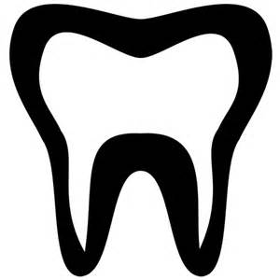
We Like Your Smile!
Date of last dental exam________________
You are due for a teeth cleaning and exam
Please call our office to schedule
an appointment
Phone Number
A Friendly reminder from
Dra. Anderson & Staff
ANC Pediatric Dental Care
Address
We Like Your Smile!
Date of last dental exam________________
You are due for a teeth cleaning and exam
Please call our office to schedule
an appointment
Phone Number
A Friendly reminder from
Dra. Anderson & Staff
ANC Pediatric Dental Care
Address

