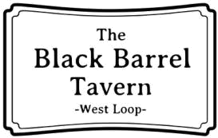
Homemade

Barrel Infusions

Pineapple Tequila Watermelon Rum
Banana Jameson’s Pear ~ Ginger Vodka
Apple ~ Cinnamon Bourbon
5

Signature Cocktails
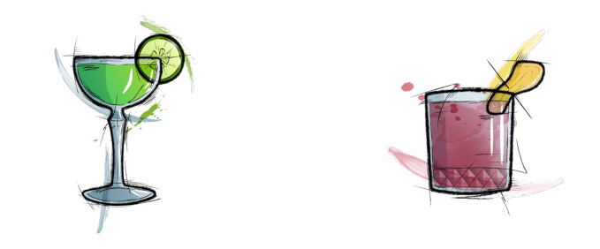

Think About It | The Real Goat
Effen cucumber vodka, | Great Goose vodka, ginger
St. Germain, fresh lime | syrup, raspberry puree,
juice, simple Syrup. | lemon. We all know who’d
British “Beer Can” | win 1-on-1.
sounds like Jamaican | 13
“bacon”
13
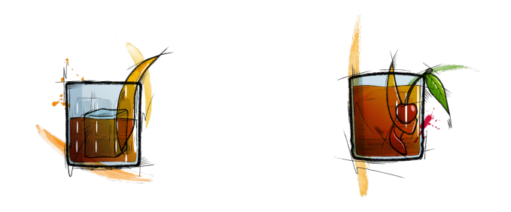

Spanish Old | Rye n’ Reynolds
Fashioned | Rittenouse Rye, BG
Maker’s mark, Pedro | Reynolds, Falernum
Ximenez Sherry Nectar, | Syrup, fresh lemon juice,
demerara syrup, | walnut bitters. Write
angostura. The sherry | that down.
makes it Spanish OK? | 13
14
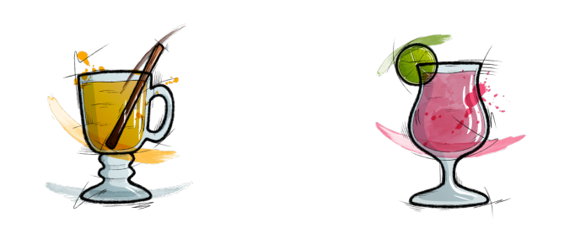

RB Toddy | [Inaudible Chatter]
Basil Hayden’s bourbon, | Death’s Door Gin,
honey, fresh lime juice, | prickly pear, fresh lime
cloves, anise, Doctor’s | juice, seltzer.
Orders. | [Mouthing} “Hi!”
12 | 12
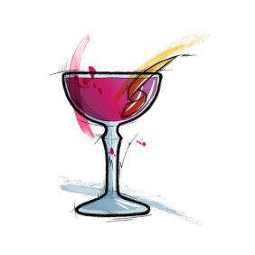

Wine n Bubbles

Red |  | White
Federalist | 11, 49 | Camria | 12, 55
Red Blend, ca |  | Chardonnay, ca
Iconoclast | 15, 70 | Kim Crawford | 13, 58
Cabernet, ca |  | Sauvignon Blanc, nz
Joel Gott | 11, 49 | Lunardi | 11, 49
Cabernet, ca |  | Pinot Grigio, italy
Meiomi | 12, 55 | Schmitt Sohne | 9, 40
Pinot Noir, ca |  | Reisling, germany
Siduri | 13, 58 | Sanford | 15, 70
Pinot Noir, OR | 9, 40 | Chardonnay, ca | 9, 40
Sycamore Lane | 9, 40 | Sycamore Lane | 9, 40
Cabernet, ca |  | Chardonnay, ca
Sycamore Lane | 9, 40 | Sycamore Lane | 9, 40
Pinot Noir, ca |  | Pinot Grigio, CA
Terrazas Reserve 12, 55 |  | Wairau River | 11, 49
Red Blend, ca |  | Sauvignon Blanc, nz
Rose n Bubbles
Band of Roses | 9, 40 | Giuliana | 10, 45
Rose, wa |  | Prosecco, italy
Bieler | 11, 52 | Mionetto | 9 glass
Rose, france |  | Prosecco, italy
Chandon Brut | 10, 45 | Mionetto | 9 glass
Sparkling, ca |  | Sparkling Rose, italy
Copain | 14, 60 | Veuve Clicquot | 125 btl
Rose, ca |  | Champagne, France
Draft Beer
MainStay
Goose Island 312 6 |  | Guinness (20oz) | 8
Bud Light 5
Rotating
3 Floyds Alpha King 7 |  | Founders Kentucky
apa, in 6.5% |  | Breakfast Stout | 12
3 Floyds Flying Tigersault 7 |  | Imperial, mi 12.3%
Pilsner, in 4.8% |  | Goose Island Bourbon
5 Rabbit cerveceria 5 lizard 6 |  | County Stout 14
Witbier, bedford park, IL 4.3% |  | Imperial, Chicago, il 14.7%
Allagash White | 7 | Lagunitas ipa | 7
Belgian Wheat, me, 5.2% |  | ipa, Chicago, il 6.2%
Bell’s 2 hearted | 7 | Maplewood Son | 7
ipa, mi 7% |  | of Juice | 7
Blue Nose Cool Hair 7 |  | ipa, Chicago, IL 6.3%
Raspberry Sour, Chicago, il 7% |  | Revolution | 7
Boulevard Tank 7 | 8 | Anti-Hero | 7
Belgian Saison, MI 8.5% |  | ipa, Chicago, il 6.5%
 |  | Weihenstephan | 7
 |  | Hefeweiss | 7
Wheat ale, germany 5.4%

Bo les n Cans

The Tess | Fugin’ Banana
Hibiscus-infused | Tempus Fugit Creme de
Aviation, Giuliana | Banana, Bacardi Gold,
prosecco, simple. It’s | Cinnamon, walnut
actually a Lookie-loo | bitters. En fuego!
with a bundle of joy. | 14
13
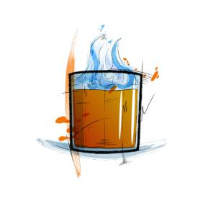
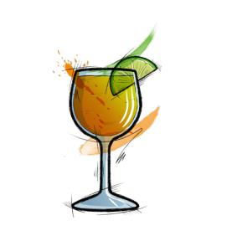

Private Label Margarita
Patron Private Black Barrel Label
Tequila, fresh lime juice, agave
nectar, Part Anejo, Part Reposado.
All Ours.
13
3 Floyds Gumballhead 7
American Pale Wheat
3 Floyds Space Station Middle Finger 8
APA

Amstel Light lager 6 Angry Orchard cider 6

Ballast Point Sculpin ipa 7 Bells Lager of the Lakes 6 Blue Moon Belgian Wheat 6 Brewdog Punk ipa 7
Bud Light lager 5
Budweiser lager 5
Burnt city two
hearted boy 7
Belgian Pale
Busch Light lager 5
Cider Boys First Press 5 Corona Extra lager 6 Corona light lager 6

Cruz Blanca el Train 7 American ipa
Dogfish head 60 min ipa 6
Founders Centennial ipa 6
Founders solid gold lager 5

Laganitas Lil Sumpin’ Sumpin Ale 7
American Wheat Ale

Left hand nitro milk stout 7 Magic Hat #9 7
Not-Quite Pale Ale
Michelob Ultra lager 5
Miller High Life lager 5
Miller Light lager 5

Modelo lager 6
Moody Tongue Nectarine ipa 8 Natureday 5
North coast old rasputin 8
Imperial Stout
Noon Whistle M-Punk 6
Red ale

Ommegang pale sour 10 Pbr lager 5
Revolution Fist City 6
Chicago Pale ale
Shiner Bock Bock 6
Sierra Nevada pale ale 6
Smithwick’s Red ale 6
Stella Artois lager 6
Strongbow cider cider 8

