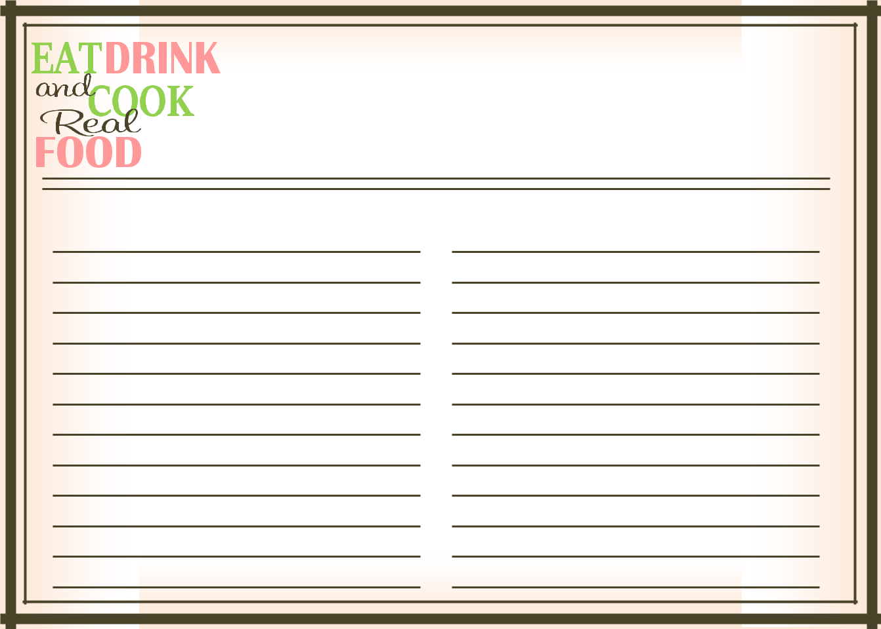
Recipe Name

1 cup this
1 cup that
- tbs
- tsp

a dash of

mix and melt and bake

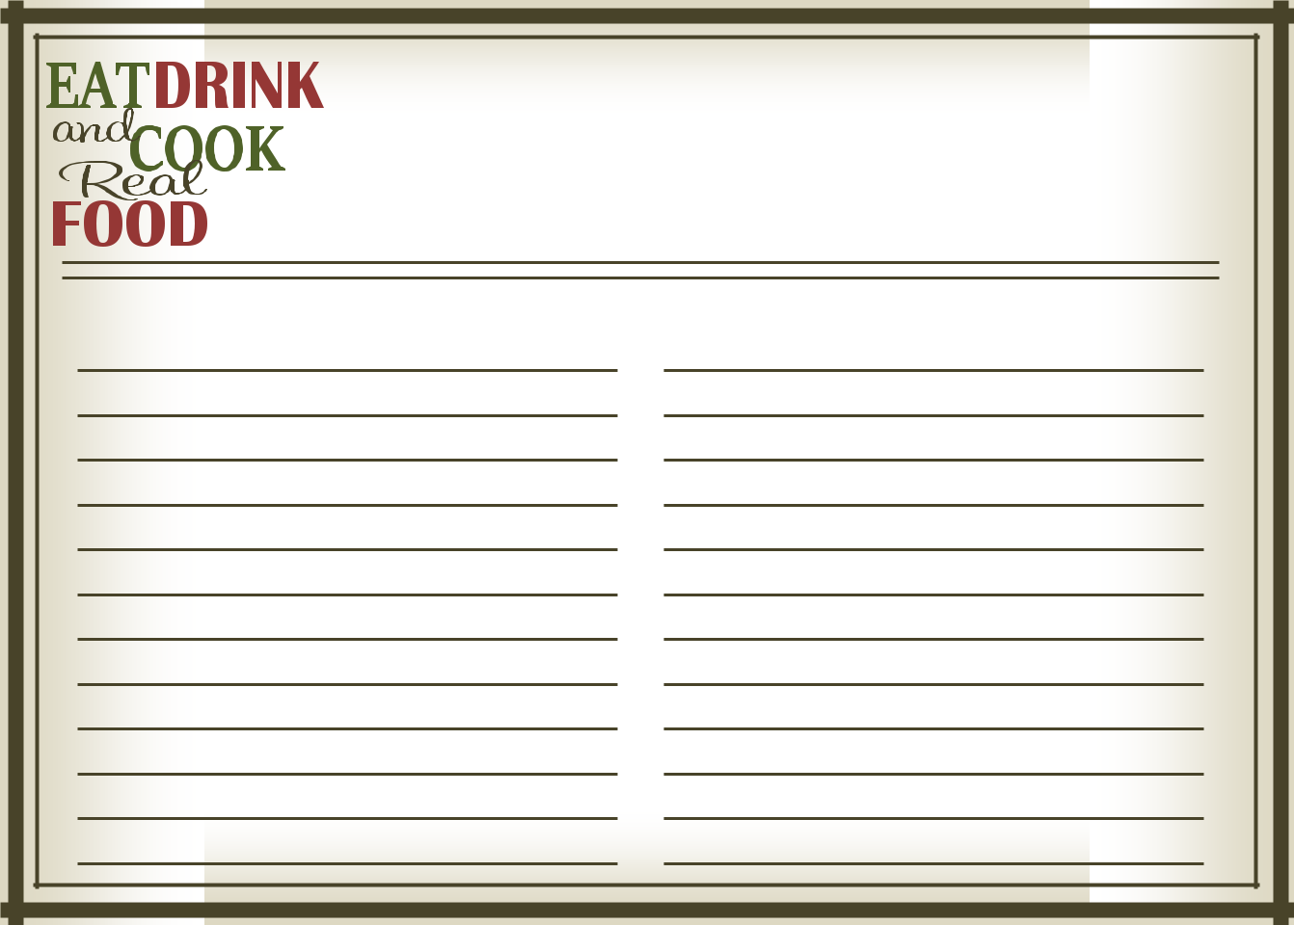
Recipe Name

1 cup this
1 cup that
- tbs
- tsp
a dash of

mix and melt and bake

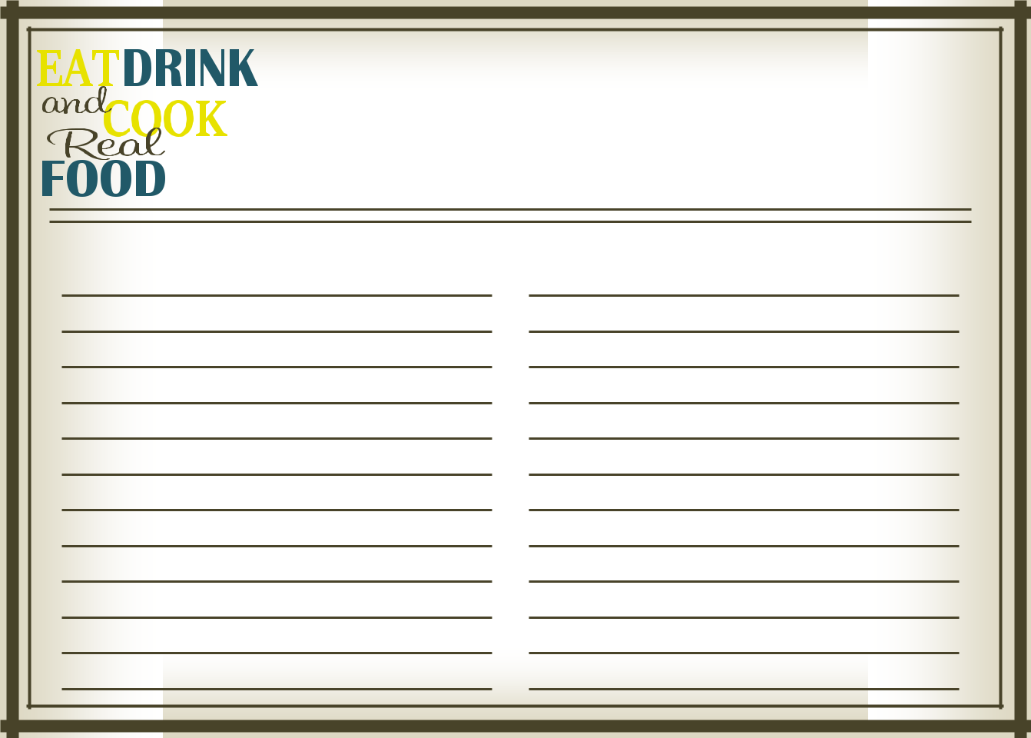
Recipe Name

1 cup this
1 cup that
- tbs
- tsp
a dash of

mix and melt and bake

