

Client Intake Form Page 1 of 2

PLEASE PRINT LEGIBLY

Name ______________________________________ Email __________________________________________

Address ______________________________________ City:___________________ State ___ Zip _____________

Phone: Home_____________Work_____________Cell_______________ Birth Month ______ Birth Year ________

Occupation ________________________________ How did you hear about us? ____________________________

In Case of Emergency Please Contact ______________________________Phone____________________________
General and Medical Information (Please circle Y for YES or N for No)
Have you ever had a professional massage? Y / N If yes, how often? ____________________________________

Are you pregnant? Y / N If yes, how far along are you?______

Are you sensitive to touch/pressure in any area? Y / N Ticklish? Y / N
Are you allergic or sensitive to any oils (essential oils, nut oils, scents)? Y / N If yes, please list:__________________
List of current medications and reason:_______________________________________________________________
List of surgeries (type and date): __________________________________________________________________
On a scale from 1-10, 10=highest, rate your levels of: Stress ________ Pain ________ Energy ________
How did your symptoms begin and when did they start? ________________________________________________

What have you done for relief? ____________________________________________________________________
Is the condition getting better/worse? (circle one)
Please check all that apply: □ Skin Problems |  |  | □ Rash □ Warts | □ Hives | □ Skin cancer □ Lymphatic Problems
□ Swollen Gland | □ Nasal Congestion |  | □ Lymph Edema | □ Joint Problems |  | □ Stiffness
□ Arthritis | □ Sacroiliac Problems |  | □ TMJ | □ Bone Condition |  | □ Osteoporosis | □ Fracture
□ Headaches | □ Recent injury: _____________________________ □ Accident:_______________ |  |  |  |  |  | □ Whiplash
□ Sprain | □ Bruise | □ Cut □ Scratch | □ Any other type of injury at all_________________
□ Circulatory Problems |  | □ High Blood Pressure □ Varicose Veins |  | □ Blood Clots □ Numbness / Tingling |  |  | □ Sciatica
- Tendonitis □ Bursitis □ Diabetes □ Other: ____________________ Describe your problem areas:________________
- Hepatitis □ HIV/AIDS □ Cancer □ Seizures Any ailment, disease or problem not listed here:_____________________

Would you like to receive a free spinal exam from a chiropractic physician? (circle one) Yes or No

Please mark in the diagram below to show any areas where you have pain or discomfort.
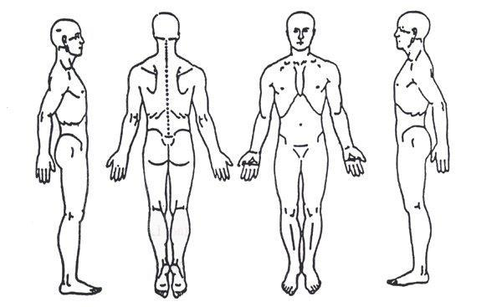

Client Intake Form Page 2 of 2
Massage Therapy Client Waiver

Please take a moment to read and initial all of the following statements

If I experience pain or discomfort during the session, I will immediately inform my therapist so that pressure/strokes can be adjusted to my level of comfort. I will not hold my therapist responsible for any pain or discomfort I experience during or after the session.

_____

I understand that the services offered today are not a substitute for medical care. I understand that my therapist is not qualified to perform spinal or skeletal adjustments, diagnose, prescribe, or treat physical or mental illness.

_____
I affirm that I have notified my therapist of all known medical conditions and injuries.
_____

I agree to inform the therapist of any changes in my health and medical condition. I understand that there shall be no liability on the therapist’s part should I forget to do so.

_____

I understand that massage is entirely therapeutic and non-sexual in nature.
_____

By signing this release, I hereby waive and release my therapist from any and all liability, past, present, and future relating to massage therapy and bodywork.

_____

I understand that should I cancel an appointment less than 24 hours before the scheduled time or “no show” an appointment, I am subject to a fee equal to the cost of the missed appointment. This fee is monetary & can’t be taken as an additional “punch” off a massage package card. If the appointment was booked under a gift certificate, it will be voided in lieu of the fee.

_____
Information and Suggestions

- Prior to your massage, please remove contact lenses and all jewelry. Pull long hair back with a clip or band.

- In general, massage is given while you are unclothed. However, you may choose to wear undergarments or a swimsuit. You will be covered with a top sheet throughout your session. This is your massage and you should be as comfortable as possible.

- Feel free to ask your therapist any questions before, during, or after the session. Your therapist is a highly trained professional and will be happy to make you feel informed and comfortable.

I have received the policy statement, and have read and agree to the policies therein.

Client Print Name:_______________________________________________________________

Client signature:_________________________________________________________________

Date:__________________________________________________________________________

Therapist signature:______________________________________________________________

