NATURAL PROGRESSION, LLC.

MASSAGE THERAPY

PHONE: (206) 979-1987

1409 140TH PL NE, SUITE 107
ROCKWOOD OFFICE PARK, BELLEVUE, WA, 98007

CONFIDENTIAL MASSAGE CLIENT INTAKE FORM

Name: (Last) |  |  |  |  |  |  |  |  |  |  | (First) |  |  |  |  |  |  |  |  |  | (M.I.)
Address:
City: |  |  |  |  |  |  |  |  |  |  |  |  |  | State: |  |  | Zip:
Phone: (home) |  |  |  |  |  |  |  |  |  |  | (cell)
Email: |  |  |  |  |  |  |  |  |  |  |  |  |  |  |  | Date of Birth:
Occupation:
Who referred you?
Have you received massage in the Past? |  |  |  |  |  |  |  |  | Yes |  | No If yes, what type(s) of massage?

Please describe any Accidents, Injuries or Surgeries:

More than 5 years ago:

Less than 5 years ago:

Are you receiving medical or chiropractic care currently? |  |  |  |  |  |  |  | Yes | No
If yes, please describe and by what doctor(s):
Are you taking any medication? |  |  | Yes |  |  | No If yes, please explain:

Heavy | Moderate | LightNone

Do you drink Water?

Do you drink alcohol?

Do you consume caffeine?

Do you smoke?

Do you exercise?

What type(s) of exercise do you do?

Please complete page 2.
Are you experiencing any of the following conditions? (Please circle)

AIDS | Digestive Problems | Phlebitis
Allergies | Disc Problems | Rashes
Anemia | Epilepsy/Seizures | Ringworm
Arthritis | Headaches | Sciatica
Bursitis | Heart Ailments | Stiff/Sore Joints
Back Pain: | Hemophilia | Strains/Sprains
upper/middle/lower
Cancer | Herpes Virus | Excess Stress
Circulation Problems | High Blood pressure | Swollen Feet/Legs
Colitis Diverticulitis | Low Blood Pressure | Tendonitis
Chronic Fatigue | Migraines | Tumors
Constipation | Muscle Spasms | Whiplash
Diarrhea | Neck Pain | Flu or Cold
Pregnancy | Inflammation | Fever
Infection | Contagious Disease | TMJ Dysfunction

Have you experienced any of the following conditions in the Past?

Back Pain: | Heart Ailments | Stroke
upper/middle/lower
Broken Bones | Migraines | Tendonitis
Cancer | Neck Pain | Whiplash
Disc Problems | Numbness/Tingling
Epilepsy/Seizures | Sciatica

On the figures below, please indicate any “problem” areas, or areas of pain:
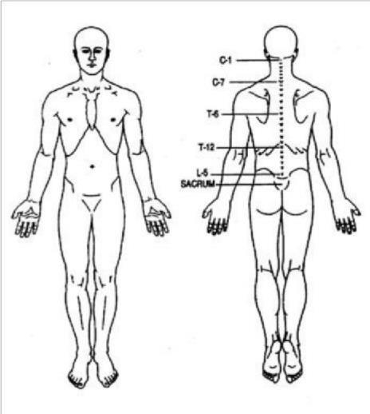

Client Agreement:

I have completed the above information to the best of my knowledge and have discussed it with my practitioner. I take responsibility for alerting my practitioner to any physical conditions that would affect my treatments. I also understand

that a 24-hour notice for cancellation is required. Failure to provide notice 24 hours prior to my scheduled appointment will result in a charge to my account for the full cost of the treatment.

Signature Date

