
massage & bodywork

MASSAGE INTAKE FORM - CONFIDENTIAL INFORMATION

WELCOME! I would like to make your appointment as pleasant and comfortable as possible. If at any time you have questions regarding your session, please let me know.

Name |  |  |  |  |  |  |  |  |  |  |  |  |  |  |  |  |  |  |  |  |  |  |  |  |  |  | Date of birth
Address |  |  |  |  |  |  |  |  |  |  |  |  |  |  |  |  |  |  |  |  |  |  |  |  |  |  |  | City
State |  |  |  | Zip |  |  |  |  | Email
 |  |  | Phone |  |  |  |  |  |  |  |  |  |  |  |  |  |  |  |  | Occupation
Have you ever received massage therapy? |  |  |  |  |  |  |  |  |  |  |  |  |  |  |  | Yes* |  |  |  |  |  |  | No |  | *If yes, how often?
Type(s) of massage experienced
Are you currently taking any medications? |  |  |  |  |  |  |  |  |  |  |  |  |  |  | Yes |  |  |  |  |  |  | No
If yes, please list name and reason for medications
Are you currently seeing a healthcare professional? |  |  |  |  |  |  |  |  |  |  |  |  |  |  |  |  |  |  |  |  | Yes |  |  |  |  |  |  | No
If yes, please list reason/treatment
Exercise routine, if any?
Please review this list and check those conditions that have affected your health either recently or in the past.

arthritis diabetes blood clots
broken/dislocated bones bruise easily
cancer chronic pain
constipation/diarrhea auto-immune condition hepatitis (A, B, C, other) skin conditions
stroke
recent surgery
TMJ disorder/jaw pain anemia
herniated disks neurological problems
depression, panic disorder, other psych condition ulcers
varicose veins
headaches heart conditions
back problems high blood pressure insomnia
muscle strain/sprain
currently pregnant scoliosis
seizures
whiplash/recent car accident chemical dependency (alcohol, drugs) respiratory problems
fainting spells/dizziness muscle cramping

If you have any other medical condition that we should be aware of or you need to elaborate on a condition you checked above, please tell us here:

Do you have any of the following today:
 |  | skin rash |  |  |  | cold/flu |  |  |  |  |  |  | open cuts
 |  | anything contagious |  |  |  | severe pain |  |  |  |  |  |  | injuries/bruises
Do you have any allergies to:
 |  | environmental allergens (dust, pollen, fragrances) |  |  |  |  |  |  |  |  |  |  |  |  | medications
 |  | reactions to skin care products |  |  |  |  |  |  |  |  |  |  |  |  | foods (nuts, etc.)

If any of the above are checked, please give details:

Are you wearing: contact lenses hearing aid hairpiece
Please mark and label the diagram with aches, pains, numbness, or other problems.
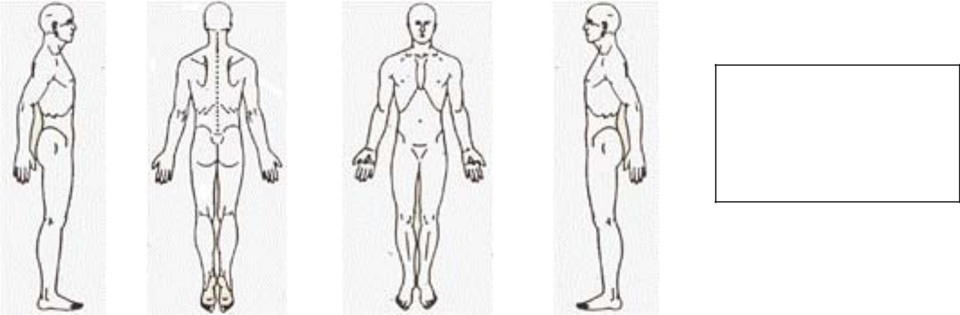

X – Stabbing Pain O – Numbness

//// – Aches
+++ – Pins and Needles
---- – Burning

What are your goals/expectations for this therapy session?

The following sometimes occurs during massage. They are normal responses to relaxation. Trust your body to express what it needs to:
moving or changing position * sighing, yawning, change in breathing * stomach gurgling emotional feelings and/or expression * memories * energy shifts * falling asleep

Please read the following information and sign below:

- I understand that although massage therapy can be very therapeutic, relaxing and reduce muscular tension, it is not a substitute for medical examination, diagnosis and treatment.
- This is a therapeutic massage and any sexual remarks or advances will terminate the session and I will be liable for payment of the scheduled treatment.

- Being that massage should not be done under certain medical conditions, I affirm that I have answered all questions pertaining to medical conditions truthfully.

Signature: Date:

