Therapeutic Massage – Client Intake Form

Personal Information

Name ____________________________________ Phone (day) _____________________ (evening) _______________________

Address __________________________________ City, State, Zip __________________________________________________

Email (optional) ____________________________ Date of Birth __________________ Occupation _______________________

Emergency Contact _________________________ Phone _____________________

Physician _________________________________ Phone _____________________

Massage Information

How did you hear about us? ________________________________

Have you ever had a professional massage before? □ yes □ no

If yes, how often to you receive massage therapy? ______________

If yes, do you have a style or pressure preference? □ yes □ no Specify : □ light pressure □ medium pressure □ deep pressure
- trigger point therapy □ energywork

- Other ___________________________

What Type of massage are you seeking today?

□ Relaxation □ Deep Tissue/Therapeutic □ Pregnancy

- Senior □ Integrated Bodywork (functional)

- Other ________________________

Are you sensitive to fragrances or perfumes? □ yes □ no

Do you have sensitive skin? | □ yes | □ no
Do you wear contact lenses? | □ yes | □ no
Do you exercise regularly? | □ yes | □ no

If so, what type(s)? _______________________________________

What are your common areas of pain or tension?

_______________________________________________________

_______________________________________________________

Circle any specific areas you would like the massage therapist to concentrate on during the session:
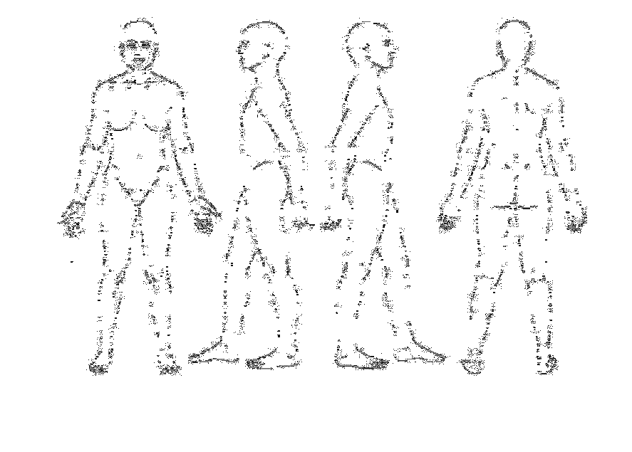
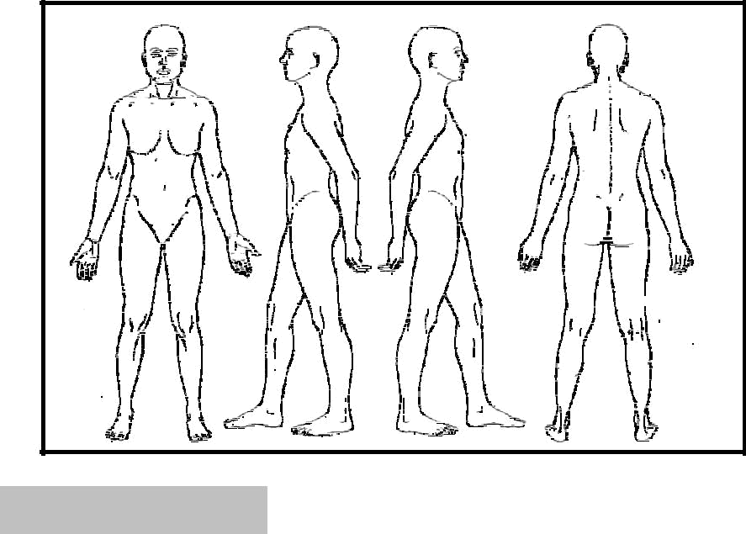
Medical History

Do you suffer from chronic or persistent pain/discomfort?

_______________________________________________

If so, for how long? ______________________________

Do you know what caused it or when then symptoms seem to get worse or better? ____________________________
_______________________________________________

Do you see a chiropractor? □ yes □ no

If so, how often? __________________________________

Are you currently under medical care? □ yes □ no Are you currently taking any prescription medication? If
so, for what? _____________________________________

________________________________________________

________________________________________________

Please indicate any conditions that you have had or currently have:
□ headaches, migraines □ varicose veins

□ allergies, sensitivity □ pregnancy

□ arthritis, tendonitis □ blood clots

□ cancer, tumors □ neck / back injuries

□ TMJ problems □ diabetes

□ abnormal skin condition □ paralysis

□ heart/circulation problems □ fibromyalgia

□ joint replacement / surgery □ numbness

□ high / low blood pressure □ sprains, strains

□ major accident □ recent injuries

□ lack of or reduced feeling / sensation _______________

Explain any conditions that you have marked above:

________________________________________________

________________________________________________

________________________________________________

Clear Form

