

Massage Intake Form

How did you hear about Life ‘n Balance? _________________________________________________________

Name: ____________________________________________ Occupation: ____________________________

□ Home #: _________________ □ Cell # : _______________ □ Business #: _______________ (check preferred) Address: _________________________________________________ Postal Code: _____________________

Email: _______________________________________________ Date of Birth: ________________________

Emergency Contact (name and number): _________________________________________________________

_ _ _ _ _ _ _ _ _ _ _ _ _ _ _ _ _ _ _ _ _ _ _ _ _ _ _ _ _ _ _ _ _ _ _ _ _ _ _ _ _ _ _ _ _ _ _ _ _ _ _ _ _ _ _ _ _ _ _ _ _ _

The following information will be used to help plan safe and effective massage sessions. Please answer the questions to the best of your knowledge.

Date of Initial Visit: ____________________________

1. | Have you had a professional massage before? Yes No
 | If yes, how often do you receive massage therapy? _____________________________
2. | Do you have difficulty lying on your front, back, or side? Yes No
 | If yes, please explain ______________________________________________________
3. | Do you have sensitive skin or allergies to oils, lotions, or ointments? | Yes | No
 | If yes, please explain ______________________________________________________
4. | Are you wearing contact lenses ( ), dentures ( ), or a hearing aid ( )?
5. | Do you sit for long hours at a workstation, computer, or driving? Yes | No
 | If yes, please describe _____________________________________________________
6. | Do you perform any repetitive movement in your work, sports, or hobby? |  | Yes | No
 | If yes, please describe _____________________________________________________
7. | Do you experience stress in your work, family, or other aspect of your life? |  | Yes | No
 | If yes, how do you think it has affected your health?
 | muscle tension ( ), anxiety ( ), insomnia ( ), irritability ( ), other: __________________

- Is there a particular area of the body where you are experiencing tension, stiffness, pain or other discomfort? Yes No
If yes, please identify _____________________________________________
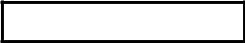

Please Flip Over

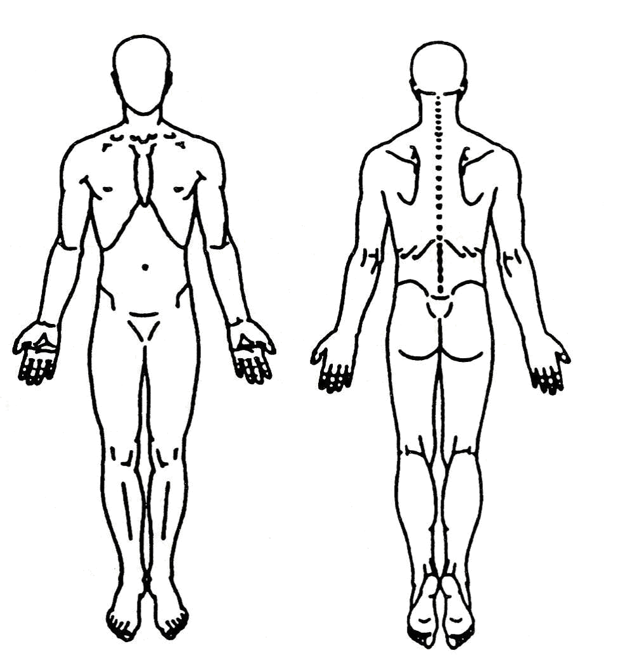
- Circle any specific areas you would like the massage therapist to concentrate on during the session.

- Indicate on a scale of 10 the amount of pain you are experiencing.
 |  |  | 1 |  | 2 |  | 3 |  |  | 4 |  |  | 5 |  |  |  |  | 6 |  | 7 |  | 8 |  |  |  | 9 |  | 10
11. |  |  | Do you see a chiropractor? Yes |  |  |  |  |  |  |  |  |  |  |  |  |  |  | No
12. |  |  | Do you have a medical doctor? |  |  |  |  |  |  |  |  |  |  |  |  |  |  | Yes |  | No
13. |  |  | Are you currently taking any medications? |  |  |  |  |  |  |  |  |  |  |  |  |  |  |  |  |  |  |  | Yes | No

If yes, please list ____________________________________________________________

14. Please check any condition listed below that applies to you:

( ) Recent accident or injury | ( ) Recent fracture | ( ) Recent surgery
( ) Sprains/strains | ( ) Allergies/sensitivities | ( ) Current fever
( ) Contagious skin condition | ( ) Open sores or wounds | ( ) Easy bruising
( ) High or low blood pressure | ( ) Circulatory disorder | ( ) Heart condition
( ) Atherosclerosis | ( ) Varicose veins | ( ) Swollen glands
( ) Deep vein thrombosis | ( ) Osteoporosis | ( ) Diabetes
( ) Decreased sensation | ( ) Fibromyalgia | ( ) Cancer
( ) Arthritis | ( ) Pregnancy (How many months: __________ )

If yes, please explain _____________________________________________________

- Is there anything else about your health history that you think would be useful for your massage therapist to know to plan a safe and effective massage session for you?

________________________________________________________________________

- Draping will be used during the session – only the area being worked on will be uncovered. Informed written consent must be provided by parent/guardian if under 18.

I, ____________________________________ understand that the massage I receive is provided for the basic purpose of relaxation and relief of muscular tension. If I experience any pain or discomfort during the session, I will immediately inform the therapist so that the pressure may be adjusted to my level of comfort. I further understand that massage should not be construed as a substitute for medical examination, diagnosis, or treatment and that I should see a physician, chiropractor, or other qualified medical specialist for any mental or physical ailment that I am aware of. Because massage should not be performed under certain medical conditions, I affirm that I have stated all my known medical conditions, and answered all questions honestly. I agree to keep the therapist updated as to any changes in my medical profile and understand that there shall be no liability on the therapist’s part or Life ‘n Balance should I fail to do so.

Signature of Client: _____________________________ Date: ____________________

Signature of Therapist: __________________________ Date: ____________________

