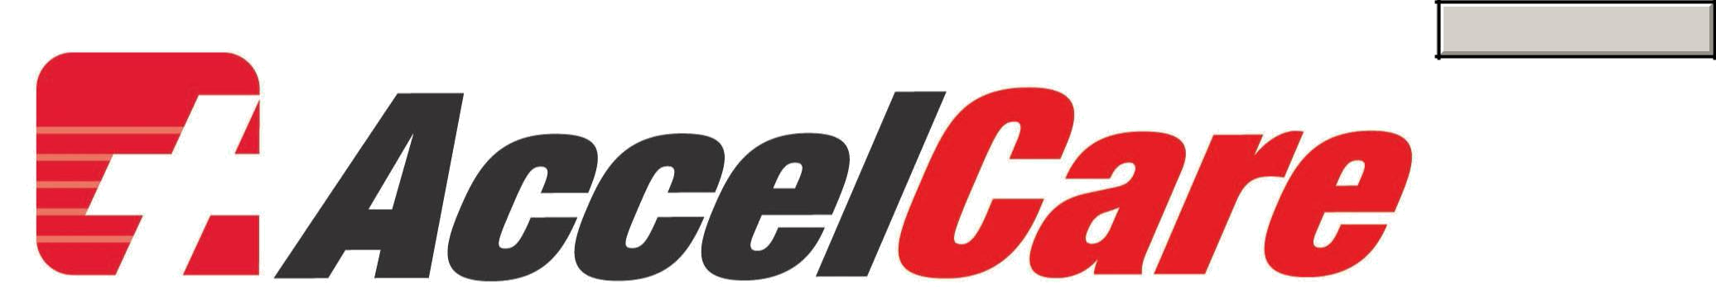
Print Form

Patient Satisfaction Survey

We would like to know how you feel about the services we provide. We value your input which will be used to improve our services and ensure we are meeting the needs of our patients. All information will be kept confidential.
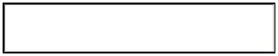
Date Visited 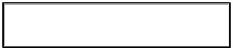 Location

Name (optional) 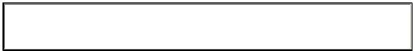

1-Excellent 2-Good 3-Acceptable 4-Unacceptable 5-Poor
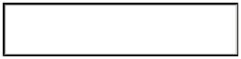

Were you seen and treated in a timely fashion?
Was staff professional and courteous?
Quality of medical care?
Was the clinic neat and clean?
Accessibility/Convenience?
Would you visit our clinic again?
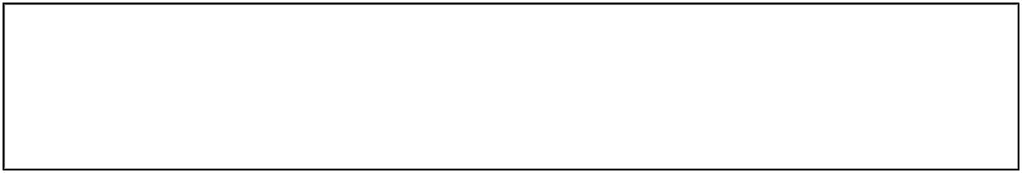

What did you like best about our service?

How do you feel we can improve?
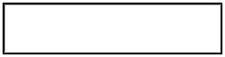

May we call you back for more input?

Please return completed form to either location below:

3400 Monroe Avenue | 1300 Jefferson Road, Suite 100 | 4154 McKinley Pkwy, Suite 275
Rochester NY 14618 | Rochester NY 14623 | Blasdell NY 14219
(585) 203-1060 (fax) | (585) 413-3499 (fax) | (716) 202-1467 (fax)

