_{IFH} Independent Family Health Ltd

Patient Satisfaction Questionnaire
Independent Family Health Ltd

We would be grateful if you would take a few minutes to complete this questionnaire in order to help us improve our service to you. Please complete each section of this questionnaire by ticking the appropriate box.

No personal information will be released to any other party. Thank you in advance for taking the time to complete this form.

When this form is completed, please hand it to reception before your departure.

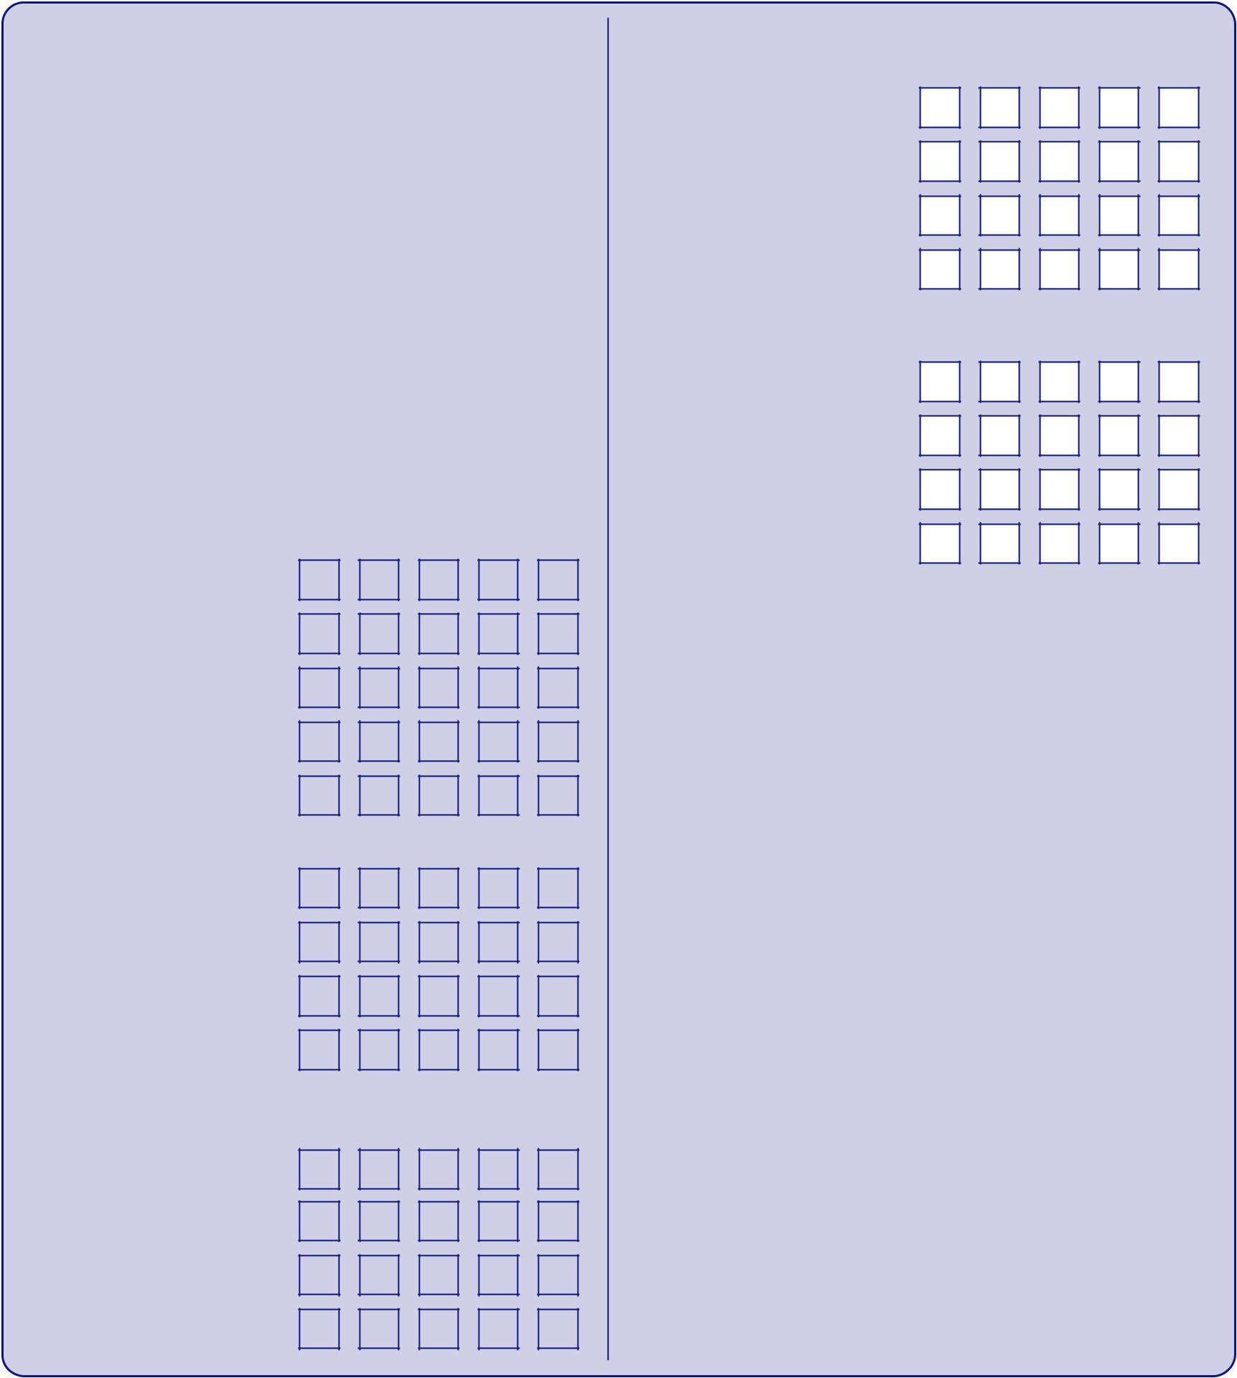

Date of visit: (dd/mm/yy) _______ / _______ / _______

 | cellente |  |  | Good
 |  |  | y
Clinic Facilities | Ex | V | r |  | Good | Fair | Poor

Is this your first visit to Independent Family Health Ltd?

How did you hear about Independent Family Health Ltd?

Are you....

How long did you wait for an appointment?

 | Yes |  | No
 |  |  |  |  |  |  | Doctor or
 | Recommendation |  |  |  |  |  | Doctor or
 |  |  |  |  |  |  | GP referral
 | Website |  |  |  |  |  | Other
 | Male |  | Female
 | Days |  |  |  |  | One Week
 | Two or Three |  |  |  |  | More than
 | Weeks |  |  |  |  | Three Weeks

Directions

Facilities / Décor

Cleanliness

Overall Impression

Taking Everything Into Account

Friendliness of Reception Staff

Friendliness of Medical Staff

Friendliness of Clinic Manager

First Impressions

Information prior to arrival

Greeting on arrival

Promptness of appointment

Explanation of procedures

Overall impressions

Level of Care

Keeping you informed

Individual attention given

Response to questions

Overall standard of care

Communication

Explanation of :

your clinical condition recommendation / treatment

Costs Involved

Payment Procedures

cellenter |  |  |  |  | Good |  |  |  |  | oor
Ex |  | V | y |  |  | Good Fair |  |  |  | P

Overall Impression

If you have visited |  | Getting Better |  |  |  |  | Getting Worse
Independent
Family Healthcare before, |  | Staying about the same
do you think the Clinic is:
 | Would you |  |  | Yes |  |  |  | No
recommend us? |  |  |  |  |  |  |  | No

Comments & Suggestions

_______________________________________

_______________________________________

_______________________________________

_______________________________________

_______________________________________

_______________________________________

_______________________________________

_______________________________________

Please include your name and address below if you would like a reply to the points you have reased.

Name ________________________________

Address ________________________________

________________________________

________________________________

________________________________

