Patient Satisfaction Survey

We invite you to complete the following satisfaction survey. Your participation will allow us to better serve you in the future.

- What type of exam did you have?

MRI

CT Scan

Ultrasound

PET/CT

X-Ray

- Why did you go to Forest City for your exam? You may select more than one:
I have been to Forest City before.
Forest City costs less than other imaging providers.
I requested that my exam be performed at Forest City.
The physician's office that ordered my exam recommended Forest City

My physician's office gave me a choice of providers and I chose Forest City
A friend or relative recommended Forest City Imaging to me.
I chose Forest City Imaging from my insurance plan listing.
I heard a radio ad for Forest City.
Other (specify):If you checked Other, enter your exam here.
- Was our office pleasant and comfortable?

Yes

If No, please explain _____________________________________

- Was our receptionist friendly and courteous?

Select 1 to 10 on the bar scale below, with 10 being the most friendly and courteous.
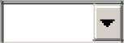

5. | Were you able to schedule your appointment within a reasonable
amount of time?
 | ! Yes | No
6. | Was the person who scheduled you friendly and courteous?

  - Yes

  - No

- If you had a prearranged appointment time, were you called for your exam in a timely manner?
Yes
No
N/A

8. If you had to wait more than ten minutes beyond your appointment time, were you given an explanation for the delay?
Yes
No
N/A

9. Was the technologist professional and caring?
Select 1 to 10 on the bar scale below, with 10 being the most professional and caring.
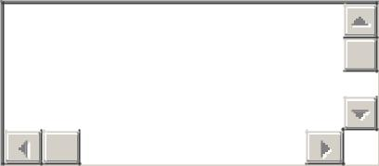

Optional comments:

- How well did the technologist explain the procedure to you prior to your exam? Select 1 to 10 on the bar scale below, with 10 being the most satisfactory explanation.

- Were you satisfied with the overall care you received at Forest City?
Select 1 to 10 on the bar scale below, with 10 being the most satisfied.

Optional comments:

12. Please provide us with your name, email address & phone number so we can address your questions and concerns. (Optional)

Optional comments:

By selecting "Yes" below, I authorize Forest City to share my feedback (without my name or contact information) on the Forest City website, on Forest City’s Facebook page, and as part of Forest City’s educational, marketing, and advertising campaigns. I understand that this authorization is not required in order to provide survey feedback, and that any such use will be without compensation, but greatly appreciated.

