
Physical Therapy Patient Satisfaction Survey

Function First Physical Therapy values your feedback and input. If you could take a moment to answer the following questions it would be greatly appreciated. We use this information to improve our services and assist us in providing superior customer service.
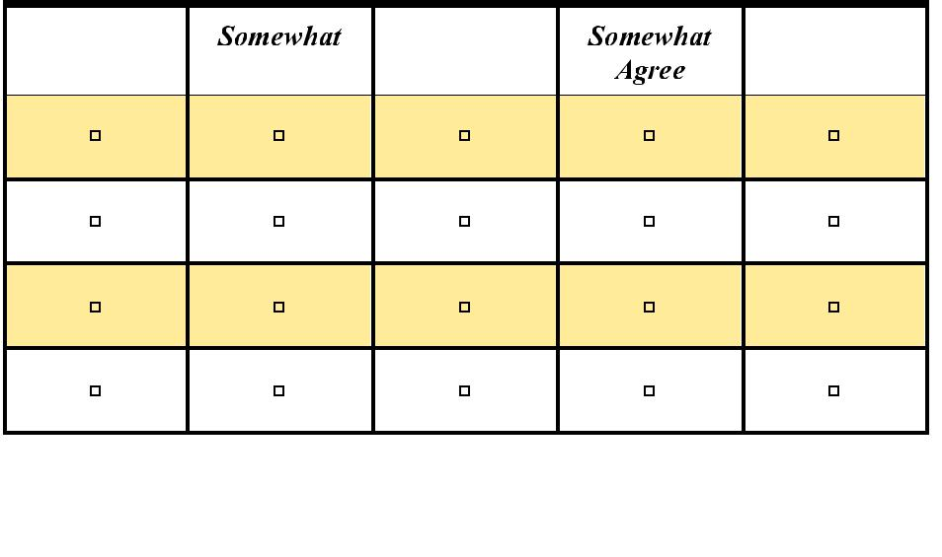

Initial Contact and Availability

- I was able to reach administrative staff during business hours.

- I was able to schedule an initial evaluation in a timely fashion.

- Insurance matters & payment were explained effectively and clear.

- All phone calls were returned in timely fashion.

Comments: ______________________________________

Strongly | Agree | Strongly
Disagree | Disagree | Agree

____________________________________________________________________________

Your First Visit

- Administrative staff was professional, courteous and friendly.

- I did not have to wait long for the initial evaluation to start.

- The physical therapist introduced him/ herself to me personally.

- The physical therapist was professional, courteous and friendly.

- The physical therapist explained my injury/problem in a way I could understand.
- The physical therapist asked what I wanted to accomplish in physical therapy.

- The physical therapist clearly stated the plan of care and time frames for physical therapy.
- I have trust & confidence in my physical therapist.

- The physical therapist gave me home exercises & proper instructions at the initial evaluation.

Comments: ___________________________________________

 | Strongly |  | Somewhat |  | Agree |  | Somewhat |  | Strongly
 | Disagree |  | Disagree |  |  |  | Agree |  | Agree
 | ▫ |  | ▫ |  | ▫ |  | ▫ |  | ▫
 | ▫ |  | ▫ |  | ▫ |  | ▫ |  | ▫
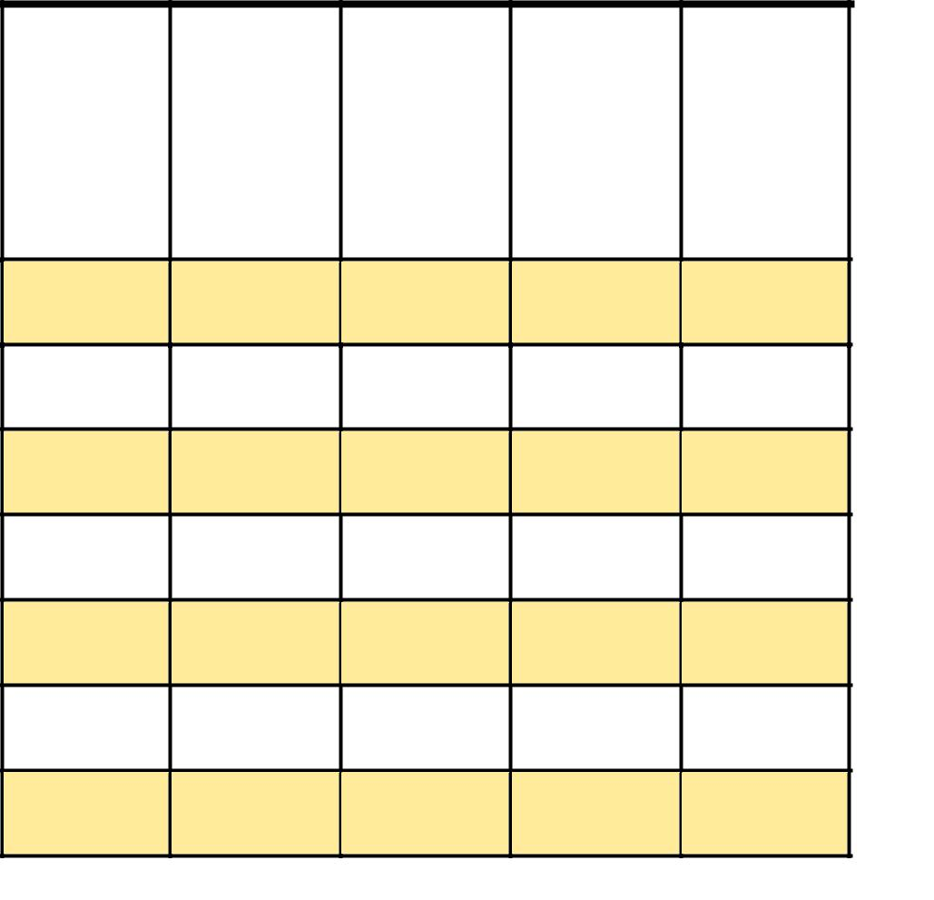
▫ | ▫ | ▫ | ▫ | ▫

▫ | ▫ | ▫ | ▫ | ▫

▫ | ▫ | ▫ | ▫ | ▫

▫ | ▫ | ▫ | ▫ | ▫

▫ | ▫ | ▫ | ▫ | ▫

▫ | ▫ | ▫ | ▫ | ▫

▫ | ▫ | ▫ | ▫ | ▫

_________________________________________________________________________________

Follow Up Visits and Quality of Care

- When I arrived for each session, my appointment began on time.

- I was consistently on time for my appointments.

- At follow-up visits, I received enough individual attention from staff.

- My home exercise program was updated frequently.

- I understood the progression of my home exercises.

- I did all that my therapist asked me to do to help myself get better during my course of treatment.

- I had a clear understanding of my responsibilities & precautions for my diagnosis.
- I felt treatment progressed appropriately.

- I felt my physical therapist communicated with my physician regarding my progress.

Strongly | Agree
Disagree | Disagree
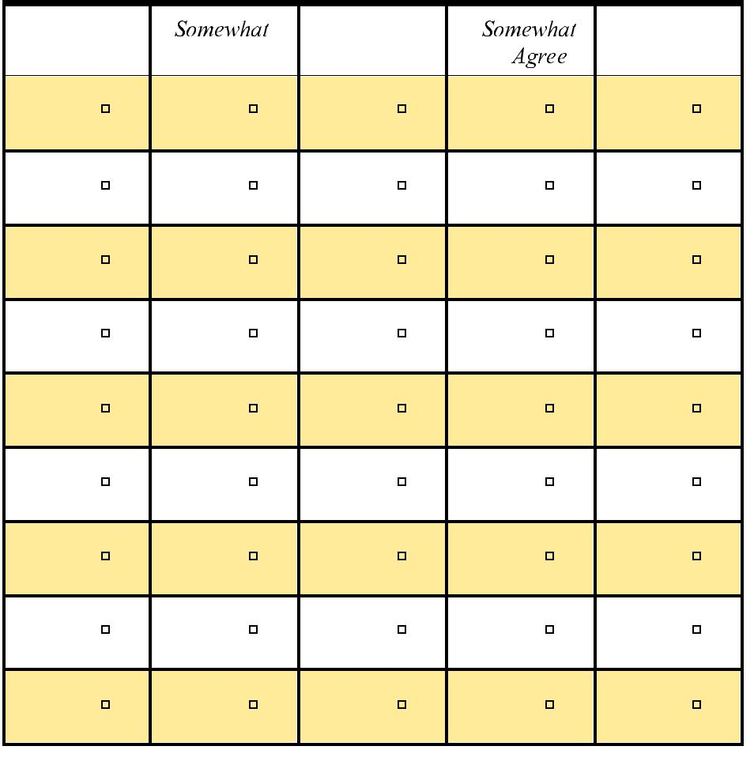

Strongly

Agree

Comments: _______________________________________

__________________________________________________________________________

Care and Outcomes
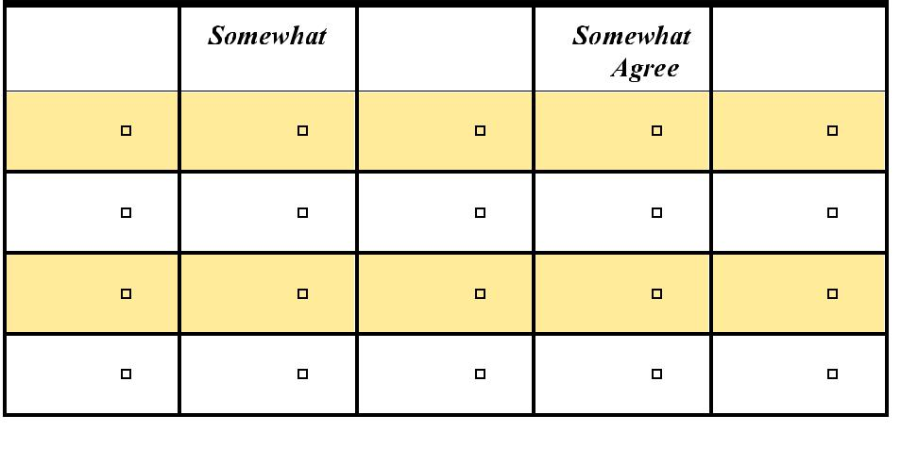  Strongly | Agree
Disagree | Disagree
- The therapists showed me how I improved from my first visit to my last.

• I was given clear instructions on my last visit for strategies regarding my condition.

- I would recommend Function First Physical Therapy to friends and family.
- I will encourage my doctor to refer more people to Function First Physical Therapy.

Comments: _________________________________________________________________

___________________________________________________________________________

Strongly

Agree

How would you rate your percentage of improvement (0-100%) from your treatment at Function First Physical Therapy?
0-‐25% | 26%-‐40% | 40%-‐65% | 66%-‐85% | 86%-‐100%

How would you rate your overall experience at Function First Physical Therapy?

Poor | Fair | Average | Great | Fantastic

Are there any staffs members you think deserve special recognition for the work they did with you during your care? Please Explain ______________________________________

_________________________________________________________________________

_________________________________________________________________________

What did you like least about your experience at Function First Physical Therapy?

_________________________________________________________________________

_________________________________________________________________________

What did you like most about your experience at Function First Physical Therapy?

_________________________________________________________________________

_________________________________________________________________________

How did you hear about Function First Physical Therapy?

_________________________________________________________________________

_________________________________________________________________________

What could we have done better to improve your care?

_________________________________________________________________________

_________________________________________________________________________

Name: (optional) ______________________________________________

Would you like to receive our monthly e-newsletter? E-mail: ________________________

