Please tell us how we are doing

MARKING INSTRUCTIONS

Office Use Only

- Use a No. 2 pencil or a blue or black ink pen only.

- Do not use pens with ink that soaks through the paper.
- Make solid marks that fill the response completely.

- Make no stray marks on this form.

CORRECT: INCORRECT:
To Our Patients:

We want to know how you feel about the care you get at our health center. Please take a few minutes to complete this survey and then return it to us. Let us know your feelings about today's visit and any visits during the last year or so. Safe and effective care is our goal. Your answers are important to us.

SiteCORRECLocation


0 | 0 | 0 | 0
1 | 1 | 1 | 1
2 | 2 | 2 | 2
3 | 3 | 3 | 3
4 | 4 | 4 | 4
5 | 5 | 5 | 5
6 | 6 | 6 | 6
7 | 7 | 7 | 7
8 | 8 | 8 | 8
9 | 9 | 9 | 9

Provider
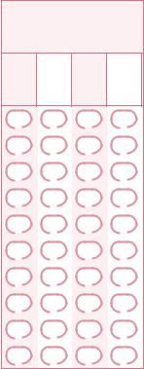

0 | 0 | 0 | 0
1 | 1 | 1 | 1
2 | 2 | 2 | 2
3 | 3 | 3 | 3
4 | 4 | 4 | 4
5 | 5 | 5 | 5
6 | 6 | 6 | 6
7 | 7 | 7 | 7
8 | 8 | 8 | 8
9 | 9 | 9 | 9

About Patient

What is your age? |  |  |  | What is your gender?
0-12 | 20-29 | 40-49 | 65+ | Male | Female | Transgender
13-19 | 30-39 | 50-64
Do you consider yourself Hispanic or Latino? |  |  | Yes, Hispanic or Latino |  | No, not Hispanic or Latino
What is your race? (mark one or more)
Asian | Black/African American |  | White
Native Hawaiian | Other Pacific Islander |  | American Indian/Alaskan Native
 |  | Very Good | Good | Fair | Poor
How would you rate your general health? |  | 4 | 3 | 2 | 1
Ease of Getting Care |  | Very Good | Good | Fair | Poor
Able to get appointment for checkups (yearly exams, well-visits, |  | 4 | 3 | 2 | 1
regular follow-up visits)
Able to make same day appointment when sick or hurt |  | 4 | 3 | 2 | 1
Health center hours work for me |  | 4 | 3 | 2 | 1
Phone calls get through easily |  | 4 | 3 | 2 | 1
I get called back quickly |  | 4 | 3 | 2 | 1
Able to get medical advice when the office is closed |  | 4 | 3 | 2 | 1
Length of time waiting at the clinic |  | 4 | 3 | 2 | 1
Facility |  | Very Good | Good | Fair | Poor
Easy to find clinic |  | 4 | 3 | 2 | 1
Lobby and waiting room was comfortable and clean |  | 4 | 3 | 2 | 1
Exam room was comfortable and clean |  | 4 | 3 | 2 | 1
Handicap accessibility |  | 4 | 3 | 2 | 1
Front Desk |  | Very Good | Good | Fair | Poor
Friendly and helpful to you |  | 4 | 3 | 2 | 1
Nurses and Medical Assistants |  | Very Good | Good | Fair | Poor
Listens to you |  | 4 | 3 | 2 | 1
Friendly and helpful to you |  | 4 | 3 | 2 | 1
Answers your questions |  | 4 | 3 | 2 | 1
 | Please see questions on other side


Provider(s) (the person who took care of you) | Very Good |  | Good |  |  |  |  |  |  | Fair |  |  |  |  |  |  | Poor
Listens to you | 4 |  | 3 |  |  |  |  |  |  | 2 |  |  |  |  |  |  | 1
Spends enough time with you | 4 |  | 3 |  |  |  |  |  |  | 2 |  |  |  |  |  |  | 1
Answers your questions | 4 |  | 3 |  |  |  |  |  |  | 2 |  |  |  |  |  |  | 1
Friendly and helpful to you | 4 |  | 3 |  |  |  |  |  |  | 2 |  |  |  |  |  |  | 1
Gives you information you can understand | 4 |  | 3 |  |  |  |  |  |  | 2 |  |  |  |  |  |  | 1
Considers your personal or family beliefs | 4 |  | 3 |  |  |  |  |  |  | 2 |  |  |  |  |  |  | 1
Involves other doctors and caregivers in your care when needed | 4 |  | 3 |  |  |  |  |  |  | 2 |  |  |  |  |  |  | 1
Gives you good advice and treatment | 4 |  | 3 |  |  |  |  |  |  | 2 |  |  |  |  |  |  | 1
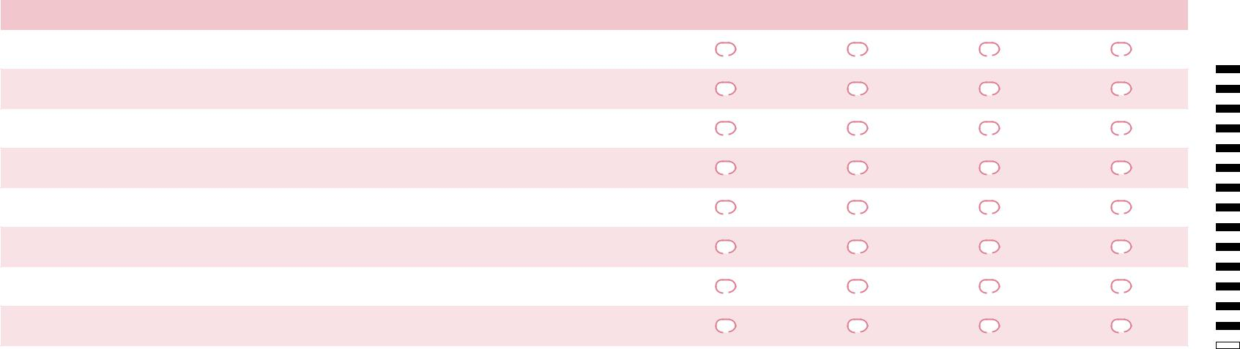
Experience with Today's Visit |  | Yes |  |  |  |  |  |  | No |  |  |  |  |  |  | Not Applicable
Did anyone ask if you have problems with the medicine you take?
 |  |  |  | Y |  |  |  |  |  |  | N |  |  |  | NA
Do you have problems getting your medication?
 |  |  |  | Y |  |  |  |  |  |  |  | N |  |  |  | NA
(transportation, pharmacy hours or cost)
Did someone talk with you about your goals for your health?
 |  |  |  | Y |  |  |  |  |  |  |  | N
Did you get a copy of your care plan?
 |  |  |  | Y |  |  |  |  |  |  |  | N |  |  |  | NA
Were you asked if you had visits with other healthcare providers
 |  |  |  | Y |  |  |  |  |  |  |  | N
since your last visit with us?
Were you helped with making appointments to see other providers
 |  |  |  | Y |  |  |  |  |  |  |  | N |  |  |  | NA
or for specialty care?
General | Yes |  |  |  |  |  | No |  |  |  |  |  | Not Applicable
Have you ever been given information on what it means to have a
 |  | Y |  |  |  |  |  | N
"health home" or a "medical home"?
If yes, do you feel that we are your health/medical home?
If yes, do you feel that we are your health/medical home? |  | Y |  |  |  |  |  |  | N |  |  |  | NA
You may need other services that we do not provide. Have we
You may need other services that we do not provide. Have we |  | Y |  |  |  |  |  |  | N |  |  |  | NA
helped you find other services you need?
Do you feel that we help you to make healthy lifestyle choices?
 |  | Y |  |  |  |  |  |  | N
Would you send your friends and family to us?
Would you send your friends and family to us? |  | Y |  |  |  |  |  |  | N
Do you understand what we ask you to pay for your care?
Do you understand what we ask you to pay for your care? |  | Y |  |  |  |  |  |  | N |  |  |  | NA
Do you feel what you pay is reasonable?
Do you feel what you pay is reasonable? |  | Y |  |  |  |  |  |  | N |  |  |  | NA
Comments
What one thing could we do to make your visits with us better?

Thank you for letting us know how we are doing!

