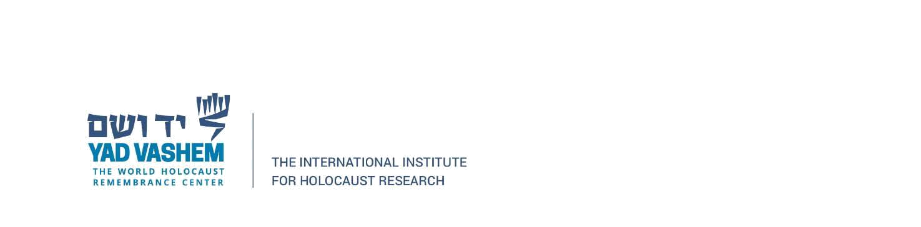

THE YAD VASHEM INTERNATIONAL BOOK PRIZE

FOR HOLOCAUST RESEARCH IN MEMORY OF

BENNY AND TILLY JOFFE z"l

2020

Permission Letter

I, the undersigned, hereby grant my permission to send the pdf version of my book to the those selected as judges for the Yad Vashem International Book Prize for the year of my submission.

Date:_________________ Signature:_______________________________
