
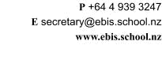

PERMISSION LETTER for FUNDRAISING
of Whittakers Chocolate

- _____________________________________________ (name of parent) give permission that the organisers of the EBIS Fundraising Project give _________________

(number of boxes) to my child, _______________________________ (name of child) in Room _________.

As parent signing this form I understand that:

- We are obliged to pay $72 per box either in cash or via KINDO to the school on Friday 24 July at the latest
- We will support our child to sell this product

Signature of parent or guardian ______________________ Date_____________________

