Permission Letter for Minors

If you are not 18 you will need your parent(s) permission. Please prepare the following letter.

We suggest:

- that this letter be prepared on your organization's letterhead

- that this form be notarized

- that this form be carried by the trip leader when travelling
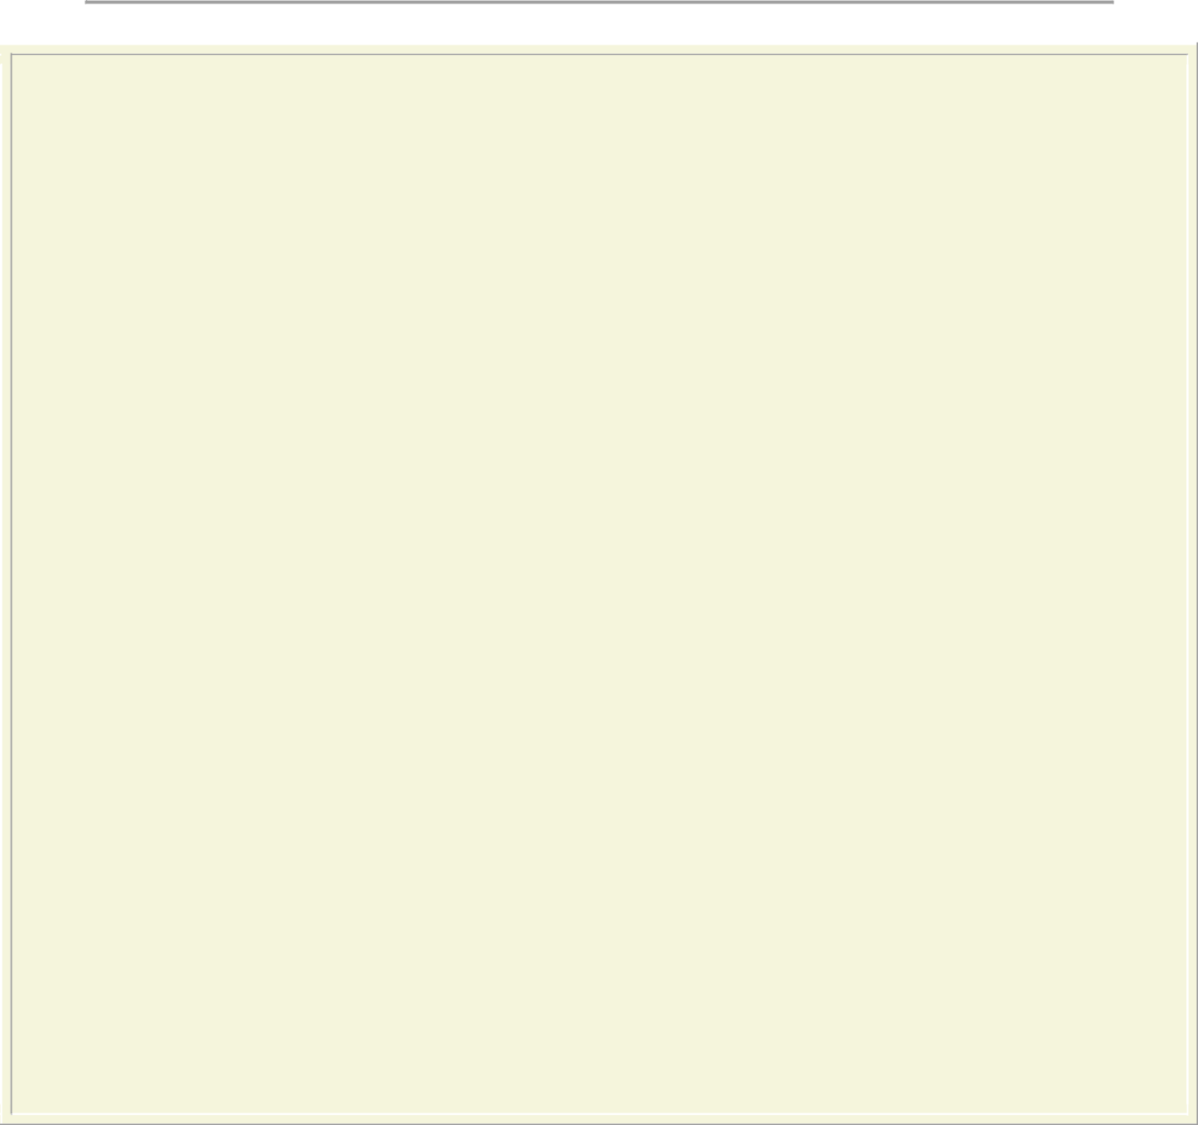

Letterhead
insert date

Re: Permission Letter for Minor Participating in the insert group name here Mission Trip to Managua, Nicaragua

To Whom It May Concern:

Insert group name here has approved a Mission Trip to Managua, Nicaragua. The person in charge is insert group leader's name here . The trip is being organized by P.A.N. (Presbyterians Aiding Nicaraguans). The trip is from insert start date to insert end date.

While there the group will be staying at:

Angel’s Inn
Kilometro 12 Carretera Masaya
100 vara al est, detras de Taller Vosmo Bosch
Managua, Nicaragua
Tel: 011 505 279 7142

I hereby give my consent for insert child or children's name to take part in this trip.

Parent's Name: Print name of Parent

Parent's Signature: Insert parent's signature

Dated this insert day of month Day of insert month , 20?? at insert city or town , insert province.

Parent's Name: Print name of Parent
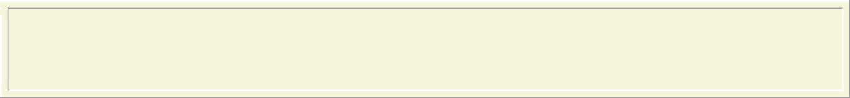
Parent's Signature: Insert parent's signature

Dated this insert day of month Day of insert month, 20?? at insert city or town , insert province.

A Completed Letter would look like this:


St. Andrew's Church

23 Main Street.,

Middletown, Ontario, X0X 0X0
Telephone: 519-555-5555

November 15, 2005

Re: Permission Letter for Minor Participating in the St. Andrew's, Middletown Mission Trip to Managua, Nicaragua

To Whom It May Concern:

St. Andrew's, Middletown has approved a Mission Trip to Managua, Nicaragua. The person in charge is Stuart Goodguy. The trip is being organized by P.A.N. (Presbyterians Aiding Nicaraguans). The trip is from January 1, 2007 to January 15 2007 .

While there the group will be staying at:

Angel’s Inn
Kilometro 12 Carretera Masaya
100 vara al est, detras de Taller
Vosmo Bosch
Managua, Nicaragua
Tel: 011 505 279 7142

I hereby give my consent for Amy Goodkid and Richard Goodkid to take part in this trip.

Parent's Name: James Goodkid

Parent's Signature: Insert parent's signature

Dated this 23rd Day of September, 2006 at Middletown, Ontario.
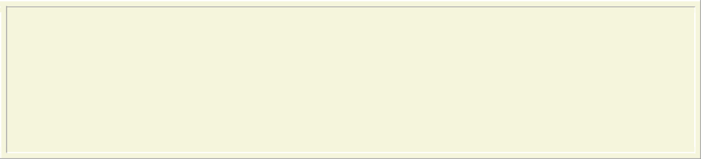

Parent's Name: Eve Goodkid

Parent's Signature: Insert parent's signature

Dated this 23rd Day of September, 2006 at Middletown, Ontario.

