
Customer Service
FACT SHEET

CUSTOMER SERVICE AT VERITIV

What does Customer Service mean to Veritiv? A whole lot. Customer service is a critical part of our business, and the very concept is embedded in our values. Customer Focus means staying

committed to understanding our customers’ needs and providing solutions that add value – and it can make all the difference in whether we win or lose. Customer Focus is driven, in large
part, by Veritiv Customer Service Professionals, who works hard each and every day to make sure that every Veritiv customer – no matter how big or how small – is satisfied.

CUSTOMER SERVICE PROFESSIONALS

801 Customer Service Professionals
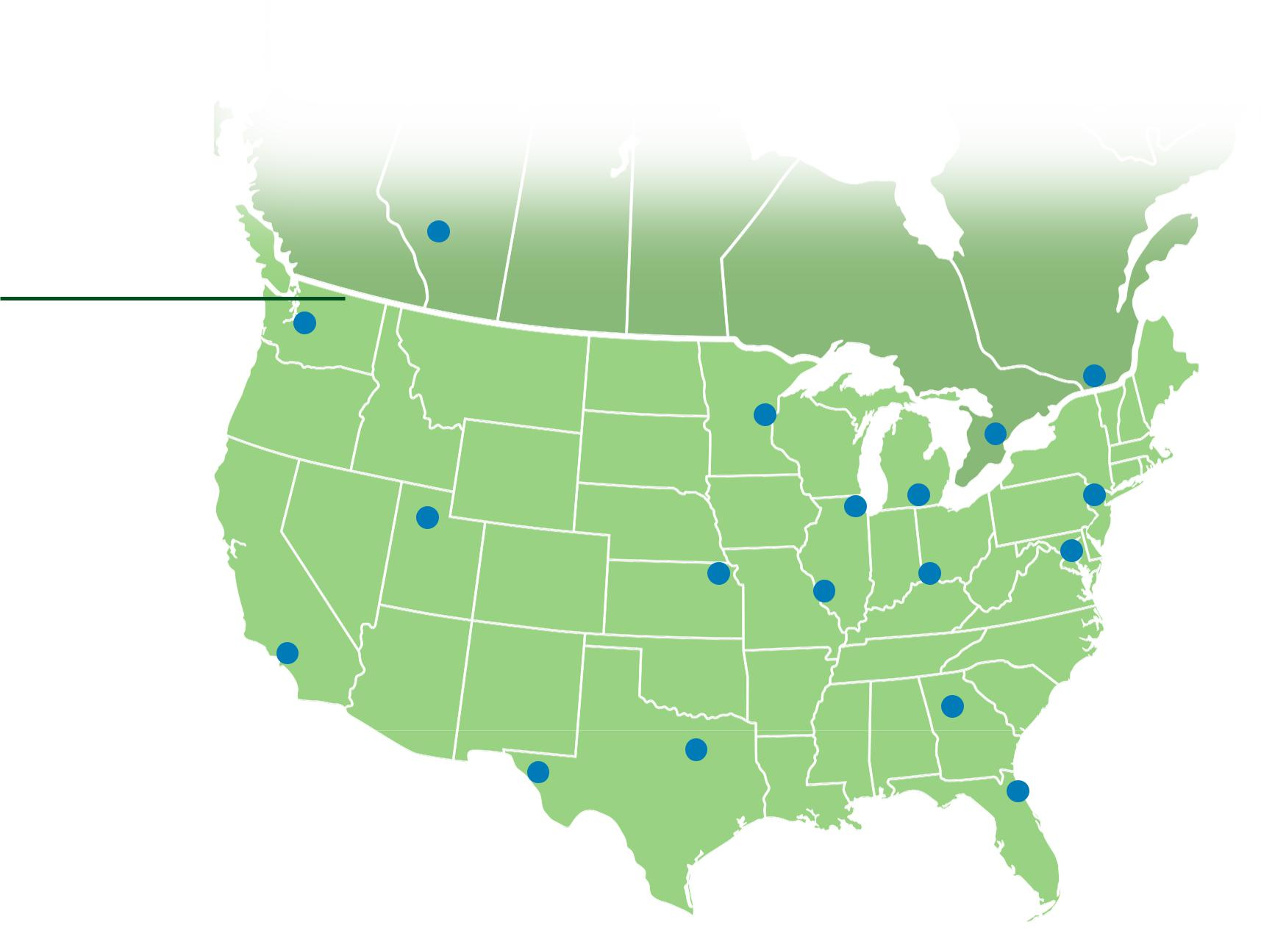
25 bilingual Customer Service Professionals in Canada (French/English)

35 bilingual Customer Service Professionals across the U.S. (Spanish/English)

 CUSTOMER

 SERVICE LOCATIONS

18 Customer Service locations across North America

CUSTOMER TOUCHPOINTS

Customers can get in touch with Veritiv Customer Service Professionals
via phone  or email 

More than 2 million phone calls are received by Veritiv Customer Service Professionals annually.

 CUSTOMER SERVICE PHILOSOPHY

We are advocates for the customer, and we strive to retain and grow our customer base by offering unmatched service.
veritivcorp.com

As of July 2016. © Veritiv Corporation. All rights reserved. Veritiv and the Veritiv logo are trademarks of Veritiv Corporation or its affiliates.



