Does Your Project Require an Application to the Cornell IRB Office?

Decision Tree #1



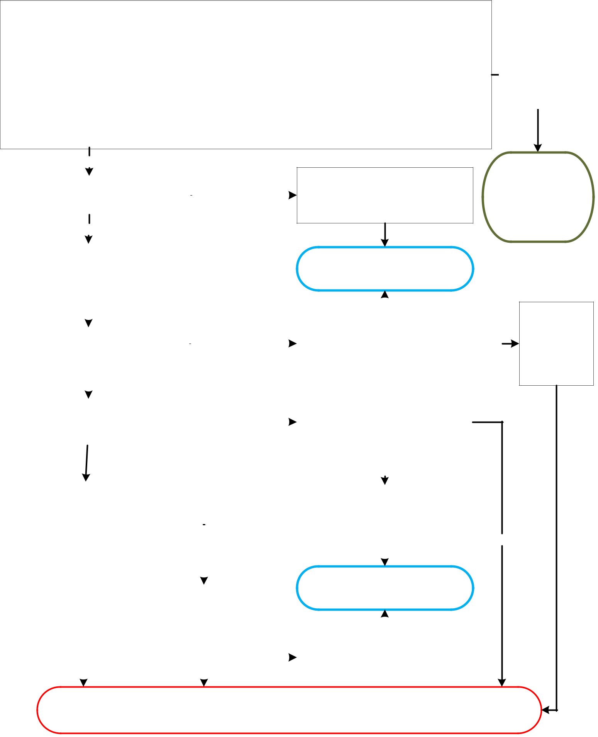

Will you, a member of your research team or a collaborator observe, interact with, or intervene with individuals to gather information that will be used for research? Examples:

Surveys, questionnaires, focus groups, interviews
Games, experiments in physical or in electronic environments

Physical or biomedical procedures – imaging, scanning, blood collection, anthropomorphic procedures Diet, nutrition studies, taste tests
Studies examining effectiveness of educational tools or curricula
Use of instruments or devices, including phones, to collect data or monitor or influence behavior
Passive observation of public behavior (in physical or online environments, including social media)
Studies examining individuals’ responses to manipulation of their physical or online environment

Another activity that involves observation of, or interaction with, individuals to gather information for research

YES

 |  |  |  |  | The focus of the project is only on products,
Is the information being collected |  |  |  |  | methods, policies, procedures, organizations: e.g.,
Is the information being collected |  |  | NO |  | methods, policies, procedures, organizations: e.g.,
‘about’ individuals? |  |  | NO |  | interviewing transportation staff and officials
‘about’ individuals? |  |  |  |  | about parking or transportation policies and
 |  |  |  |  | procedures.

YES

NO,

research will use only existing data

Refer to IRB Decision Tree #2 on Existing/ Secondary data

 | The focus of the project is on people or their |  |  |  |  |  |  |  |  |  |  |  |  |  |  |  |  |  |  |  |  |  |  |  |  |  |  | Not human participant research. No
 | opinions, perceptions, choices, decisions
regarding themselves or how methods, policies, |  |  |  |  |  |  |  |  |  |  |  |  |  |  |  |  |  |  |  |  |  |  |  |  |  |  |  | application to the IRB office is needed.
 | procedures, organizations etc. affect them or
 | their environment.
 |  |  |  |  |  |  |  |  |  |  |  |  |  |  |  |  |  |  |  |  |  |  |  |  |  |  |  |  | YES
 |  |  |  |  |  |  |  |  |  |  |  |  |  |  |  |  |  |  |  |  |  |  |  |  |  |  |  | Is the sole intent of the project to meet
 |  |  |  |  |  |  |  |  |  |  |  |  |  |  |  |  |  |  |  |  |  |  |  |  |  |  |  | course requirements, with no intention
 | Is this a class project? |  |  |  |  |  |  |  |  |  |  |  |  |  |  |  |  | YES
 |  |  |  |  |  |  |  |  |  |  |  |  |  |  |  |  |  |  |  |  |  |  |  |  |  |  |  | to use the results for something other
 |  |  |  |  |  |  |  |  |  |  |  |  |  |  |  |  |  |  |  |  |  |  |  |  |  |  |  | than the course assignment?
 |  |  |  | NO
 |  |  |  |  |  |  |  |  |  |  |  |  |  |  |  |  |  |  |  |  |  |  |  |  |  |  |  | Does the project involve stories that will
 | Is the project an oral history, |  |  |  |  |  |  |  |  |  |  |  |  |  |  |  |  |  |  |  |  |  |  |  |  |  |  | or may draw broad conclusions about
 |  |  |  |  |  |  |  |  |  |  |  |  |  |  |  |  |  |  | YES |  |  |  |  |  |  |  |  | the population, cultures, norms and
 | ethnographic, or journalistic piece?
 |  |  |  |  |  |  |  |  |  |  |  |  |  |  |  |  |  |  |  |  |  |  |  |  |  |  |  | practices; even if no research hypothesis
 |  |  |  |  |  |  |  |  |  |  |  |  |  |  |  |  |  |  |  |  |  |  |  |  |  |  |  | is being tested or validated?
 |  |  | NO
 |  |  |  |  |  |  |  |  |  |  |  |  |  |  |  |  |  |  |  |  |  |  |  |  |  |  |  |  |  | NO
 | Is this a quality assurance/quality |  |  |  |  |  |  |  |  |  |  |  |  |  |  |  |  |  |  |  |  |  |  |  |  |  |  | Published materials will be limited to only
 | improvement/organizational |  |  |  |  |  |  |  |  |  |  |  |  |  |  |  |  |  |  |  |  |  |  |  |  |  |  | documenting or reporting on events, situations,
 | effectiveness study? I.e. to |  |  |  |  |  |  |  |  |  |  |  |  |  |  |  |  |  |  |  |  |  |  |  |  |  |  | policies, institutions or systems without the intent
 |  |  |  |  |  |  |  |  |  |  |  |  |  |  |  |  |  |  |  |  |  |  |  |  |  |  |  | to form hypotheses, draw conclusions, or
 | assess, improve, or develop |  |  |  |  |  |  |  |  |  |  |  |  |  | YES
 |  |  |  |  |  |  |  |  |  |  |  |  |  |  |  |  |  |  |  |  |  |  |  |  |  |  |  | generalize findings.
 | programs or services for an
 | organization?
 |  |  |  |  |  |  |  |  |  |  |  |  |  |  |  |  |  |  |  |  |  |  |  |  |  |  |  | Not human participant research. No
 |  |  |  |  |  |  |  |  |  |  |  | Will outcomes be |  |  |  |  |  |  |  |  |  |  |  |  |  |  |  | application to the IRB office is needed.
 |  |  |  |  |  |  |  |  |  |  | generalized for other
 |  |  |  |  |  |  |  |  |  |  |  |  | organizations,
 |  | NO
 |  |  |  |  |  |  |  |  |  |  |  |  | programs or
 |  |  |  |  |  |  |  |  |  |  |  |  | services?
 |  |  |  |  |  |  |  |  |  |  |  |  |  |  |  |  |  |  |  |  |  |  |  | NO
 |  |  |  |  |  |  |  |  |  |  |  |  |  |  |  |  |  |  |  |  |  |  |  |  |  |  |  | Outcomes will remain specific to the organization,
 |  |  |  |  |  |  |  |  |  |  |  |  |  |  |  |  |  |  |  |  |  |  |  |  |  |  |  | programs or services, although other organizations
 |  |  |  |  |  |  |  |  |  |  |  |  |  |  | YES |  |  |  |  |  |  |  |  |  |  |  |  | may use the results for their own programs.

The project may lead to use of the results outside of
NO the course (e.g., for

- publication, presentation, thesis, or dissertation).

YES

Project is research with human subjects.
An application to the IRB office and written notice of approval required before the study can begin.
Forms available at www.irb.cornell.edu. Questions? Contact irbhp@cornell.edu

Does Your Research Involving Secondary or Existing Data, Documents or Biological Specimens Require
Review by the Cornell IRB Office?

Decision Tree #2


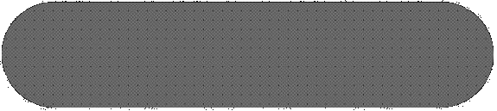

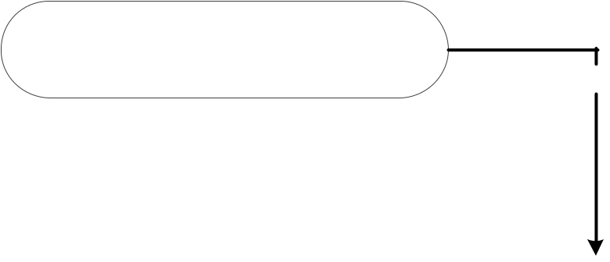

Are the data/specimens about or from
individuals who are or may be still living? | YES
NO. Materials are from cadavers, or

data is about deceased individuals

 |  |  |  |  |  |  |  | Project is Not Human |  |  |  |  |  |  |  |  |  |  |  |  |  |  |  |  |  |  |  |  |  |  |  |  |  | Are the specimens (human cell lines,
 |  |  |  |  |  |  |  |  |  |  |  |  |  |  |  |  |  |  |  |  |  |  |  |  |  |  |  |  |  |  |  |  |  | tissue, etc.) obtained from a producer
 |  |  |  |  |  |  |  |  |  |  |  |  |  |  |  |  |  |  |  |  |  |  |  |  | YES.
 |  |  |  |  |  |  |  |  | Subjects Research |  |  |  |  |  |  |  |  |  |  |  |  |  |  |  |  |  |  |  |  |  |  |  |  | or supplier of public use data; or
 |  |  |  |  |  |  |  |  |  |  |  |  |  |  |  |  |  |  |  |  |  |  |  |  | Data is
 |  |  |  |  |  |  |  | No application to the |  |  |  |  |  |  |  |  |  |  |  |  |  |  |  |  |  |  |  |  |  |  |  |  |  | Is all the information about the
 |  |  |  |  |  |  |  |  |  |  |  |  |  |  |  |  |  |  |  |  |  |  |  | publically available
 |  |  |  |  | Cornell IRB office needed* |  |  |  |  |  |  |  |  |  |  |  |  |  |  |  |  |  |  |  |  |  |  |  |  |  |  |  |  | specimens/data available in the public
 |  |  |  |  |  |  |  |  |  |  |  |  |  |  |  |  |  |  |  |  |  |  |  |  |  |  |  |  |  |  |  |  |  | domain?
 |  |  |  |  |  | NO. Data is |  |  |  |  |  |  |  | de-identified |  |  |  |  |  |  |  |  |  |  |  |  |  |  |  |  |  |  |  |  |  |  | NO
 |  |  |  |  |  |  |  |  |  |  |  |  |  |  |  |  |  |  |  |  |  |  |  |  |  |  |  |  |  |  |  |  |  | Were/will the specimens/data (be) collected
 |  |  |  |  |  |  |  | Can the provider link the
 |  |  |  |  |  |  |  |  |  |  |  |  |  |  |  |  |  |  |  |  |  |  |  |  |  |  |  |  |  |  |  |  |  | specifically for the research through an
 |  | specimens/data, directly or indirectly, |  |  |  |  |  |  |  |  |  |  |  |  |  |  |  |  |  |  |  |  |  |  |  | NO
 |  |  |  |  |  |  |  |  |  |  |  |  |  |  |  |  |  |  |  |  |  |  |  |  |  | NO |  |  |  |  |  |  |  | interaction or intervention with living
 |  |  |  |  | to identifiable living individuals?
 |  |  |  |  |  |  |  |  |  |  |  |  |  |  |  |  |  |  |  |  |  |  |  |  |  |  |  |  |  |  |  |  |  |  | individuals?
NO. Provider is solely
providing,
 |  |  |  |  |  |  |  |  |  |  |  |  |  |  |  |  |  |  |  |  |  |  |  |  |  |  |  |  |  |  |  |  |  |  |  | YES
with no role in |  |  |  |  |  |  |  |  |  |  | YES
the research
 |  |  |  |  |  |  |  |  |  |  |  |  |  |  |  |  |  |  |  |  |  |  |  |  |  |  |  |  |  |  |  |  |  | Project is Human Subjects Research
 |  | Can the recipient link the specimens/ |  |  |  |  |  |  |  |  |  |  |  |  |  |  |  |  |  |  |  |  |  |  | YES. |  |  |  |  |  |  |  |  | Application to the IRB office and written
 |  |  | data directly to identifiable living |  |  |  |  |  |  |  |  |  |  |  |  |  |  |  |  |  |  |  |  |  | Recipient has |  |  |  |  |  |  |  |  | notice of approval or notice of exemption
 |  | individuals either directly or through |  |  |  |  |  |  |  |  |  |  |  |  |  |  |  |  |  |  |  |  |  |  | access to |  |  |  |  |  |  |  |  | required before research can begin.
 |  |  |  |  |  |  |  |  |  | a code? |  |  |  |  |  |  |  |  |  |  |  |  |  |  | identifiable data |  |  |  |  |  |  |  |  | Forms at www.irb.cornell.edu
 |  |  |  |  |  |  |  |  |  |  |  |  |  |  |  |  |  |  |  |  |  |  |  |  |  |  |  |  |  |  |  |  |  | Questions? Contact irbhp@cornell.edu
 |  |  |  |  |  |  |  |  |  |  |  |  | NO
 |  | Is the provider a collaborator in the
 |  | recipient’s research? i.e. involved in |  |  |  |  |  |  |  |  |  |  |  |  |  |  |  |  |  |  |  |  |  |  |  |  |  |  |  |  |  | YES,
 |  | the design, conduct or reporting of |  |  |  |  |  |  |  |  |  |  |  |  |  |  |  |  |  |  |  |  |  |  |  |  |  |  |  |  | recipient and
 |  | the research, listed as collaborator on |  |  |  |  |  |  |  |  |  |  |  |  |  |  |  |  |  |  |  |  |  |  |  |  |  | provider are collaborators
 |  |  |  |  | research proposals or protocols, |  |  |  |  |  |  |  |  |  |  |  |  |  |  |  |  |  |  |  |  |  |  |  |  |  | on the research
 |  | planned sharing of authorship credit.


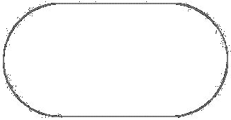




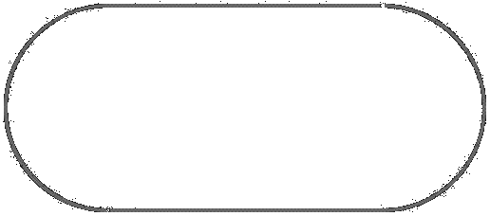













*Contact the Cornell Office of Sponsored Programs (www.ovpr.cornell.edu/osp) if acquiring the data requires a Data Use Agreement or a Materials Transfer Agreement between the provider and recipient.
Reference:

“Research Involving Private Information or Biological Specimens Flowchart”, National Institute of Health (NIH), January 2006, https://grants.nih.gov/grants/policy/hs/PrivateInfoOrBioSpecimensDecisionChart.pdf

