
Home Furnishings Networking Conference, Presented by the North American Home Furnishings Association

EVENT AND SPONSORSHIP FACT SHEET

WHEN: May 17-19, 2015

WHERE: Disney’s Coronado Springs Resort, Walt Disney World Resort, FL

WHAT: The Home Furnishings Networking Conference, presented by the North American Home Furnishings Association, brings together retailers from across the nation to network and learn from others in their field. The HFNC provides an array of opportunities to engage in a friendly, fun environment. From nuts-and-bolts education and best practices to operational resources, the Networking Conference has it all. The HFNC attracts a national audience of power players and entrepreneurs ready to talk business, share stories, find solutions and make connections.

WHY: When the industry gathers for a signature conference, you need to be involved. Your sponsorship of this highly visible event is loaded with value. It allows you to reach an influential, nationwide audience in two and a half days and creates brand visibility and strengthens your ties in the industry. It also presents your brand as a company that gives back to those who have helped shape your success.

WHO: The NAHFA is committed to delivering unparalleled value in educational events and services while championing the voice of the home furnishings retailer at the local and national level. You can be a part of one of the most significant networking events in our industry by participating in the HFNC and build relationships that last a lifetime.

THE AUDIENCE: With more than $45 billion in combined annual sales, this audience is rich with opportunity.

Representing companies from the top 100 retailers to single storefront operations, the audience is a perfect mix to strategically grow your portfolio.

THE PRODUCT SHOWCASE: During the conference, time is devoted exclusively to showcasing your product. Our Exhibitor Showcase, comprised of 48 booths and 12 premier tabletops, provides the venue to highlight your best products and services to this exclusive group of decision makers. You are sure to see new customers, and build committed relationships.

CINDI WILLIAMS

Sponsorship Development

Director of Events, North American Home Furnishings Association


Direct: 916-960-0277 • Cell: 916-425-9346

email: cwilliams@nahfa.org

website: www.theHFNC.com

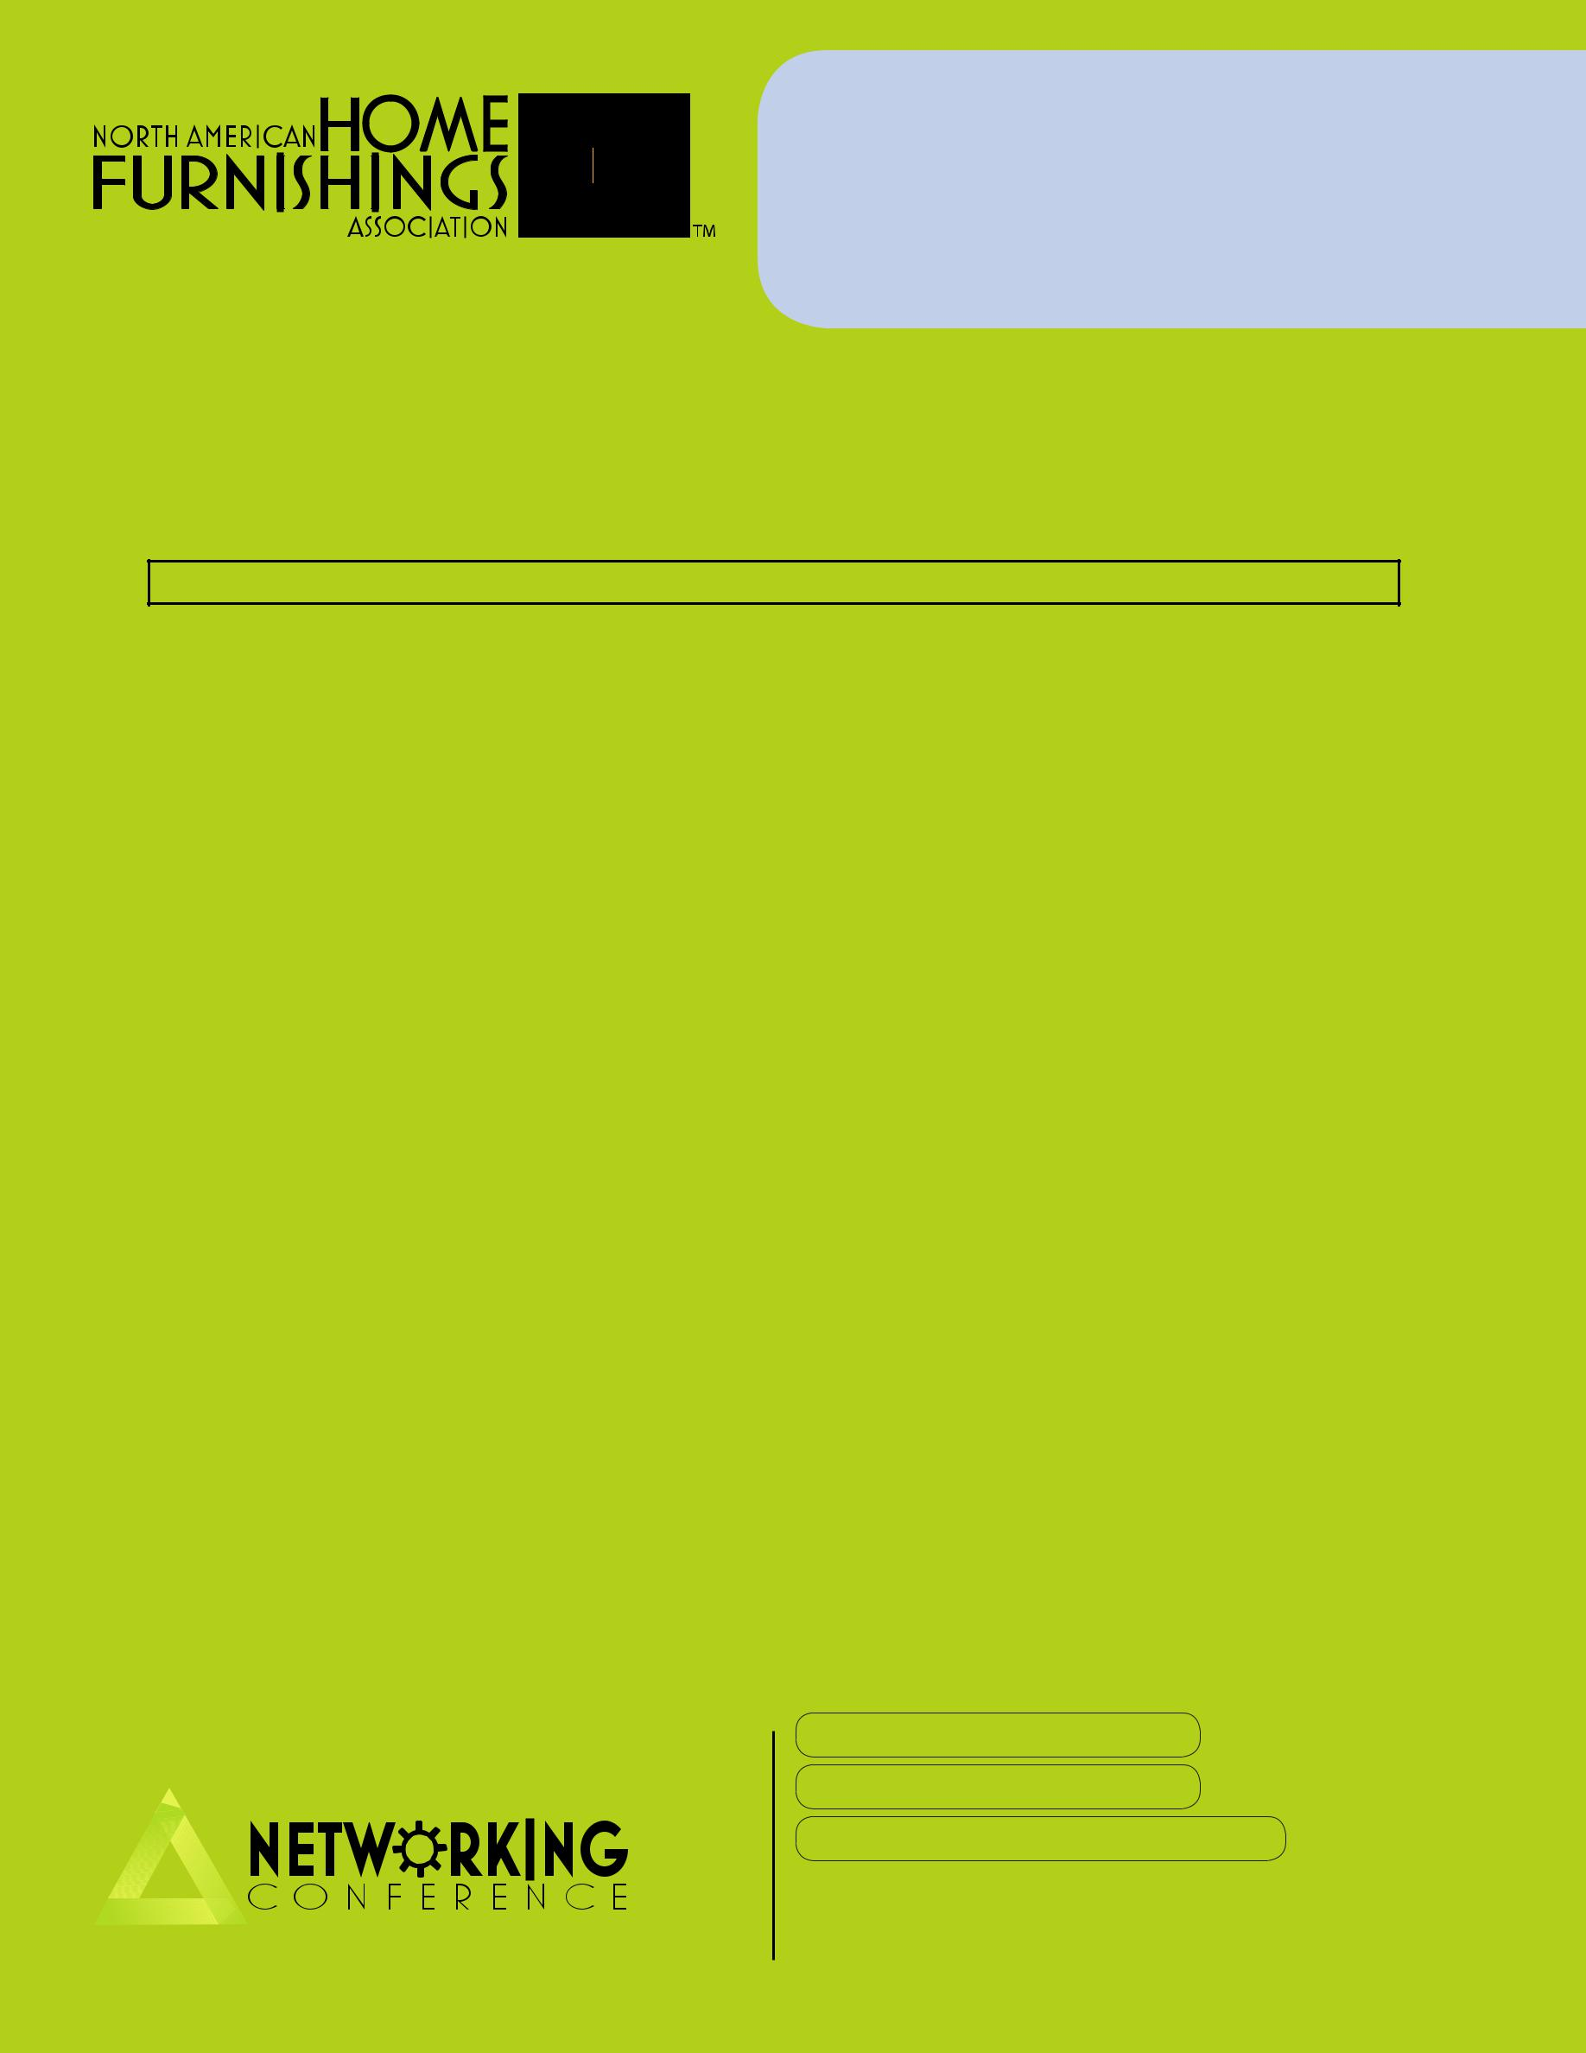
HOME FURNISHINGS NETWORKING CONFERENCE

Premier Sponsors (Limited to four) $30,000+ Call to discuss customized package

• All benefits of Titanium sponsorship and/or

• *Listed as Premier partner on select printed materials.

• *Gobo lighting package at HFNC

• *30 % media channel discounts.

• *10x30 Complimentary Exhibit space at the HFNC

Every advantage counts in establishing and elevating your business and brand. Nothing matches the energy and opportunity that awaits you at the 2015 Home Furnishings Networking Conference. The industry’s premier networking event of the year.

2015 HOME FURNISHINGS NETWORKING CONFERENCE ALLOCATION OPPORTUNITIES

Hospitality:
Retailer of the Year Event May 17, 2015 | $ | 45,000
Step into the Scene Photo Experience included
Luncheons (x2) | $ | 15,000
The Magic Behind the Business Tour | $ | 15,000
Presidential Suite | $ | 10,000
Breakfast (x2) | $ | 10,000
Showcase Reception (x1) | $ | 10,000
Refreshment breaks (x4) | $ | 3,000
See photo montage opportunity
Educational:
Master of Ceremonies | $ | 20,000
Mitch Joel – May 17th | $ | 20,000
Scott Stratton – May 18th | $ | 20,000
Peter Sheahan – May 19th | $ | 20,000
Best Idea Exchange | $ | 15,000
The Nuts & Bolts sessions | $ | 10,000
Breakouts (x16) | $ | 5,000
Promotional:
Conference Tote | $ | 15,000
Conference Journal | $ | 15,000
Custom HFNC Map | $ | 10,000
Coffee Bar Photo Montage | $ | 10,000
Technology Charging Station2 (x2) | $ | 10,000
Door Drop (x2) | $ | 10,000
Registration Desk | $ | 10,000
Conference Lanyards | $ | 8,000
Glass, stairway and hanging banner signage
Call for custom quantities, pricing and locations

HOME FURNISHINGS

¦ TITANIUM - $10,000+

All Platinum Benefits and/or
- Complimentary exhibit space
- Two complimentary conference registrations
- One 2 minute speaker introduction – as available
- Exclusive signature event sponsorship
- Reserved table at dinner functions
- Two Exclusive NAHFA Board Meeting invitations
- One Full page 4 color Ad in the RetailerNOW magazine
- NAHFA Membership
- 25% media channel discounts

¦ PLATINUM - $5000+

All Gold/Silver Benefits and/or
- Two complimentary conference registrations
- Exclusive breakout or event sponsorship
- Placement of materials in HFNC Welcome Bag
- Logo recognition included on all sponsor listings
- NAHFA Board Meeting invitation
- VIP Sponsor Appreciation Event invitation
- One half page 4 color Ad in the RetailerNOW magazine
- 20% media channel discounts

¦ GOLD/SILVER - $3000+

All Bronze Benefits and/or
- One complimentary conference registration
- Exclusive education session sponsorship
- Exclusive break sponsorship
- 15% media channel discounts

¦ BRONZE $1000+

- Press release acknowledging sponsors
- Company name included in all sponsor listings
- Sponsor ribbons for all staff attending
- Sponsor recognition sign for display in booth

CINDI WILLIAMS
Sponsorship Development

Director of Events, North American Home Furnishings Association

email: cwilliams@nahfa.org

website: www.theHFNC.com

916-960-0277 direct 916-425-9346 cell

*Contract signing date determines selected printed materials

