

Comfort Inn at Thousand Hills

Kathy Woods - Assistant General Manager

Telephone - 877.335.4727
KathyWoods@myerhotels.com

Myer Hotels - Corporate

Kathy Smith - Director of Sales
Telephone - 888.837.2537
Kathy@myerhotels.com

Wes Stoner - Sales Manager
Telephone - 888.273.2468
Wes@myerhotels.com

2012 Inn of the Year

for Choice Hotels

2011, 2013, 2014 & 2015 Choice Hotels

Platinum Award and

Inn of the Year Finalist

Certified Green by Missouri Hotel and Lodging Association

203 South Wildwood Drive
Branson, MO 65616

Telephone | 417.335.4727
Toll Free | 877.335.4727
Fax | 417.335.4748

Tod Grisham - General Manager Email: gm.mo068@choicehotels.com Web: www.myerhotels.com

Check-In 3:00 PM

Check-Out 11:00 AM

Breakfast 6:30 – 9:30 AM
Indoor Pool/Hot Tub Available

9:00 AM – Midnight

100% Smoke Free Property

Updated 3/9/16

Property Fact Sheet
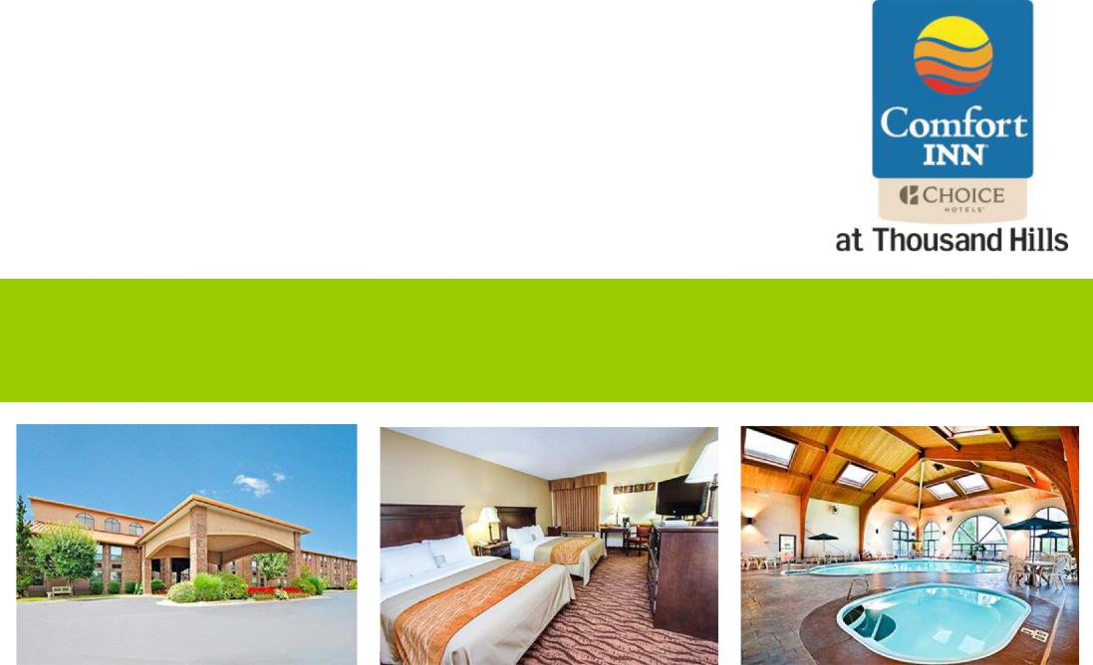

This Choice Hotels Platinum award-winner, overlooking Thousand Hills Golf Course is on Branson’s Yellow Route--just a block off the famous Highway 76, Country Music Boulevard in Branson and convenient to theaters, shops and restaurants. A full service restaurant is adjacent to this hotel. This hotel was selected as Choice Hotels Inn of the Year in 2012 and finalist in 2013, ‘14 and ‘15.

Guest room amenities include 32” LED flat screen televisions, electronic lock, viewfinder, safety latch, iron/ironing board, coffee maker, hair dryer, toiletries, alarm clock radio, cable/movie channels, free local calls, free wireless Internet, refrigerator, microwave, recliner, activity table, sitting area, connecting rooms and double granite vanities in most rooms.

The free hot breakfast includes such foods such as scrambled eggs, sausage patties, biscuits and sausage gravy, and fresh Belgium waffles. Additionally, fresh fruits, yogurts, breads and pastries, juices, milk, coffee and teas are served. A detailed list can be provided upon request.

Parking: Adequate/Level | Floors: 4
Entry: Interior | Hot Tub: Indoor |  | Gift Shop: Yes
Pool: Indoor | Shuttle Bus/Van: No |  | Sauna: Yes
Fitness Room: Yes | In-House Ticketing/Concierge: Yes |  | Elevator: Yes
Room Service: No | Local Restaurant Delivery: Yes |  | Sun Deck: Yes
Guest Laundry: Yes | Pets Allowed: No | (Service Animals Welcome)
Restaurants | Distance | Shopping Centers |  | Distance
Lone Star Steak | next door | Tanger Mall |  | 0.6 miles
Florentina’s | 0.1 miles | Stone Hill Winery |  | 1.0 miles
Panera Bread | 0.3 miles | Branson Landing |  | 3.3 miles
Theaters | Distance | Attractions |  | Distance
Andy Williams | 0.4 miles | Thousand Hills Golf |  | adjacent to hotel
Branson Variety | 0.4 miles | White Water |  | 1.6 miles
Baldknobbers | 0.5 miles | Titanic Museum |  | 1.0 miles
 |  | Branson Rec Plex |  | 5.5 miles
 |  | Branson High School |  | 6.5 miles
Airport | Distance | Airport |  | Distance
Branson Airport (BKG) | 14.3 miles | Springfield Airport (SGF) |  | 56.0 miles
Northwest Arkansas (XNA) | 95.6 miles

Guest Rooms (108 Total) – 100% Non-Smoking – All Interior Corridors

03 Standard with 2 Queen beds (refrigerator, flat screen television)

85 Deluxe with 2 Queen beds (double vanity, refrigerator, and microwave, flat screen television) 05 King (flat screen television, double vanity, refrigerator, microwave, and recliner)

03 King (flat screen television, double vanity, refrigerator, microwave, recliner and one-person Jacuzzi tub)

05 Handicap King (flat screen television, bench provided for tub shower, refrigerator and microwave and recliner)

02 Handicap King (flat screen television, roll-in shower, refrigerator, microwave and recliner)

02 King Honeymoon Suite (flat screen television, refrigerator, microwave couch/sitting area, recliner and two-person Jacuzzi tub)

02 Two-Room Family Suite, 6 person. 1st room, flat screen television,(1) Bathroom (1) Queen bed, refrigerator, microwave, 2nd room, flat screen television (1) queen bed and sleeper sofa.

01 Two-Room Family Suite 8 person, 1st room has (2) Queen beds, refrigerator, microwave, and a flat screen television. 2nd room has (1) Queen bed, sleeper sofa, flat screen television, and one bathroom in Foyer.

Meeting Room: (please check with guest services for cost and availability)
- 760 Sq Ft ; 38’ x 20’, 8’ ceiling

- Seating 50-Theater, 40-Classroom/Banquet, 20 U-Shape

- Podium/lectern, flip chart, LCD projector and screen available on-site

