Product Fact Sheet

Keysight BenchVue Software


Data capture simplified.
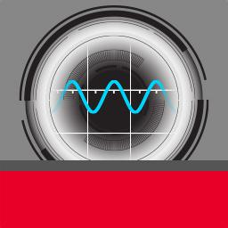
Keysight’s BenchVue software for the PC reinvents your bench testing by making it simple to connect, record and achieve results across multiple instruments with no programming. Compared to alternative software, BenchVue users derive results

faster by easily viewing, logging and exporting measurement data and screen shots with a few clicks. With BenchVue, it is as simple as: click, capture, done.

Key features and benefits:

–– Visualize multiple instrument measurements simultaneously –– Easily log data, screen shots and system state

–– Recall a past bench state to replicate results

–– Fast measurement data export in desired format –– Quickly access manuals, drivers, FAQs and videos –– Monitor and control bench from mobile devices

Key characteristics:

–– No programming or separate instrument drivers required –– One application to integrate all your bench instrumentation –– Powerful no cost version always available for download
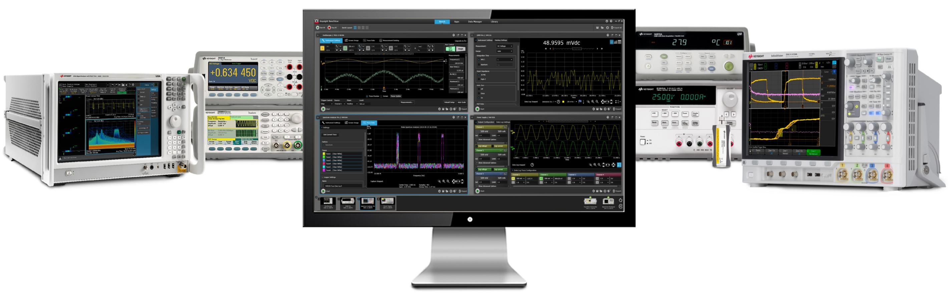

BenchVue supports Keysight digital multimeters, oscilloscopes, data acquisition units, signal analyzers, power supplies, function generators and power sensors.


Keysight | BenchVue Software – Product Fact Sheet

Click. Capture. Done.

BenchVue contains many no cost applications to control instruments and record measurement data. Optional Pro upgrades are are available to extend functionality:
Product | Data capture | Base | Mobile | Optional | Pro features | Pro
 | functionality | logging | support | Pro upgrade |  | model
 |  | duration |  | available? |  | number
Digital | –– Measurements | 1 hour | Yes | Yes | –– Digitizer functions | BV0001A
multimeter app | –– Instrument state |  |  |  | –– Unrestricted data
 |  |  |  |  | logging
 |  |  |  |  | –– Limit testing and
 |  |  |  |  | alerts
Function | –– Instrument state | N/A | Yes | Yes | –– Waveform editing | BV0002A
generator app |  |  |  |  | capabilities
Power | –– Output V&I data | 1 hour | Yes | Yes | –– Status alerts | BV0003A
supply app | –– Instrument state |  |  |  | –– Unrestricted data
 |  |  |  |  | logging
Oscilloscope | –– Measurements | 1 hour | Yes | Yes | –– Limit testing and | BV0004A
app | –– Screen images |  |  |  | alerts
 | –– Trace data |  |  |  | –– Unrestricted data
 | –– Instrument state |  |  |  | logging
Spectrum | –– Screen images | 1 hour | Yes | Yes | –– Deep memory | BV0005A
analyzer app | –– Trace data |  |  |  | capture
 | –– Instrument state |  |  |  | –– Unrestricted data
 |  |  |  |  | logging
Data | –– Measurements | 8 hour | No | Yes | –– Unrestricted data | BV0006A
acquisition app | –– Instrument state |  |  |  | logging
Power meter | –– Measurements | 1 hour | No | Yes | –– Unrestricted data | BV0007A
app | –– Instrument state |  |  |  | logging
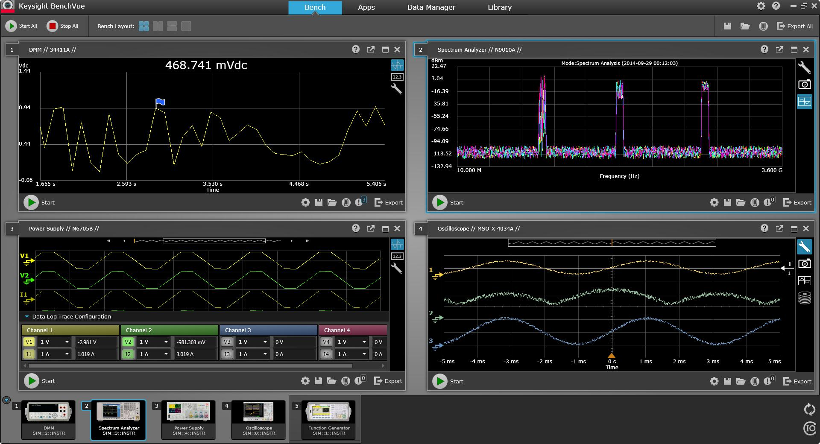

View multiple measurements simultaneously.

BenchVue Software Supported Instruments
Data | Power | Digital | Function | DC power supplies |  |  | Signal | Oscilloscopes (164)
acquisition | sensors | multimeters | generators |  | (46) |  | analyzers
units (2) | (7) | (9) | (17) |  |  |  | (21)
34970A | U2021XA | 34401A | 33210A | E3631A |  | N6953A | PSA E444x | 2000-X Series (12)
34972A | U2022XA | 34405A | 33220A | E3632A |  | N6954A | ESA E440x | 3000-X Series (18)
 | U2041XA | 34410A | 33250A | E3633A |  | N6970A | UXA N9040B | 3000T Series (20)
 | U2042XA | 34411A | 33521A | E3634A |  | N6971A | PXA N9030A | 4000-X Series (16)
 | U2043XA | 34450A | 33522A | E3640A |  | N6972A | MXA N9020A | 5000 (5)
 | U2044XA | 34460A | 33509B | E3641A |  | N6973A | CXA E9000A | 6000-X Series (4)
 | U2049XA | 34461A | 33510B | E3642A |  | N6974A | EXA N9010A | 6000 Series (16)
 | LAN
 | LAN | 34465A | 33511B | E3643A |  | N6976A | N9320B | 7000 Series (28)
 |  | 34470A | 33512B | E3644A |  | N6977A | N9322C | 9000 Series (8)
 |  |  | 33519B | E3645A |  | N7950A | BSA N9320B | 90000 (6)
 |  |  | 33520B | E3646A |  | N7951A | BSA N9322C | 90000 Q-Series (5)
 |  |  | 33521B | E3647A |  | N7952A |  | 90000 X-Series (12)
 |  |  | 33522B | E3648A |  | N7953A |  | S Series (14)
 |  |  | 33611A | E3649A |  | N7954A
 |  |  | 33612A | N6700A/B |  | N7970A
 |  |  | 33621A | N6701A |  | N7971A
 |  |  | 33622A | N6702A |  | N7972A
 |  |  |  | N6705B |  | N7973A
 |  |  |  | N6785A |  | N7974A
 |  |  |  | N6786A |  | N7976A
 |  |  |  | N6950A |  | N7977A
 |  |  |  | N6951A
 |  |  |  | N6952A

For more information about Keysight BenchVue software and to download a no cost version, please visit www.keysight.com/find/BenchVue

This information is subject to change without notice.
© Keysight Technologies, 2014 - 2015

Published in USA, April 20, 2015

5991-3819EN www.keysight.com

