MV2687 4/2003 Record the Odometer Reading:
- At the beginning of each day or trip.

- When leaving each Jurisdiction.

- At the end of each day or trip.

DAILY VEHICLE MILEAGE AND FUEL REPORT

Wisconsin Department of Transportation

(IRP & IFTA Vehicles Only)

See instructions on reverse side

Power Unit Vehicle Identification Number or Unit Number | Power Unit Fleet Number | Fuel Type | Name (Fuel Filer/IRP Registrant) | Fuel Filer Name (If Other Than IRP Registrant) | Driver(s) Name

AL |  |  | MILEAGE INFORMATION |  |  |  |  |  |  | FUEL INFORMATION |  |  | TRIP INFORMATION
AL |  |  | HIGHWAYS |  | JURISDICTION | ODOMETER READING |  | JURISDICTION | GALLONS |  | VENDOR
AK |  | TRIP | HIGHWAYS |  | JURISDICTION | ODOMETER READING |  | JURISDICTION | GALLONS |  | VENDOR
AZ |  | DATE | USED |  | NAME | BEGIN |  | MILES | RECEIVED |  | NAME | ORIGIN |  | DESTINATION
AR
CA
CO
CT
DE
DC
FL
GA
ID
IL
IN
IA
KS
KY
LA
ME
MD
MA
MI
MN
MS
MO
MT
NE
NV
NH
NJ
NM
NY
NC
ND
OH
OK
OR
PA
RI
SC
SD
TN
TX
UT
VT
VA
WA
WV
WI
WY
MX
AB
BC
NB
NK
NF
NT
NS
ON
PE
PQ
SK
YT
 |  |  |  |  |  | END
 |  |  |  |  |  |  |  | 0 | TOTAL TRIP MILES

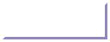  GENERAL INFORMATION | Back

A Daily Vehicle Mileage and Fuel Report must account for all miles traveled and all fuel received. If you use a substitute vehicle, prepare a separate Daily Vehicle Mileage and Fuel Report

to account for the miles traveled and fuel received by the substitute vehicle.

INSTRUCTIONS

- Vehicle Identification Number or Unit Number of power unit.

- Fleet Number of power unit.

- Fuel Type:

(D) diesel, (G) gasoline, (P) propane, (GH) gasohol, (NG) Natural gas.

- Name of the IRP registrant or fuel tax licensee.

- Fuel Filer - complete if different than 4.

- Driver(s) Name(s).

MILEAGE INFORMATION

- Trip Date

- Highways used - e.g.; I90, STH 69

- Jurisdiction Name - abbreviation of the jurisdiction in which your vehicle is traveling, e.g., WI for Wisconsin, etc.
- Odometer Reading:

  - Record at the beginning of each day or trip.

  - When leaving each jurisdiction.

  - At the end of each day or trip.

- Jurisdiction Miles - record the mileage traveled in each jurisdiction by trip date.

- Total trip miles - Record total trip miles.

FUEL INFORMATION

- Gallons received.

- Vendor name (name from whom you received fuel).

TRIP INFORMATION

- Origin - Where trip started.

- Destination - Where trip ended.
MV2687 |  | 1. At the beginning of each day or trip. |  |  | DAILY VEHICLE MILEAGE AND FUEL REPORT
MV2687 |  | Record the Odometer Reading:
 | 1 | 2. When leaving each Jurisdiction. |  | 2 | 3 |  | Wisconsin Department of Transportation |  | 5 | Example
 | 1 | 3. At the end of each day or trip. |  | 2 |  |  | (IRP & IFTA Vehicles Only) | 4 | 5 | Example
Power Unit Vehicle Identification Number or Unit Number |  |  | Power Unit Fleet Number |  |  | Fuel Type | Name (Fuel Filer/IRP Registrant) |  | Fuel Filer Name (If Other Than IRP Registrant) | Driver(s) Name | 6
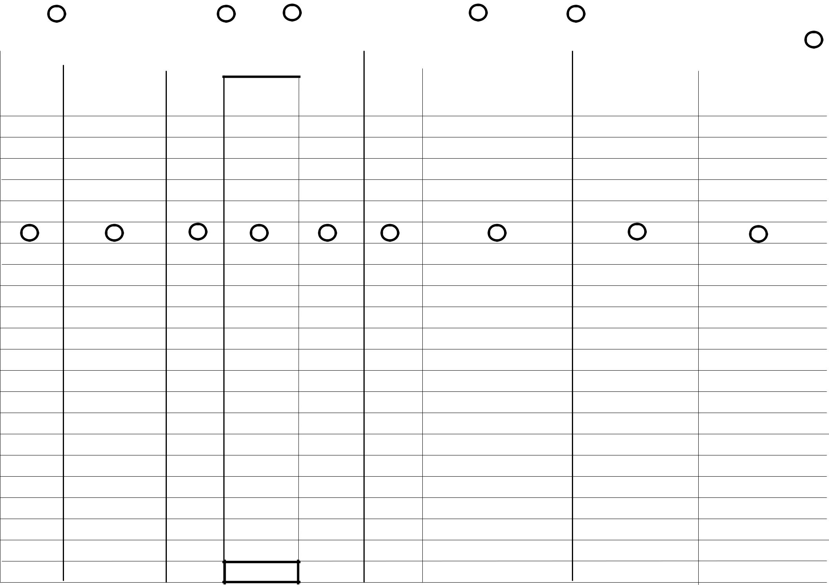

AL

AK

AZ

AR

CA

CO

CT

DE

DC

FL

GA

ID

IL

IN

IA

KS

KY

LA

ME

MD

MA

MI

MN

MS

MO

MT

NE

NV

NH

NJ

NM

NY

NC

ND

OH

OK

OR

PA

RI

SC

SD

TN

TX

UT

VT

VA

WA

WV

WI

WY

MX

AB

BC

NB

NK

NF

NT

NS

ON

PE

PQ

SK

YT

 | MILEAGE INFORMATION |  |  |  |  | FUEL INFORMATION |  | TRIP INFORMATION
TRIP | HIGHWAYS | JURISDICTION | ODOMETER READING | JURISDICTION | GALLONS | VENDOR
DATE | USED | NAME | BEGIN | MILES | RECEIVED | NAME | ORIGIN | DESTINATION

7 | 8 | 9 | 10 | 11 | 13 | 14 | 15 | 16

END
12 | TOTAL TRIP MILES


