Rent Receipt

 |  |  | Company or Firm Name (If Applicable) |  |  | Lic. No. (Your text here)
 |  |  |  |  | Date:
 |  |  |  |  | Receipt#:
Landlord: |  | Landlord Address 1
 |  |  | Landlord Address 2 | Phone# Contact number, Email
 |  |  | Landlord City, State ZIP | Mobile# Mobile#
 |  |  | Landlord Name (Company Name)


Tenant:

Phone #

Mobile#

Description of Property:

- Broadway Apt yyy New York, NY 10007
3 bed ·3.5 bath ·2,554 sq ft

1910 built

$15,500/month
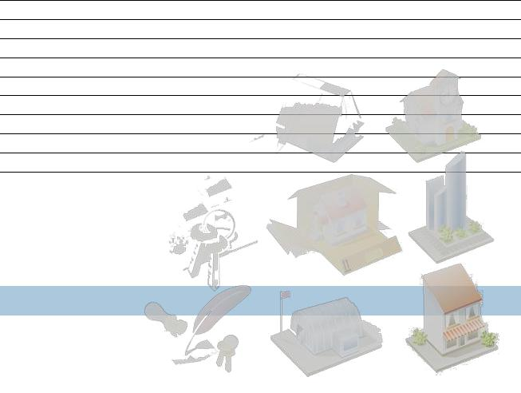

Total Amount to be Received | 20,000.00
Amount Received | 10,000.00
Money Received By
Total Due
Total Due | 10,000.00

THANK YOU FOR YOUR BUSINESS!

