

eTicket Receipt

Prepared For

JONES /DANA MS

RESERVATION CODE | FNTPAI
ISSUE DATE | 05Mar19
TICKET NUMBER | 0792182186140
ISSUING AIRLINE | PHILIPPINE AIRLINES
ISSUING AGENT | Philippine Airlines/CPM
ISSUING AGENT LOCATION | WEB PHILIPPINES, PHILIPPINES

Itinerary Details

TRAVEL | AIRLINE | DEPARTURE | ARRIVAL | OTHER NOTES
DATE
11Aug19 | PHILIPPINE AIRLINES, | OZAMIZ, PHILIPPINES | CEBU MACTAN INTL, | Class ECONOMY
 | INC |  | PHILIPPINES | Seat Number CHECK-IN
 | PR 2894 |  |  | REQUIRED
 |  | Time |  | Baggage Allowance NIL
 |  | 09:05 | Time | Booking Status OK TO FLY
 | Operated by: | 09:05 | 10:05 | Fare Basis O9PR78
 | PAL EXPRESS |  | 10:05 | Not Valid After 31DEC19

Payment/Fare Details

Fo rm o f Payment | CREDIT CARD - MAST ERCARD : XXXXXXXXXXXX
 | 84 93
Endorsement / Restrictions | NONREF/NONEND/PR78/FARE RULES APPLY
Fare Calculation Line | OZC PR CEB678PHP678END
Fare | PHP 678.00
Taxes/Fees/Carrier-Impo sed Charges | PHP 77.00 | YQF (SERVICE FEE - FUEL)
 | PHP 15.00 | PD2 (PD2)
 | PHP 100.00 LI (PASSENGER SERVICE CHARGE)
 | PHP 91.00 | PV (VALUE ADDED TAX)
To t al Fare | PHP 961.00
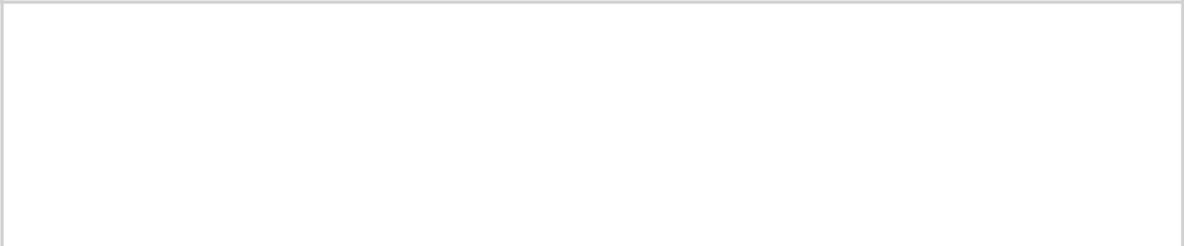

Positive identification required for airport check in

Notice:

IF THE PASSENGERS JOURNEY INVOLVES AN ULTIMATE DESTINATION OR STOP IN A COUNTRY OTHER THAN THE COUNTRY OF DEPARTURE THE WARSAW CONVENTION OR THE MONTREAL CONVENTION MAY BE APPLICABLE AND THESE CONVENTIONS GOVERN AND MAY LIMIT THE LIABILITY OF CARRIERS FOR DEATH OR BODILY INJURY AND IN RESPECT

OF LOSS OF OR DAMAGE TO BAGGAGE. MANY AIR CARRIERS HAVE WAIVED THE WARSAW CONVENTION LIMITS. FOR DEATH OR BODILY INJURY. FURTHER INFORMATION MAY BE OBTAINED FROM THE CARRIER. SEE ALSO NOTICES HEADED ADVICE TO INTERNATIONAL PASSENGERS ON LIMITATION LIABILITY AND NOTICE OF BAGGAGE LIABILITY LIMITATIONS.

Notice of Incorporated Terms

Air transportation whether domestic or international is subject to the conditions of carriage of the transporting carrier(s), which are herein incorporated by reference and made part of the contract of carriage. Other carriers on which you may be ticketed may have different conditions of carriage. International air transportation, including the carriers’ liability may be governed by applicable tariffs on file with the U.S. and other governments and by Warsaw or Montreal Convention.Passengers may obtain further information or inspect the full text, from any location where the carrier’s tickets are sold,or at https://www.philippineairlines.com/AboutUs/LegalNotices,, which include, but are not limited to:

- Limits on liability for injury or death, and for loss, damage, or delay of baggage, including fragile or perishable goods;

- Claim restrictions, including time periods within which passengers must file a claim or bring action against the carrier;

- Rights of the carrier to change terms of the contract of carriage;

- Rules on reservations, baggage allowance, check-in times, travel documentary requirements & refusal to carry;

- Rights of the carrier & limits of liability for delay, cancellations or failure to perform service including scheduled changes, substitution of air carrier or aircraft and rerouting;

- Refund and rebooking policies; and

- Other important reminders.

Data Protection Notice: Your personal data will be processed in accordance with Philippine Airlines' Data Privacy Policy which may be viewed here and/or the applicable carrier's privacy policy and, if your booking is made via a system provider ("GDS"), with its privacy policy. These are available at https://www.iatatravelcentre.com/privacy or from the carrier(s) or GDS directly. You should read this documentation, which applies to your booking and specifies, for example, how your personal data is collected, stored, used, disclosed and transferred.

The Data Privacy Policy, General Conditions of Carriage, and other legal notices, which may be viewed here are incorporated herein by reference.

Important Legal Notices

