

eTicket Receipt

Prepared For

VANDENDOLDER/BRINDA M MRS
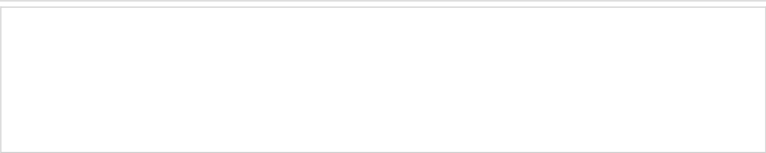

ETIHAD AIRWAYS RESERVATION CODE | YOGIBN
ISSUE DATE | 07Sep2013
TICKET NUMBER | 6072121103784
ISSUING AIRLINE | ETIHAD AIRWAYS
ISSUING AGENT | Etihad Airways/SS5
TOUR CODE | ITBRUT114

Itinerary Details

TRAVEL | AIRLINE | DEPARTURE | ARRIVAL | OTHER NOTES
DATE
16Dec | ETIHAD AIRWAYS | Brussels Airport | Abu Dhabi International | Fare Family Economy Saver
- 17Dec | EY 56 |  |  | Seat Number 35H
 |  |  |  | (CONFIRMED)
 |  | Time | Time | Baggage Allowance 30K
 |  | 21:20 | 06:55 | Booking Status OK TO FLY
 |  | 21:20 | 06:55 | Fare Basis EPR3MBE
 |  |  | Terminal | Fare Basis EPR3MBE
 |  |  | Terminal | Not Valid Before 16 DEC
 |  |  | TERMINAL 3 | Not Valid After 16 DEC
17Dec | ETIHAD AIRWAYS | Abu Dhabi International | Jomo Kenyatta | Fare Family Economy Saver
 | EY 641 |  | International Airport | Seat Number 17D
 |  |  |  | (CONFIRMED)
 |  | Time |  | Baggage Allowance 30K
 |  | 09:45 | Time | Booking Status OK TO FLY
 |  | 09:45 |  | Fare Basis EPR3MBE
 |  | Terminal | 13:45 | Fare Basis EPR3MBE
 |  | Terminal | 13:45 | Not Valid Before 17 DEC
 |  | TERMINAL 3 |  | Not Valid After 17 DEC
08Jan | ETIHAD AIRWAYS | Jomo Kenyatta | Abu Dhabi International | Fare Family Economy Saver
 | EY 642 | International Airport |  | Seat Number 12F
 |  |  |  | (CONFIRMED)
 |  |  | Time | Baggage Allowance 30K
 |  | Time | 20:25 | Booking Status OK TO FLY
 |  |  | 20:25 | Fare Basis VLAPBE
 |  | 14:35 | Terminal | Fare Basis VLAPBE
 |  | 14:35 | Terminal | Not Valid Before 08 JAN
 |  |  | TERMINAL 3 | Not Valid After 08 JAN
09Jan | ETIHAD AIRWAYS | Abu Dhabi International | Brussels Airport | Fare Family Economy Saver
 | EY 57 |  |  | Seat Number 20H
 |  |  |  | (CONFIRMED)
 |  | Time | Time | Baggage Allowance 30K
 |  | 02:35 | 07:10 | Booking Status OK TO FLY
 |  | 02:35 | 07:10 | Fare Basis VLAPBE
 |  | Terminal |  | Fare Basis VLAPBE
 |  | Terminal |  | Not Valid Before 09 JAN
 |  | TERMINAL 3 |  | Not Valid After 09 JAN

Payment/Fare Details

Form of Payment | CREDIT CARD - MASTERCARD : XXXXXXXXXXXX
 | 7851
Endorsement / Restrictions | VLD EY/NON ENDO/CHG150EUR/NO SHOW NOT
 | ALLOWED
Fare Calculation Line | BRU EY X/AUH EY NBO180.78EPR3MBE EY X/AUH EY
 | BRU284.65VLAPBE NUC465.43END ROE0.760562
Fare | EUR 354.00
Taxes/Fees/Carrier-Imposed Charges | EUR 214.00 YQF (SERVICE FEE - FUEL)
 | EUR 28.38 BE (PASSENGER SERVICE AND SECURITY
 | CHARGE)
 | EUR 30.37 TU (INTERNATIONAL PASSENGER
 | SERVICE CHARGE)
Total Fare | EUR 626.75


Notice:

Where purchase has been made through the internet, to use this electronic ticket you must present proof of identity. Transportation and other services provided by Etihad Airways are subject to conditions of carriage of passengers and baggage which are hereby incorporated by reference and form part of the contract of carriage between you and Etihad Airways. You are invited to take note, in advance of your journey, of these conditions the full text of which is available from Etihad Airways or its agents or on the website www.etihad.com

.

If your receipt is issued in respect of the ancillary products or services you have purchased other than passenger air transportation, it is subject to the applicable terms and conditions specific to the offer of such product or service. These terms and conditions are available on request from the issuing airline, its authorized agent (from whom the product or services were obtained).

Following baggage allowances are allowed free of charge for each guest on flights operated by Etihad Airways to/from any destination except USA or Canada:

 | Checked-in luggage | Carry-on luggage
Diamond | • Bags with a total not exceeding 50kg | • 2 bags, total of 12kg
First Class | • Each item must not exceed 32kg, and the | • Each item must not exceed maximum total
 | dimensions 45cm x 72cm x 90cm | dimensions of 115 cm (for example, 40cm x 54cm
 |  | x 21cm)
Pearl | • Bags with a total not exceeding 40kg | • 2 bags, total of 12kg
Business | • Items must not exceed the dimensions 45cm x | • Each item must not exceed maximum total
Class | 72cm x 90cm | dimensions of 115 cm (for example, 40cm x 54cm
 | Even if you choose to exceed your luggage | x 21cm)
 | allowance (at additional cost) each item must not
 | exceed 32kg
Coral | • Bags with a total not exceeding 30kg | • 1 bag, total of 7kg
Economy | • Items must not exceed the dimensions 45cm x | • Each item must not exceed maximum total
Class | 72cm x 90cm | dimensions of 115 cm (for example, 40cm x 54cm
 | Even if you choose to exceed your luggage | x 21cm)
 | allowance (at additional cost) each item must not
 | exceed 32kg
Infants (in | 1 bag with the total weight not exceeding 30 kg - | Items must not exceed the dimensions 45cm x
any class of | including carry cot/car seat and all other | 72cm x 90cm
travel) | accessories

For a full list of other items that may be allowed on board free of charge and for extra baggage allowance that may be allowed free of charge for Etihad Guest members, visit www.etihad.com
.

Following baggage allowances are allowed free of charge for each guest on flights operated by Etihad Airways to/from USA or Canada:
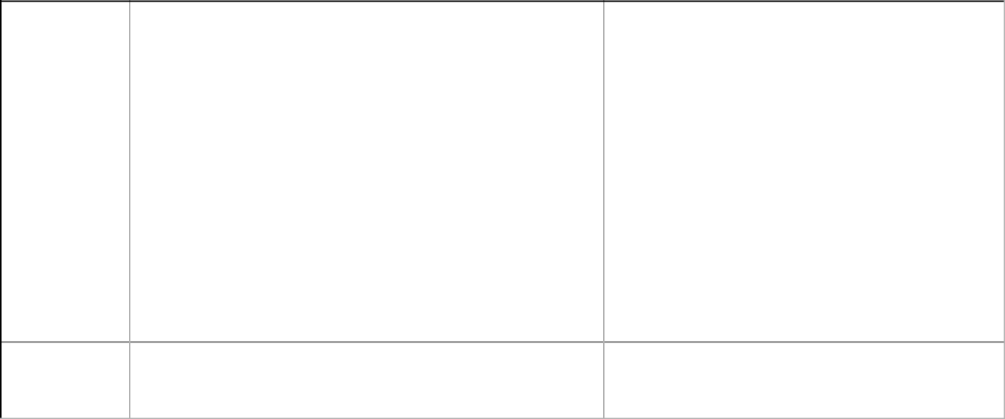

 | Checked-in luggage | Carry-on luggage
Diamond | • 2 bags – maximum for each bag 32kg (70lbs) | • 2 bags, total of 12kg
First Class | Maximum total weight of 64kg (140lbs) | • Each item must not exceed maximum total
 | • Each item must not exceed 32kg, and the dimensions | dimensions of 115 cm (for example, 40cm x
 | 45cm x 72cm x 90cm | 54cm x 21cm)
Pearl | • 2 bags – maximum for each bag 32kg (70lbs) | • 2 bags, total of 12kg
Business | Maximum total weight of 64kg (140lbs) | • Each item must not exceed maximum total
Class | • Each item must not exceed 32kg, and the dimensions | dimensions of 115 cm (for example, 40cm x
 | 45cm x 72cm x 90cm | 54cm x 21cm)
Coral | • 2 bags – maximum for each bag 23kg (50lbs) | • 1 bag, total of 7kg
Economy | Maximum total weight of 46kg (100lbs)• Each item must | • Each item must not exceed maximum total
Class | not exceed 23kg (50lbs) and maximum total dimensions | dimensions of 115 cm (for example, 40cm x
 | of 158 cm | 54cm x 21cm)
 | (for example, 50 x 70 by x 38)

Infants (in One bag only, not exceeding 23 kg (50 lbs)

any class of

travel)

Each item must not exceed 23kg (50lbs) and maximum total dimensions of 158 cm (for example, 50 x 70 by x 38)

For a full list of other items that may be allowed on board free of charge and for information on charges for excess baggage, visit www.etihad.com
.

Notice

If the passengers journey involves an ultimate destination or a stop in a country other than the country of origin, the Warsaw convention or the Montreal convention as stated in the conditions of carriage of passengers and baggage may apply to the entire journey, including any portion entirely within the country of origin or destination. These conventions may limit the liability of the carrier for loss of life or bodily injury; in respect of delay, and for loss or damage to baggage. Etihad airways has waived the limits of liability applicable under the Warsaw Convention (or that convention as amended at the Hague 1955 or protocols nos. 1 and 2 of 1975) with respect to loss of life or bodily injury attributable to an accident. However, under Warsaw convention (or that convention as amended at the Hague 1955 or protocols nos. 1 and 2 of 1975) the liability for the loss, damage or destruction of checked baggage is limited to 17 SDR per kilogram (about usd 20).Under the montreal convention of 1999, no financial limits apply in the case of loss of life or bodily injury. Etihad Airways may make advance payments to meet immediate economic needs of the person entitled to claim compensation, subject to applicable law. The liability of Etihad Airways in respect of damage caused by delay is limited to SDR 4150 (about usd 6200) and the liability in respect of destruction, loss, damage, or delay of baggage is limited to sdr 1000 (about usd 1,500.)For flights originating from any state member of the European Union Etihad Airways is committed to respect the specific European regulations relating to liability in case of denied boarding, cancellation of a flight or substantial delay.


For security reasons, all knives, sharp objects or cutting implements of any kind and any length, whether of metal or other material, knitting needles, and sporting goods, must be packed in your checked baggage. They cannot be carried in cabin baggage or on person. Passengers carrying hypodermic needles will need to declare them at the screening point where possible documentation or identification to confirm their medical condition should be produced. Medication should have professionally printed label identifying the medication or a manufacturer's name or pharmaceutical label affixed.It is forbidden that passengers carry in their baggage articles, liquids, or other substances which are capable of posing a significant risk to health, safety and property when transported by air, including explosives, compressed gases and/or aerosoles, flammable liquids, corrosives, oxidising materials, magnets, materials easily ignited, poisonous, offensive or irritating substances, munitions of war and any further items which are prohibited by applicable laws, regulations or order of any state to be flown from, to or over. For questions or additional information please contact your travel agent or visit the website www.etihad.com
.

Important Legal Notices

