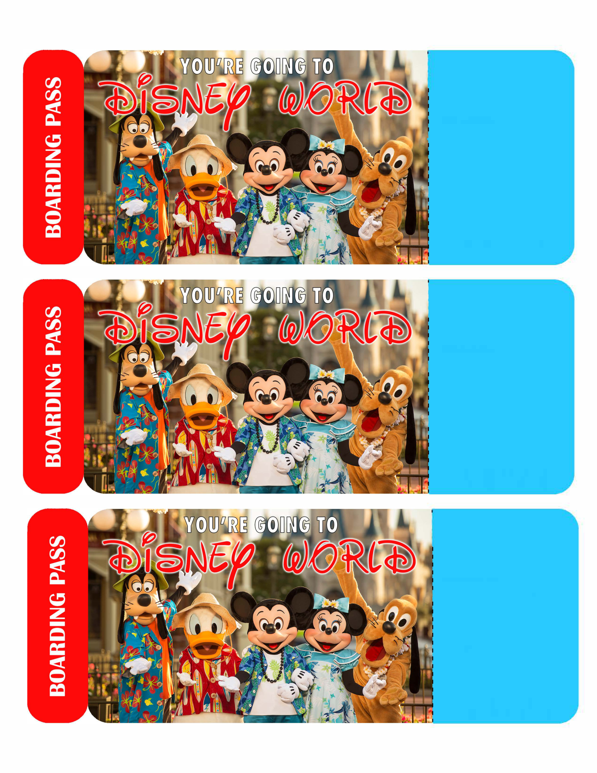
EDITABLE BOARDING PASSES - 8.5 x 1 1" Sheet (Can also print onto A4 page size)

: BOARDING PASS

I

¹ PASSENGER

DESTINATION

I DISNEV WORLD

DATE

₁ COMMENTS

111111111 1111 11111111 11 1111 11111111111 1111 111111

: BOARDING PASS

I

¹ PASSENGER
I DESTINATION

DISNEV WORLD

DATE

₁ COMMENTS

111111111 1111 11111111 11 1111 1111111111 1111 111111

: BOARDING PASS

I

¹ PASSENGER

DESTINATION

I DISNEV WORLD

DATE

COMMENTS

111111111 1111 11111111 11 1111 11111111111 1111 111111

© ELLIE ROSE PARTY DESIGNS WWW.ELLIEROSEPARTYDESIGNS.COM FOR PERSONAL USE ONLY

