C L I P - A R T C R A F T : PLACECARDS P A G E 1 o f 1

TEMPLATE
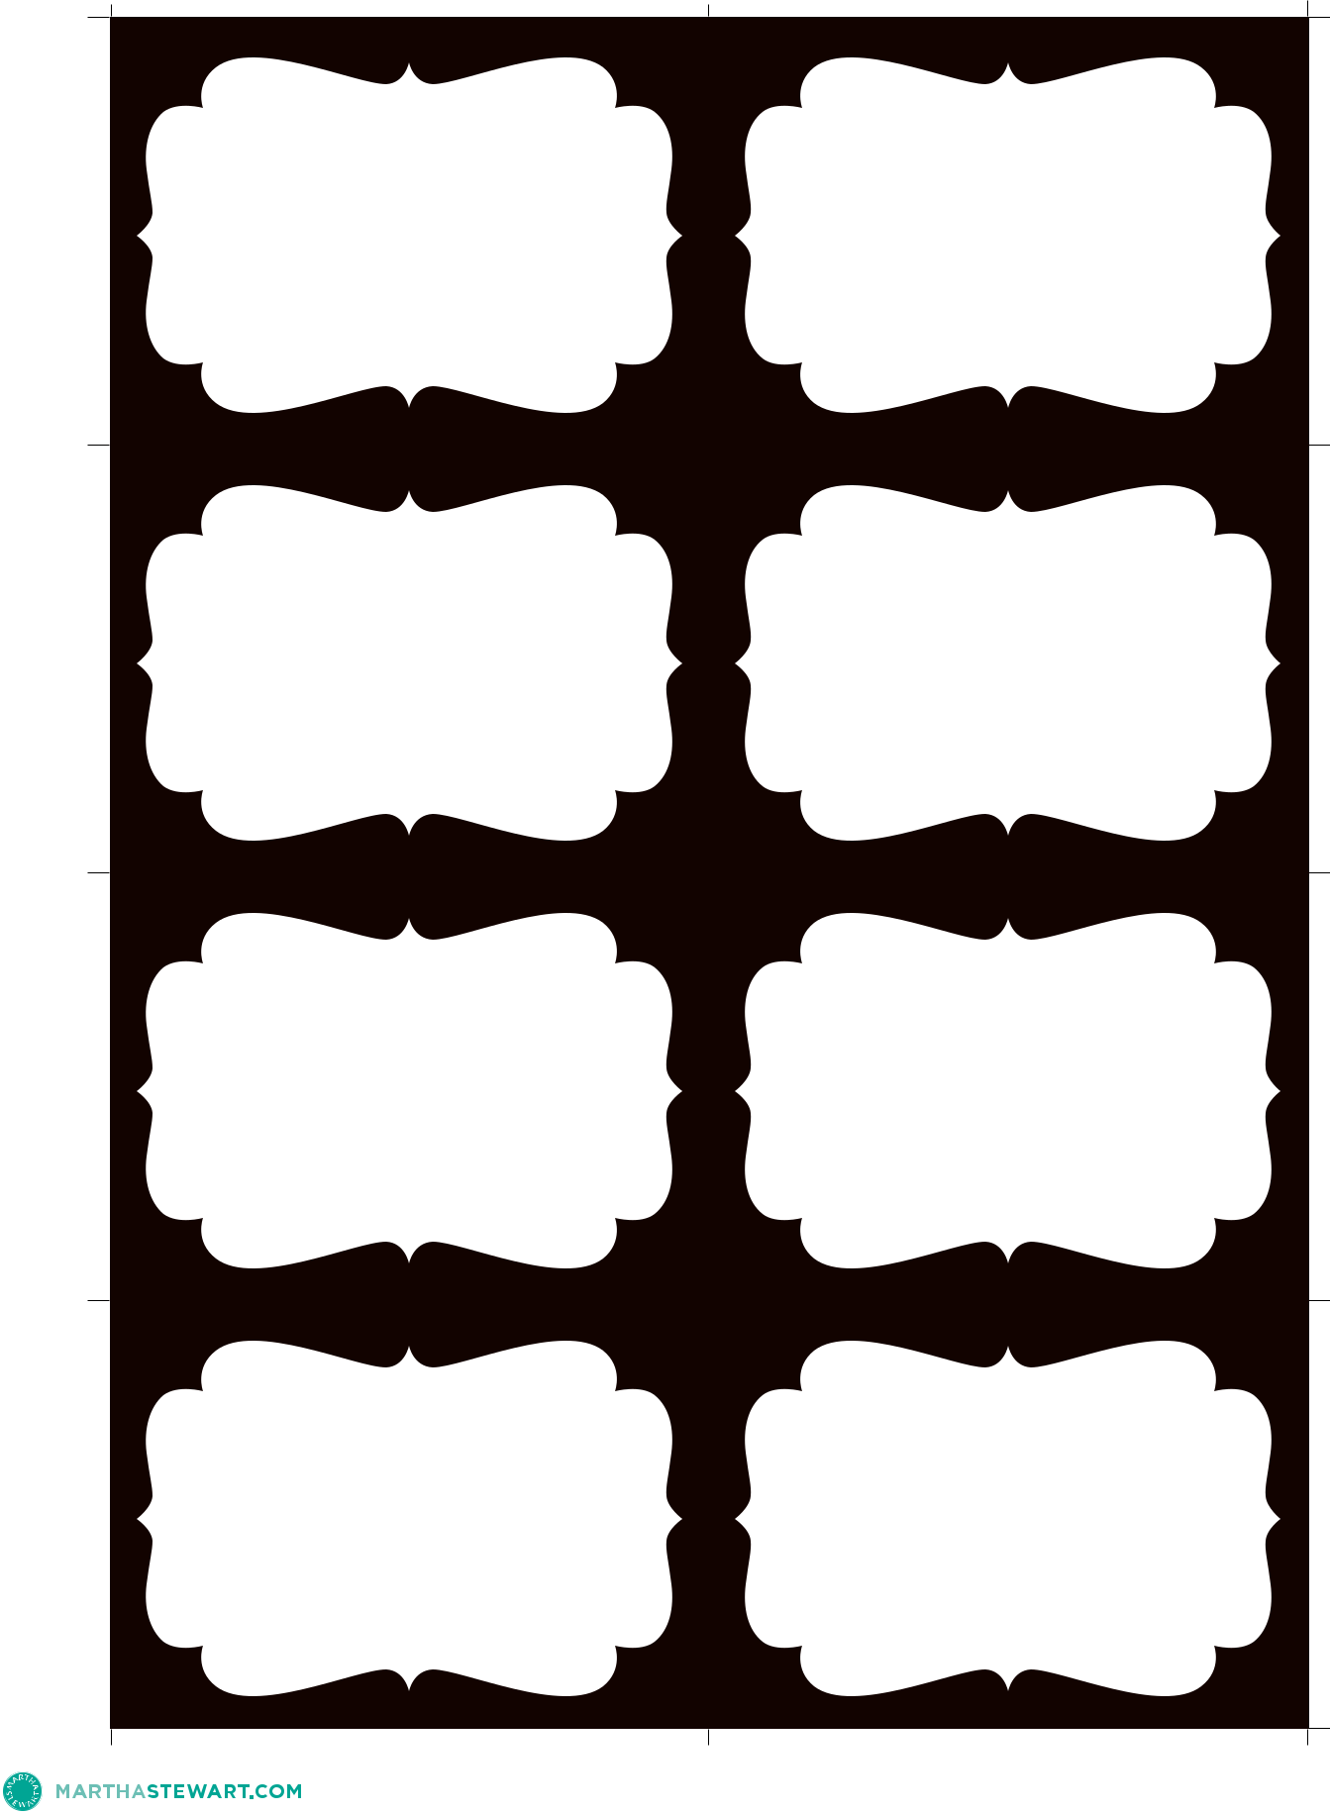

©2007 MARTHA STEWART LIVING OMNIMEDIA

